SOAL : 17 | Bahasa Inggris SMP/MTs

- Arrange these sentences below into a good paragraph.
- I had no choice but to go to barber, It was time to be bold.
- So, she started to snip my hair with a scissors,
- My father was overseas. He usually cuts our hair for us.
- It all happened when I noticed that my hair had grown too long.
- But my sister stopped me and said that she can do it for free,
- Halfway through, I came out my guts and panicked.
- I would get a cut from a professional barber, I got ready, to go.
- My beautiful hair reduced to nothing more than a haphazard.

A. 3-1-2-8-6-5-7-4
B. 7-4-8-5-6-1-2-3
C. 4-3-7-5-2-6-8-1
D. 8-1-2-5-6-3-4-7

The following text is for questions 2 and 3.

- How many pieces of treadmill does the company sell in a month?
A. 185
B. 764
C. 1500
D. 1599

- Why should you hurry to buy the product?
A. The stock is limited.
B. The price is very cheap now.
C. You will get more profits.
D. Other buyers are waiting.

For questions 4 to 6, complete the text with the correct word.
The island of Sangalaki in Kalimantan was opened for diving in 1993. Its shallow reef system extends over 200 meters from the (4) ... . It is (5) ... as Indonesian Marine Park. The island is also a breeding ground for green turtles. At night female turtles come ashore and lay their eggs. Baby turtles hatch and they (6) ... struggle their way to the sea while avoiding hungry birds.

- A. land
B. island
C. continent
D. archipelago

- A. boring
B. famous
C. luxurious
D. uninteresting

- A. lazily
B. carelessly
C. differently
D. desperately

The following text is for questions 7 and 8.

- Which information can be found in the text?
A. The meeting is held at 4496 St. Claude Ave
B. Food and drink will be served during the meeting.
C. Mr. Nan Roman will talk about politics in the US.
D. The meeting will be done in the afternoon

- "Join us at our 20th “Anniversary meeting".
The underlined word refers to....
A. unity organization
B. homelessness people
C. New Orleans citizen
D. Nan Roman, the speaker

The following text is for uuestions 9 to 13.
Ojek “motorcycle taxi” began appering in Jakarta after becak was banned in 1994. Ojek service began as a people's initiative to provide an alternative transportation for people who used becak from main roads into housing complexes.
There is no government license or control for ojek. By the law, all motorcycle passengers should wear helmet so ojek drivers should have a spare for their passengers to wear. Ojek tends to congregate at T-junction on main roads and near smaller road that are not serviced by bus routes.
Ladies should have a careful position in taking ojek. Also, if the women wear a dress, they have to sit sidewise on the back of the vehicle. You have to bargain before you get on and ask a local people about the usual price.

- What is mainly discussed in the text?
- Housing complexes.
- Motorcycle taxi.
- Alternative transportation.
- People's initiative.

- Where do ojeks gather?
A. In main roads.
B. At housing complexes.
C. At t-junctions.
D. On bus routes.

- What had started ojek to appear?
A. government control over ojek.
B. Bus services that cover smaller road.
C. Becak were banned in 1994.
D. New housing complexes were built.

- What is the am ide of paragraph three?
- Tips or ojek passengers
- Law for motorcycles passengers
- The beginning of ojek service
- Ojek service's coverage area

- From the text, we know that …………………
A. Ojek passengers are mainly women
B. Ojek has replace becak's function
C. Ojek only operate in housing complexes
D. Ojek has fixed price for its routes

This text is for the following question 14 to 17
Once upon a time, there was a poor woman who had lost her husband and had a son named Malin Kundang. One day, Malin Kundang went sailing to other place. Ever since Malin Kundang leaving, his mother went to the shore everyday, waiting for Malin Kundang to return.
After years, her waiting came to an end when a luxurious ship docked at the shore. A young couple in extravagant clothes stepped down from the ship. Mali's mother was sure that the young man was her son. She tried to embrace him, but he threw her away. He didn't admit the woman as his mother.
Being denied and humiliated, Malin's mother cursed her son. After a moment, the luxurious ship was attacked by a hurricane and the cursed son turned into rock.

- The old woman cursed her son because ……..
A. he went to the shore everyday
B. he docked his ship at the shore
C. he denied and humiliated her
D. he tried to embrace her

- What is the main idea of paragraph 3?
A. Malin Kundang was cursed by her mother
B. Mali's mother got angry and turned into a rock
C. Malin Kundang continued his journey
D. The luxurious ship was attacked by a hurricane

- Malin Kundang step down from the ship with his …….
A. son
B. mother
C. guards
D. wife

- What can we learn from the story?
A. All mothers love their children.
B. Be careful with your angry mother.
C. Don't leave your mother alone.
D. Always respect your mother.

The following text is for questions 18 to 21.
In 1854, Louis Pasteur was appointed professor of chemistry at the University of Lille. He demonstrated that organism such as bacteria were responsible for souring wine, beer even milk. He then invented a process where bacteria could be removed by boiling and then cooling the liquid. Today the process is known as pasteurization. He completed the first test on April 20, 1862.
In 1865, Pasteur helped to save the silk industry. He proved that microbes were attacking healthy silkworm eggs, causing the diseases, and the disease can be cured by eliminating the microbes.
Pasteur first vaccine discovery was in 1879, with .a disease called chicken pox. After accidentally exposing chicken to the attenuated form, he demonstrated that they became resistant to the actual virus. Pasteur went on to extend his germ theory to develop prototype of vaccine for diseases such as anthrax, cholera, TB, and smallpox.

- What happened to Pasteur in 1879?
A. He found his first vaccine.
B. He was appointed as chemistry professor.
C. He developed the vaccine prototype.
D. He invented pasteurization process.

- From the text, we can conclude that
A. Louis Pasteur is a method of processing milk
B. Louis Pasteur found no cure for anthrax and cholera
C. Louis Pasteur had-his own silk industry
D. Louis Pasteur invented a method called pasteurization

- What is the main idea of the last paragraph?
A. Louis Pasteur completed the test well.
B. Louis Pasteur demonstrated his theory.
C. Louis Pasteur-became a professor.
D. Louis Pasteur discovered vaccination.

- "He then invented..." (first paragraph).
What does the word "invented" mean?
A. Looked for.
B. Used.
C. Created.
D. Thought about.

The following text is for questions 22 and 23.
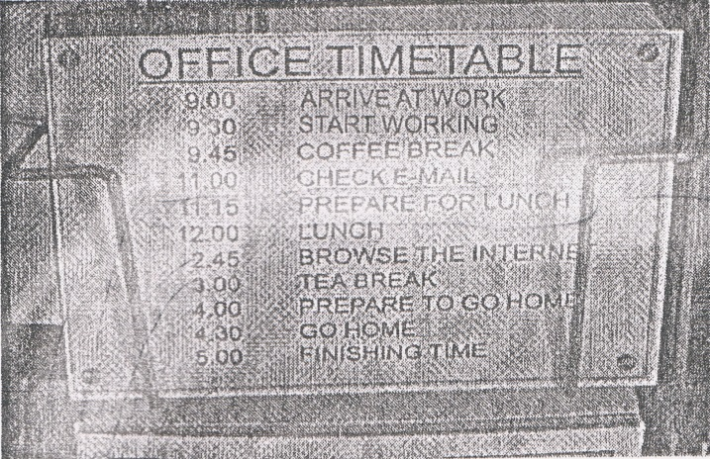

- What will the employees do at eleven fifteen?
A. Have a Coffee break.
B. Check their e-mail.
C. Prepare for 1unch..
D. Browse the Internet.

- From the timetable, we can conclude that
A. the tea break lasts for one hour
B. the busiest work is browsing the Internet
C. the employees arrive home at-six in the afternoon
D. there will be much work after taking the tea break

The following text is for questions 24 to 26.
Hawaii Excelsior Hotel
August 4th , 2012

Dear Marry,
How are you? Have you finally found a new flat? And how was your holiday?
I'm writing to you from Hawaii. I came a week ago and stayed with my friend, Caroline, in a luxurious hotel called Excelsior Hotel. We had a spacious, comfortable room with a large terrace overlooking the ocean.
Yesterday, we started learning surfing. We really enjoyed it and the instructor said we were doing quite well. I started scuba diving course three days ago and tomorrow going to dive in the ocean for the first time. I'm very excited about it!
That's all for now, I must rush for a spectacular party tonight.

Take care,
Jessica

- The text mostly talks about....
A. Hawaiian people
B. luxurious hotel
C. holiday in Hawaii
D. diving and surfing

- What did Jessica do three days ago?
A. Arrived in Hawaii.
B. Stayed in a hotel.
C. Decided to learn surfing.
D. Started scuba diving course.

- The writer is very excited about scuba diving because....
A. the instructor said she was doing quite well
B. she started scuba diving course three days ago
C. she's going to dive in the ocean for the first time
D. the hotel has a large terrace overlooking the ocean

The following text is for questions 27 to 30.
One of the most interesting places to visit in Singapore is the Bird Park. It is located in the industrial area in Singapore, called Jurong. The bird park is about twelve kilometers from the center of the city, and it's easy to get there by bus or by taxi.
It is one of the largest bird park in the world. The birds are kept in large cages, and there are hundreds of beautiful birds from many different parts of the world, Including penguins, parrots, eagles, and ostriches. There is a large lake in the park with a restaurant beside it. There is also a very large cage which you can walk in to get a closer look at the birds.
It takes about two hours to see all the birds. You can walk around the park or ride on a bus. The best time to visit the park is in the early morning or late afternoon, when it

- How far is the park from the city center?
A. 2km.
B. 10 km.
C. 12 km.
D. 100 km.

- Why do many people like to visit the bird park late in the afternoon?
- They are busy working in the morning.
- The weather is not hot in the afternoon.
- The birds in the park are caged in the morning.
- They live in many different parts of the world.

- What is the main idea of the second paragraph?
A. The most interesting place in Singapore is the bird park.
B. There is a restaurant next to a large lake in the park.
C. There are hundreds of very beautiful birds in the cages.
D. Singapore bird park is the largest bird park in the world.

- "It is located in the industrial area in Singapore." (paragraph 1)
What does the underlined word mean?
A. Situated
B. Held
C. Conducted
D. Performed

The following text is for questions 31 to 34
In the days when an ice cream sundae cost less, a 10 years old boy entered a hotel coffee shop and sat at a table. A waitress put a glass of water in front of him.
"How much is an ice cream sundae?"
"50 cents," replied the waitress.
The little boy pulled his hand out of his pocket and studied a number of coins in it. "How much is a dish of plain ice cream?" he inquired. Some people were now waiting for a table and the waitress was a bit impatient.
"35 cents," she said brusquely.
The little boy again counted the coins. "I'll have the plain ice cream," he said. The waitress brought the ice cream, put the bill on the table and walked away. The boy ate it, paid the cashier and departed.
When the waitress returned, she began wiping down the table and then swallowed hard at what she saw. There, placed neatly beside the empty dish, were 15 cents - her tip.
- What did the boy do after knowing he had less money?
A. He wiped down the table.
B. He swallowed hard.
C. He walked away.
D. He bought a dish of plain ice cream.

- What is the first paragraph about?
A. The waitress' underestimation of the boy.
B. The waitress' appreciation of the boy.
C. The price of ice cream sundae.
D. The hotel coffee shop's ice cream sundae.

- What is the moral message of the story?
- When there is a will there is a way.
- Don’t judge the book by its cover.
C. Every cloud has a silver lining.
D. Simplicity is the best policy.

- "The boy ate it, ….." (Paragraph 3)
The underlined word refers to …….
A. ice cream
B. empty dish
C. the bill
D. the table

This text is for the following questions 35 to 38.
Corn Flour Pudding
Ingredients:
2000 ml milk
200 gr corn flour
500 gr brown sugar
4 tbs water to dissolve the sugar
1 stick of 10 cm cinnamon
1 tbs butter
3 tbs cinnamon for sprinkling

Method:
  - Thoroughly mix milk and corn flour until smooth.
  - Boil brown sugar and water until sugar dissolved, then sieve.
  - Mix brown sugar with the milk, corn flour mixture and cinnamon stick. Add butter and simmer whilst stirring until corn flour became thick.
  - Pour into a suitable mould and let it cool.
  - When serving sprinkle with ground cinnamon
Makes : 10-15 portions, best served when cold.

- Based on the text, we pour the mixture into mould …………
- before we mix all the mixtures
- after the corn flour become thick
- after the mixtures get cool
- when the pudding is ready

- How many ingredients are needed to make Corn flour pudding?
A. 16.
B. 7.
C. 8.
D. 10.

- "Mix brown sugar with the milk, corn flour mixture ..." (step 3)
The underlined word is similar in meaning with………
A. put
B. combine
C. pour
D. shake

- The word "it" in step 4 refers to ... of corn flour-pudding.
A. the cinnamon
B. the mixture
C. the brown sugar
D. the milk

The following text is for questions 39 to 42.

Gardenia plants are popular for the strong sweet scent of their flowers. Gardenia is the national flower in Pakistan. In Japan and China, the flower is called Kuchinashi (Japanese) and Zhi zi (Chinese).
Gardeniaplants are evergreen shrubs. Their small trees can grow to 1 - 5 meters tall. The leaves are 5 - 50 centimeters long and 3 - 25 centimeters broad, dark green and glossy with a leathery texture. The flowers are in small groups, white, or pale yellow, with 5-12 lobes (petals) from 5-12 centimeters diameter. They usually bloom in mid- spring to mid-summer. Many species have strong aroma.
To cultivate gardenia as a house plant is not easy. This species can be difficult to grow because it originated in warm humid tropical areas. It demands high humidity and bright (not direct) light to thrive. It flourishes in acidic soil with good drainage and thrives on 20°— 23° C during the day and 150 - 16° C in the evening. Potting soils developed specifically for gardenias are available. It grows no larger than 18 inches in height and width when grown indoor. In climates where it can be grown outdoors, it can reach the height of 6 feet. If water hits the flowers, they will turn brown.

- How tall is a tree?
A. 3-25 cm.
B. 5-12 cm.
C. 5-50 cm.
D. 1-5 m.

- What is the main idea of the last paragraph?
A. It is easy to plant a gardenia tree.
B. A gardenia plant needs high humidity.
C. It's not easy to plant gardenia as a house plant.
D. A good drainage is important for gardenia plant.

- From the text we know that ………..
A. people don't like the strong scent of flower
B. Gardenia is widespread in Asia
C. the flower is easy to plant
D. the flower is expensive

- "... because it originated in warm ..." (paragraph 3, line 10)
The underlined word refers to ……….
A. the flower
B. the species
C. the soil
D. the leaf

The following text is for questions 43 to 45.
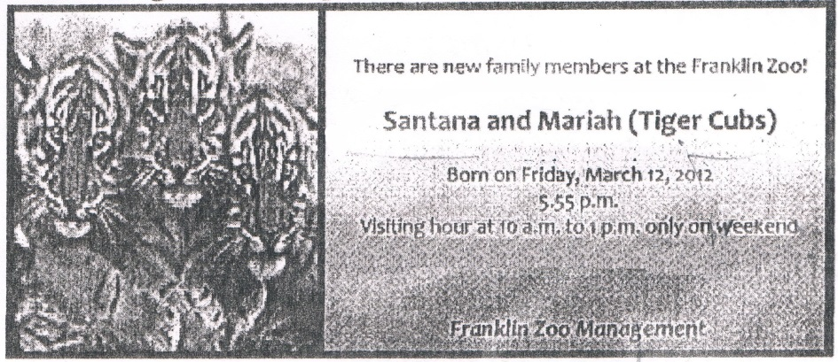

- The text tells us about
A. the management of Franklin Zoo
B. the new member of management
C. the cubs and management
D. the newborn tiger cubs

- What should people do to see the cubs?
A. Come to the zoo on weekend
B. Go to the zoo on weekdays
C. Visit them in the afternoon
D. Contact zoo management

- "Santana and Mariah (Tiger tubs)"
The synonym of the underlined word is ………..
A. families
B. babies
C. mothers
D. fathers

For questions 46 to 48, choose the most suitable words to fill in the blanks.
Last Monday was a busy day for me. I spent my time to do a lot of activities both at school and at home. First, in the morning, I did my homework with my friend, Nurhalizah. It took one hour. Then we (46) ….. to school together. But, (47)….. said that our task would be collected the following week. It made us disappointed. The class (48)..... finished at 12.30.

- A. left
B. sat
C. were
D. went

- A. the student
    - the teacher
    - friends
    - the principal

- A. quickly
B. finally
C. slowly
D. rarely

- Arrange the sentences bellow into a correct paragraph.
- We left our house at about 5 o'clock in the morning. We took a taxi to the railway station.
- Finally our train came. All of us rushed to get on the train.
- Last Lebaran, my family and I went hometown. We decided to take a train because it is more comfortable.
- It took about 5 to 7 hours to get to our hometown. We enjoyed our journey.
- We took the carriage no 3 according to our tickets.
- But without any prior information, our train was late for about fifteen minutes, so we had to wait a bit longer.
- After finding our seats we could sit comfortably.
- 8. We arrived at the station at six. Our train would leave at 6.40.

A. 3-8-6-4-5-1-2-7
B. 3-4-5-8-1-2-6-7
C. 3-1-8-6-2-5-7-4
D. 3-5-4-2-7-8-1-6

- This text is for the following question.

A. Watch out! This tool can be corrosive if you touch it.
B. Remember! This material is made of corrosive substance
C. Be careful! The material can harm you.
D. Don't touch the hand! It can damage your property.

