SOAL : 15 | Bahasa Inggris SMP/MTs

- Arrange the sentences below to be a good paragraph!
1. I chose the place under the big tree.
2. I was really sure that he was my classmate, Andi.
3. The boy was surprised then he turned around.
4. Yesterday, I went to the town square to watch a local singing contest.
5. Suddenly, I found myself behind a young boy.
6. I thought it could save me from the hot day.
7. I pinched his left shoulder a little and called his name.
8. Oh my God, actually, he was not Andy my classmate.

A. 2-1-4-6-5-8-7-3
B. 4-1-6-5-2-7-3-8
C. 4-1-7-2-3-8-6-5
D. 1-4-2-5-6-3-8-7

The following text is for questions 2 and 3.

- What is preloaded into the phone?
- Hindi movie
- A user manual
- Expandable memory
- Service center directory

- How can people buy the item?
- They should come directly to the shop. ?
- They can call, text, or send an e-mail.
- They contact the service center.
- They can leave a message for them.
Questions 4 to 6 choose the correct words to complete the text.
Mrs. Ratulin is a very healthy (4) ……. She exercises everyday and eats (5) ….. food. First thing she does in the morning is jogging around the neighborhood jogging treck. Then she takes a break for about 15 minutes. (6) ....., she takes a deep breath and drink lots of water.

- A. girl
B. aunt
C. mother
B. woman

- A. raw
B. fresh
C. canned
D. healthy

- A. Surely
B. Finally
C. Actually
D. Surprisingly

The following text is for questions 7 and 8.
Northeastern  University | Center for Academic Services  Arts and Sciences Department
September 23rd, 2012
Center for Academic Student Service  Meserve Hall  617 373 3980  cas@ncu.cdu  Visit Our Website  www.northeastern.edu | To all undergraduate and graduate students of  Arts and Sciences Department  There will be an open dialogue for students and member of the committee discussing  Arts and Sciences Department and Academic Research Journal  on  September 26th, 4:30 - 6:00 p.m., in 31B  Currie Student Center  Attached is a list of published Academic Journal  For more information, please visit our website:  http://www.northeastern.edu/collegestructure-  by attending this dialogue, hopefully you will understand more  about Academic Journal.  (This meeting has been rescheduled from September 21st)

- From the text, we can see that ……….
A. the committee will not attend the dialogue
B. every student of the department is invited
C. the dialogue is only for special student only
D. there has not been any change on the dialogue schedule

- "…...,hopefully you will understand ..."
The underlined word refers to all
A. students in the Arts and Sciences Department
B. students in Northeastern University
C. undergraduates in Arts and Sciences Department
D. students of Arts and Sciences and committee

The following text is for questions 9 to 13.
Riding on a canal bus is an enjoyable and relaxed way of getting around Amsterdam canals and it takes you to pass all the city's top sights. You'll see many kinds of buildings, from historic ones to the city's narrowest houses. Canal bus boats also cruise, bringing you to Amsterdam's mayor museums, such as Van Gogh Museum the Rijkos-Museum and the Ann Frank house.
On Board we provide a multilingual commentary. Our comfortable boats offer a frequent and regular service with 4 routes and 20 stops, including 6 transfer points.
The stops are located near the museum, shopping district and tourist attractions. Your hours ticket allows you to hop and off as often as you like.

- What is the text about?
A. Tourist resorts.
B. City boats.
C. Amsterdam canal
D. Canal bus boats.

- How many routes does the canal have?
A. 24
B. 20
C. 6
D. 4

- The passengers of the canal bus boat may hop and off as they like because it …….
A. provides a multilingual commentary
B. sells tickets for 24 hours
C. has 4 routes and 20 stops
D. has enjoyable regulation

- What is paragraph two about?
A. The schedule of canal bus boat.
B. The canal bus boat services..
C. The cost of canal bus.
D. Routes of the bus.

- From the text, we know that ....
A. the canal bus boat offers only regular service
B. passengers can enjoy the beautiful museums as well
C. passengers are not permitted to hop and off as they like
D. the canal bus boat provides only a bilingual commentary

The following text is for questions 14 to 17.
One day, Rahwana kidnapped Sinta and took her to his palace in Alengka. Rama was so sad. He tried many efforts to save his wife. He sent his best troops to search for his beloved wife but Sinta remained unfound.
After four months, Hanoman, the king of white monkeys found Sinta's crown in the bushes. It was a clue that led them to Alengka. Rama thanked his best friend Hanoman, and soon they went to Alengka with thousands of troops.
The battle was unavoidable. Rahwana's troops were very powerful giants?. They made many of Rama's soldiers wounded. The battle took two months. Yet, after Rama got involved in the battle, the probIem solved. It was also because of Rama's power. Rahwana the very powerful king of giants was killed.
Rama was so happy-to see his beloved wife. They returned to Ayoda and lived happily, forever.

- Rama thanked Hanoman because ………….
A. he wanted to go to Alengka
B. he found Shinta's crown
C. he killed thousands of troops
D. he told him an important secret

- What is the main idea of the second paragraph?
A. Hanoman found a clue of Sinta existence.
B. Rama got his wife's crown in the bush
C. Alengka had thousands of troop to fight
D. The king of white monkey went to the bushes

- From the text, we know that ……………
A. Rahwana killed a lot of Rama' s troops
B. it took months for Rama to kill Rahwana
C. Rahwana's troop could not be defeated
D. Rama was more powerful than Rahwana

- What is the moral value of the story?
A. All husbands love their wives very much
B. A good friend brought happiness into our lives
C. One must save his/her endangered beloved one
D. A husband must be powerful to defeat evil

The following text is for questions 18 to 21.
Dr. Mohammad Hatta was born in Bukittinggi, West Sumatera, Dutch East Indies (now Indonesia). He was Indonesia's first Vice President, later also served as the country's prime minister. Known as the 'proclamator', he and a number of Indonesian people including the first President of Indonesia Soekarno, fought for the independence of Indonesia from Dutch. Despites his efforts to gain Indonesian independence, he studied in the Netherlands from 1921 until 1932.
Moreover, after his early education, he studied in Dutch Schools in Indonesia. He is more remembered as Bung Hatta (Bung is an affectionate title used to address colleagues popular in the early 1900 and is still used by Indonesians).

- Why was Mohhammad Hatta called Bung Hatta?
A. To make him popular.
B. To address colleagues.
C. To gain his education.
D. To find his name easily.

- Based on the text above, we know that ……..
A. Ir. Soekarno is usually called by Bung Karno
B. Bung Hatta studied in Indonesia after 1932
C. Bung Karno and Bung Hatta were closed friends
D. Bung Hatta was the first President Of Indonesia

- The first paragraph is about …….
A. A short biography of Dr. Mohammad Hatta
B. The struggle of Mohammad Hatta against the Dutch
C. The education of Mohammad Hatta in Dutch School
D. The story of the struggle of Indonesian people

- "Known as the 'proclamator', he ..." (paragraph 1)
The underlined word means a person who…….
A. announces officially and publicly
B. is popular in Indonesia
C. helps President duty
D. leads a country and nation

The following text is for questions 22 and 23.
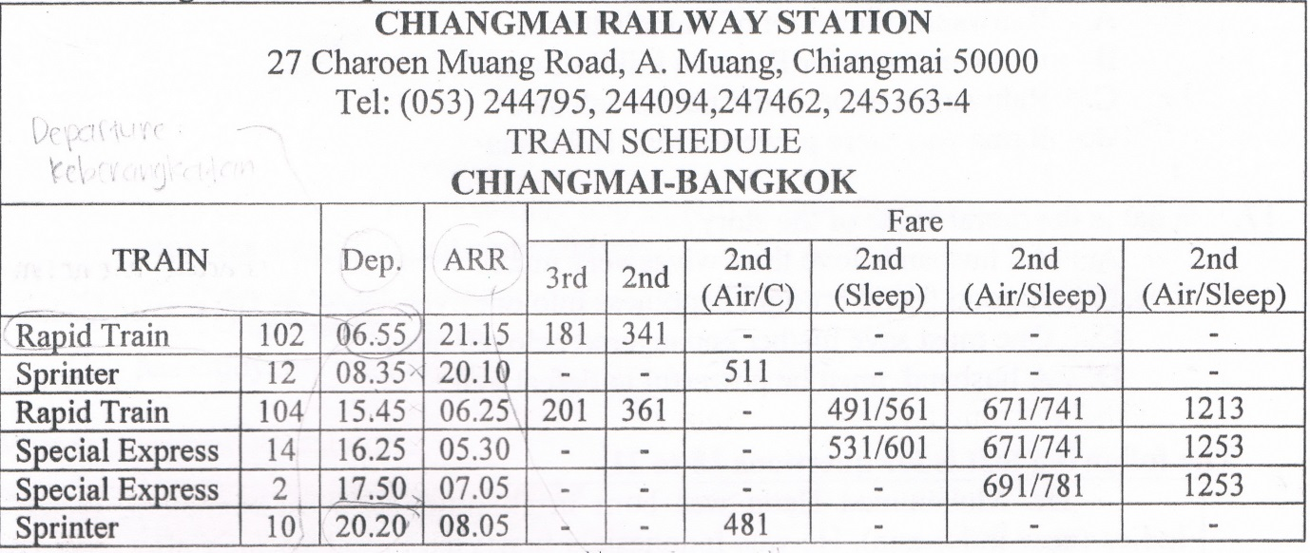

- Which train lives Chiangmai the earliest for Bangkok?
A. Special Express 2
B. Rapid Train 104
C. Sprinter 10
D. Rapid Train 102

- Which train goes to Bangkok in the evening?
A. Special Express 2
B. Rapid Train 104
C. Sprinter 10
D. Sprinter 12

The following text is for questions 24 to 26.
August 11th ,2012

James Stephen
15th Park Lane,
Hyderabad.

Dear James,
Everything is fine here and I hope you do too. I hope your studies are going great. I am writing this letter to invite you and your family to come here (Mumbai) for this summer holidays; Since we've been apart for a long time, I want to spend this summer holidays with our families and I think we will enjoy it a lot.
We are planning to go to some cool places or a mountainous area during this time so that we can have a good time. The options are Ooty, Darjeeling, Shimla and many others. After we decide the place, we can arrange trips to nearby places as well. We will make this trip as a memorable one. Please let me know if you have any other place in mind, we will consider that as well. Reply me soon so that we can plan it well. Awaiting your reply.

Your loving friend,
Radit

- What is the letter about?
- The writer's big family activities.
- A holiday invitation to Mumbai,
- A great, memorable trip in Mumbai.
- James's studies at the university.

- Where does James live?
A. Hyderabad
B. Mumbay
C. Shimlaa
D. Ooty

- Why did the writer write the letter to James?
- To inform the writer's studies in Mumbai.
- To describe the writer's school in Mumbai.
- To invite James and his family to visit Mumbai.
- D. To ask for James to study with him in Mumbai.

The following text is for questions 27 to 30.
Raja Ampat Island

Raja Ampat is located in the northwest tip of Bird's Head Peninsula of West Papua. It is an archipelago comprising over 1,500 small cays and shoals surrounding the four main islands of Misool, Salawati, Batanta, and Waigeo, and the smallest island of Kofiau.
Raja Ampat is the most bio-diverse location in the world. More than 3000 species of fish and over 300 species of corals have been identified here In a single one and half hours dive we can see more than 400 species of fish Until today, the area is virtually' unexplored and unknown due to its size. From mid-June to the end of August, Raja Ampat area has its roughest seas and lowest visibility. During the rest of the year; the sea is mostly very smooth with good visibility.
The marine natural resources in Raja Ampat make it significantly potential as a tourist destination; Many travel agents place Raja Ampat as one of their top ten diving destination while it ranks number one in underwater biodiversity. The International surveys suggest that the marine life diversity in the Raja Ampat area be the highest recorded on Earth. It is greater than any other area sampled in the Coral Triangle composed of Indonesia,_Malaysia, Philippines, Papua New Guinea, Solomon Islands, and Timor-Leste. The Coral Triangle is the heart of the world's coral reef biodiversity, making Raja Ampat possibly the richest coral reef ecosystems in the world.

- How many species of corals have been identified in Raja Ampat?
A. less than 300.
B. more than 300.
C. more than 400.
D. over 1500.

- Which information is found in the text?
A. Due to the size, the area has been known and explored.
B. The marine life diversity in Raja Ampat is the lowest on earth.
C. The sea is very rough and decreases in visibility every August.
D. The coral triangle is the heart of the world's coral reef biodiversity.

- What is the main idea of the paragraph?
A. Raja Ampat is a potential tourist destination
B. Raja Ampat is a sampled area in the Coral Triangle
C. Raja Ampat is a bio-diverse location in the world
D. Raja Ampat is an archipelago comprising 1.500 islands

- "...make it significantly potential as tourist destination." (paragraph 3)
The underlined word can be best replaced by....
A. sophisticated
B. important
C. valuable
D. good

The following is for questions 31 to 34.
A man and his son were going to the market. While they were walking, a country man passed and said, “Yu fool, what a donkey for but to ride upon?"
So the man put the boy on the donkey. But soon, some passersby said, "see that lazy young steer. He lets his father walk while he rides."
So the man ordered his boy to get off and got on himself but the passerby said, "Shame on that lazy old man, he lets his poor son walk, while he rides"
The man did not know what to do. Last, he took his boy on the donkey. Then the passerby said "Aren't you ashamed of yourself for overloading the poor donkey?"
The man and the boy got off. They cut down a pole, tied the donkey's feet to it and raised the pole to their shoulders. They arrived to a bride when the donkey, getting one of its feet loose, kick all out and caused the boy to drop his end of the pole. In the struggle, the donkey fell over the bridge and then it was drowned.

- Why did the boy get off from the donkey?
- The passerby needed him.
- His father asked him to do that.
- The donkey was tired carrying him.
- The boy wanted to be with the donkey.

- What is the main idea of the last paragraph?
A. The man and his son took a rest near the bridge.
B. The man and his donkey arrived at the market.
C. The man's behavior made the donkey alive.
D. The donkey was carried by its owners.

- What is the moral value of the text?
A. You should believe in yourself.
B. You cannot please everyone.
C. Do what everyone asked you for.
D. You must be careful when riding a donkey.

- "..., tied the donkey's feet to it..." (last paragraph)
The underlined word refers to ……….
A. the market
B. the donkey
C. the pole
D. the river

The following text is for questions 35 to 38.
Tarragon Corn Chowder Recipe
Ingredients:
- 4 ears corn - 3 bay leaves
- 3 tbsp unsalted butter - 4 small potatoes, cut into chunks
- 1 cup chopped onion - Salt
- 1 cup chopped fennel bulb - ½ cup white wine
- 2 minced garlic - 1-2 tbsp fresh chopped tarragon

Method:
  - Grill the corn directly over heat about 10-15 minutes to get extra flavor.
  - Cut kernels away from the cobs.
  - Boil 6 cups water and bay leaves and add the corn cobs to make corn broth.
  - Heat t e pot; add butter, chopped onion, fennel and garlic. Saute for about 5 minutes.
  - Ad he white wine and boil them down by half. Add potatoes to the pot with onions and fennel, then pour in the corn broth. Stir well and add salt to taeste; Simmer gently until the potatoes are tender.
  - Last, add the fresh tarragon to the not.

- What should we do before adding the potatoes to the pot?
- Add onions and white wine to the pot.
- Boil the sauté and white wine.
- Stir well the tender potatoes.
- Pour fennel to the corn broth.

- How much water do we need to make corn broth?
A. 2ciis.
B. 3 cups.
C. 4 cups.
D. 6 cups.

- "Simmer gently until the potatoes are tender." (step 5)
The underlined word means .......
A. cook
B. fry
C. bake
D. grill

- "... and boil them down by half." (step 5)
The underlined word refers to ………..
A. the water and white wine
B. the sauté and white wine
C. the white wine and onions
D. the melted butter and white wine

The following text is for questions 39 to 42.
Gardenia plants are popular for the strong sweet scent of their flowers. Gardenia is the national flower in Pakistan. In Japan and China, the flower is called Kuchinashi (Japanese) and Zhi zi (Chinese).
Gardenia plants are evergreen shrubs. Their small trees can grow to 1 – 5 meters tall. The leaves are 5 - 50 centimeters long and 3 –25 centimeters broad, dark green and glossy with a leathery texture. The flowers are in small groups, white, or pale yellow, with 5-12 lobes (petals) from 5-12 centimeters diameter. They usually bloom in mid-spring to mid-summer. Many species have strong aroma.
To cultivate gardenia a house plant is not easy. This species can be difficult to grow because it originated in warm humid tropical areas. It demands high humidity and bright (not direct - to thrive. It flourishes in acidic soil with good drainage and thrives on 20⁰ - 23° C during the day and 15⁰ - 16° C in the evening. Potting soils developed specifically for gardenias are available. It grows no larger than 18 inches in height and width when grown indoor. In climates where it can be grown outdoors, it can reach the height of 6 feet. If water hits the flowers, they will turn brown.

- How tall is a gardenia tree?
A. 3-25 cm
B. 5-12 cm
C. 5-50 cm
D. 1-5 m

- What is the main idea of the last paragraph?
A. It is easy to plant a gardenia tree.
B. A gardenia plant needs high humidity.
C. It's not easy to plant gardenia as a house plant.
D. A good drainage is important for gardenia plant.

- From the text we know that.
A. people don't like the strong scent of flower
B. Gardenia is widespread in Asia
C. the flower is easy to plant
D. the flower is expensive

- "... because it originated in warm ..." (paragraph 3, line 10)
The underlined word refers to ……….
A. the flower
B. the species
C. the soil
D. the leaf

The following text is for questions 43 to 45.
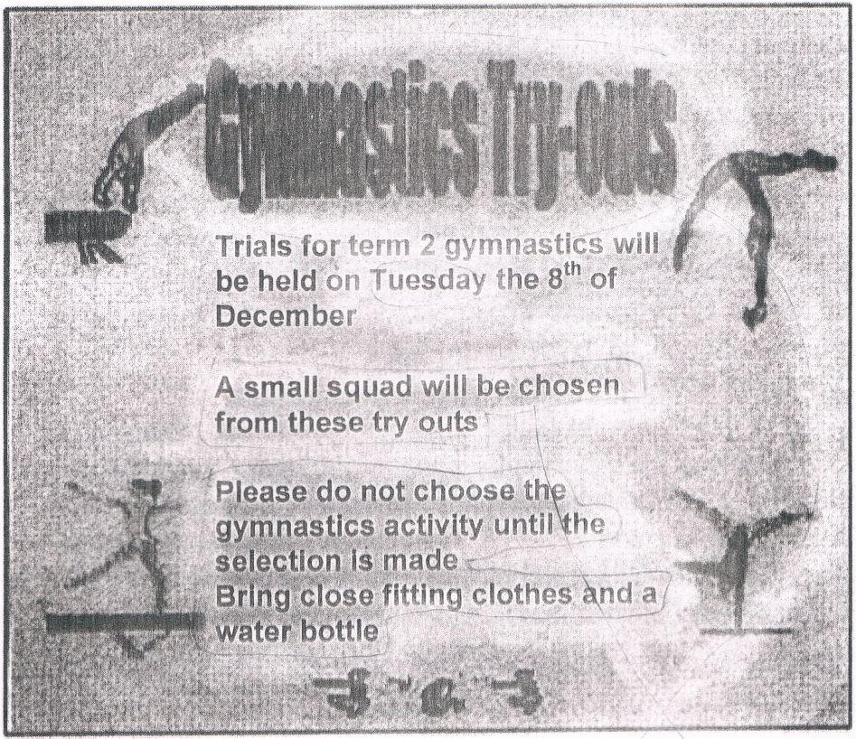

- What is the announcement about?
A. squads practice
B. squads try-outs
C. Gymnastics try-outs.
D. Gymnastic selection.

- What is the statement found in the text?
A. We should not bring a water bottle.
B. The try-out will choose a small squad.
C. The gymnastics try-out is held on Thursday.
D. We should wear loose fitting clothes.

- "A small squad will be chosen"
The underlined word has similar meaning with group (('(2ot'•
A. group
B. member
C. troop
D. unit

For questions 46 to 48, complete the text with the correct word.
When I was at the 8th grade of Junior High School, my family and I went to Bali for three days. I (46) ….. many experiences during the vacation. First day, we visited Sanur Beach in the early morning. We saw the beautiful (47) …. together. On the second day, we spent the day on Tanjung Benoa beach. We spent our last day, in Sangeh. We enjoyed the green and shady forest (48) ...... In the afternoon, we had to check out from the hotel. We went back home brining so many amazing memories of Bali.

- A. had
B. spent
C. pulled
D. wanted

- A. stars
B. moon
C. sunrise
D. sunset

- A. strangely
B. curiously
C. quickly
D. pleasantly

- Arrange the sentences bellow into a correct paragraph.
- We left our house at about 5 o'clock in the morning. We took a taxi to the railway station.
- Finally our train came. All of us rushed to get on the train.
- Last Lebaran, my family and I went hometown. We decided to take a train because it is more comfortable.
- It took about 5 to 7 hours to get to our hometown. We enjoyed our journey.
- We took the carriage no 3 according to our tickets.
- But without any prior information, our train was late for about fifteen minutes, so we had to wait a bit longer.
- After finding our seats we could sit comfortably.
- We arrived at the station at six. Our train would leave at 6.40.

A. 3-8-6-4-5-1-2-7
B. 3-4-5-8-1-2-6-7
C. 3-1-8-6-2--5-7-4
D. 3-5-4-2-7-8-1-6

- This text is for the following question.

What does the caution mean?
A. It is hazardous if we create dust from the asbestos.
B. Asbestos can create dust when we dispose it
C. It is dangerous for our health to breathe asbestos.
D. Disposing asbestos is bad for our health

