SOAL : 14 | Bahasa Inggris SMP/MTs

- Arrange these sentences below into a good paragraph.
- I had no choice but to go to barber. It was time to be bold.
- So, she started to snip my hair with a scissors.
- My father was overseas. He usually cuts our hair for us.
- It all happened when I noticed that my hair had grown too long.
- But my sister stopped me and said that she can do it for free.
- Halfway through, I came out my guts and panicked.
- I would get a cut from a professional barber, I got ready to go.
- My beautiful hair reduced to nothing more than a haphazard.

A. 3-1-2-8-6-5-7-4
B. 7-4-8-5-6-1-2-3
C. 4-3-7-5-2-6-8--1
D. 8-1-2-5-6-3-4-7

The following text is for questions 2 and 3.
Using the best method in teaching with qualified teachers,
you will get the right place to learn English.
Join us right now: Let' English!!! 100% money back if you
Can’t speak English.
Interested? Find us on Jalan Cukang Jati 11,
Gatot Subroto, Bandung.
For more details, visit us on
www.letsspeakenglish.com

- What is the focus of the study at the course?
A. Teaching
B. Reading
C. Writing
D. Speaking

- What does the advertisement, above offer?
A. you will get your money ieg1f you can't speak English
B. you will learn the best method to teach English
C. you will find Jalan Cukang Jati II as the right place
D. you would be a qualified English teacher in this place

For questions 4 to 6, choose the suitable words to fill in the blanks.
Watu Ulo is one of the popular tourist sites in Jember, East Java. It lies on the Indonesian ocean. This tourist destination is famous for its beautiful ….. (4). The visitors can cross the ……. (5) beach to get there. This cave is often used for meditation by visitors. They usually sit ….. (6) there for hours. To get there, the visitors can use public transportation or hire a rental car.

- A. picture
B. view
C. stones
D. photos

- A. wide
B. long
C. shady
D. sandy

- A. soundly
B. noisily
C. cheerfully
D. quietly

The following text is for questions 7 and 8.

Student Organization of SMP 182

To: All class captains

Please attend the monthly meeting. It will be held:
Date : Saturday, May 11, 2013
Time : After school
Place : OSIS room
We will discuss the farewell party for the grade IX students.
Your attendance will be highly appreciated

OSIS Chairman OSIS Secretary

- The monthly
A. request a monthly meeting
B. attend at OSlS room
C discuss the farewell party
D. appreciate the grade IX students

- "We will discuss the farewell party for the grade IX students" The underlined word refers to ……….
A. all grade IX students
B. OSIS chairman and OSIS secretary
C. all teacher and students of the school
D. the OSIS committee and all class captains

The following text is for questions 9 to 13.
The Boeing 787 Dreamliner is a long-range, mid-size wide body twin engine-jet airliner developed by Boeing Commercial Air Planes. It seats 210 to 290 passengers. lt is the most fuel-efficient airliner. It consumes 20 % less fuel than similarly size 767. It shares with larger 777.
The aircraft's initial designation was 7E7, prior to its renaming in January 2005. The first 787 was unveiled in a roll-out ceremony on July 8, 2007, by which time it had reached 677 orders. By October 2011, the 787 program had logged 873 orders from 57 costumers.
The 783 development and production has involved a large-scale collaboration with numerous suppliers around the globe. Final assembly is at Boeing Everett factory in Everett, Washington. Assembly is also taking place at a new factory in North Charleston, South Carolina.

- What is the text about?
A. Boeing 7E7
B. Boeing 787
C. Boeing 777
D. Boeing 767

- How many passengers can 787 seat?
A. 57
B. 290
C. 677
D. 873

- The 787 airliner is called the most efficient plane because …………..
A. it needs 20 % less fuel than the others
B. it has a small body and twin engine
C. there are many customers who want to buy it
D. it involves a large-scale collaboration

- The first paragraph tells us about ….. of 787 Dreamliner.
A. the selling price
B. the description
C. the number
D. the fuel consumption

- From the text, we know that....
A. the plane is not for commercial service
B. it has reached 677 orders in October 2011 -
C. it is the biggest plane in world.
D. 787 assembly is not only in Everett.

The following text is for questions 14 to 17.
In ancient times, the king placed a boulder on a roadway. Then he hid and watched to see if anyone would remove the huge rock. Some of the king's wealthiest merchants and courtiers came by and simply walked around it.
Many loudly blamed-the king for not keeping the roads clear but none did anything to get the big stone out of the way. Then a peasant came along carrying a load of vegetables. On approaching the boulder, the peasant laid down his burden and tried to move the stone to the side of the road. After lots of pushing and straining, he finally succeeded. As the peasant picked up his load of vegetables, he noticed a purse lying on the road where the boulder had been.
The purse contained a lot of gold coins and a note from the king indicating that the gold was for the person who removed the boulder from the roadway. The peasant learned what many others never understand.

- Why did many people blame the king?
A. He did not make good roads for them.
B. He loved to hide behind the rock.
C. He showed no care on their roads.
D. He did not keep the road clear.

- What does the last paragraph tell us?
A. The roads that people built with the king.
B. The person who liked keeping the roads well.
C. The purpose of putting the boulder and purse.
D. The way the peasant removed the boulder on the road.

- From the story, we know that .....
A. many people liked the peasant
B. the peasant was a good man
C. the boulder was really small
D. the king was very stingy

- What can we learn from the story?
A. A problem may be a blessing in disguise.
B. There are so many problems in life.
C. An obstacle may make us stronger.
D. We have to avoid any problem in our life.

The following text is for questions 18 to 21.
Marie Curie was born in Poland in 1867. She was the only person who gained two Nobel prizes at that time. She achieved one on physics and one on chemistry. She was born as Marie Sklodowska the daughter of a chemistry professor. She was the first woman who attended University of Sorbonne in paris. As a poor student, she lived in Paris on only ten cents a day for 3 years. In 1895, she married Pierre Currie, a chemist. They had two daughters Rene and Eve Marie managed three lives as a researcher, a wife and a mother.
In 1898, Marie discovered radium. Later she developed a concept of radioactivity, which marked the beginning of the atomic age. Marie and her daughter completed a new medical tool - the X – ray. Marie died in 1934, only a year before her daughter Irene won Nobel Prize in chemistry.

- What is Marrie Currie's achievement during World War I?
A. She married to her husband and had two daughters.
B. She lived with only ten cents a day for three years.
C. She completed the X- ray machine with her daughter.
D. She was the first woman to study in Sorbonne University.

- From the text, we know that………..
A. Marrie Currie's passion for chemistry was followed by her daughter
B. Pierre Currie was a Chemistry professor in Sorboime University
C. Irene Currie was Marie Currie's sister and had similar passion
D. Pierre Currie lived in Paris and went to Sorbonne University
- What is the main idea of paragraph 2?
A. Marie Currie and her Nobel prizes.
B. Marie's daughters are Irene and Eve.
C. Marie's family background.
D. Marie's achievement as a scientist.

- "In 1898, Marie discovered radium". (paragraph 2)
The underlined word means …………
A. had
B. met
C. got
D. found

The following text is for questions 22 and 23.
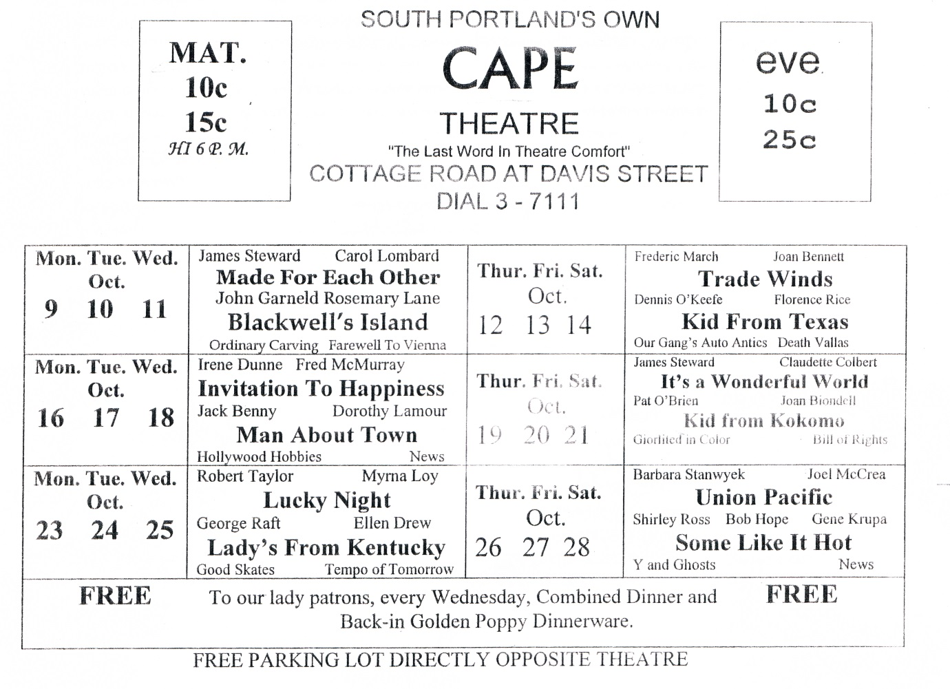
- What will be played on October 20th ?
- Made for Each Other
- Some Like it Hot
- Kid from Kokomo
- Trade Wind

- From the text, we know that ……
- Every movie is played for three days
- This is a cottage schedule in Portland
- Movie-goers will receive free dinner
- Fred McMurray is the owner of the cinema

The following text is for fluestions 24 to 26.
Dear Mira,
Hi, How are you there? I hope you are fine as usual. Mira, I am writing to tell you my experience as a voluntary worker in school. We cleaned the area around our school, move the grass and bushes behind our classroom and repainted walls.
As the chairman of the students organization (OSIS), together with our committee members, we planned and discussed the right time to do this voluntary work. After a long discussion, finally we agreed to hold it last Saturday.
On that day, fortunately we did not have to study as we had just finished our final examination. So, while waiting for our teachers who were busy writing our ‘report book’ and with the help of Pak Bejo we did it. We were having a good time because we could play while we were working. I wished you could join us at that time.
What about you? How do you spend your free time at school? How's your Karate group at school? I hope to hear from you, write me soon, Thanks.

Best Wishes,
Seno

- What is the letter about?
A. Cleaning the school.
B. Writing the report.
C. Final examination.
D. Voluntary work.

- Who was busy writing the report book?
A. Mira.
B. Pak Bejo.
C. Teachers.
D. Seno.

- Why were the students happy while they were working?
A. They could repainted freely.
B. The teachers were busy writing report.
C. They could play while working.
D. The garden was very clean.

The following text is for questions 27 to 30.
It's like a zoo but the animal are not caged. Giraffes, monkeys, hippopotamus, even lions and tigers wander around freely. Perhaps you may think, what if these animals attack? No, they won't, because you look at them from inside your car or bus. Here, it is the difference. At the zoo, the animals are locked in the cage. At the Safari Park you are the ones locked inside your vehicle.

- What are usually locked in a cage?
A. Visitors
B. Officers
C. Animals
D. Readers

- Why the animals cannot attack the visitors?
A. The animals are always fed every day.
B. The animals are well locked in the cage.
C. The visitors see animals from inside the car.
D. All the animals at the park are very tame.

- What is the main idea of the paragraph?
A. Animals at the Safari Park are not caged.
B. A zoo is the same as a Safari Park.
C. Wild animals wander freely at the park.
D. Visitors can see animals outside the car.

- "...even lions and tigers wander around freely" (line 2)
The underlined word means ……………
A. live
B. rest
C. feed
D. move

The following text is for questions 31 to 34.
There was a little boy who had a bad temper. His father gave him a bag of nails and told him that every time he loses his temper, he must hammer a nail into the fence.
The first day the boy had driven 37 nails into the fence. Over the next few weeks as he learned to control his anger, the number of nails hammered daily, gradual] dwindled down He discovered it was easier to hold his temper than to drive those nails into the fence. Finally the day came when the boy didn’t lose his temper at all. He told his father about it and the father suggested that the boy should pull out one nail for each day that he was able to hold his temper.
The days passed and the young boy was finally able to tell his father that all the nails were gone. The father took his son 17 the hand and led him to the fence. He said "You have done well, my son, but look at the holes in the fence. The fences will never be the same. When you say things in anger, they leave a scar just like this one."
You can put a knife in a man and draw it out. It won't matter how many times you say I'm sorry, the wound is still there.

- Why did the boy drive fewer nails into the fence than he did before?
A. The number of nails he got was limited
B. He had been able to control his anger.
C. He lost his temper when he nailed the fence
D. His father suggested that he pulled out the nails

- What is the main idea of paragraph 2?
A. The first day-the boy had driven 37 nails into the fence
B. The boy did not lose his temper after hammering the fence.
C. It was easier to hold temper than to drive the nails.
D. The boy did his father's suggestion to control his temper.

- What can we learn from the story?
- Do not hurt other people’s feeling.
- Everyone can get angry, so be careful.
- Do not be angry, because it hurts our heart.
- Making someone angry will hurt you.

- "... , they leave a scar just like this one." (paragraph 3)
The underlined word refers to....
A. the thing
B. the scar
C. the fence
D. the hole

The following text is for questions 35 to 38.
Nasi Lemak

Ingredients:
1 cup rice
3 screw pine leaves
Salt to taste
2 cups thick coconut milk

Method:
- First, clean the rice and drain it.
- Then, add 2 cups of thick coconut milk, screw pine leaves, and salt to the rice.
- If you desire, you can also add in some sliced onions and ginger.
- Cook the rice for one hour.
- Finally, serve this rice with sliced hard-boiled eggs, cucumber and sambal ikan Bilis.

- What should we dow after we clean and drain the rice?
A. Grated the coconut.
B. Add some sliced onions.
C. Add the thick coconut milk.
D. Serve with egg and cucumber.

- How many cups f coconut milk do we need?
A. On
B. Two
C. Three
D. Four

- "... clean the rice and drain it."
The word clean has similar meaning with ………
A. sweep
B. remove
C. rinse
D. clear

- "... clean the rice and drain it"
The word "it" refers to……
- pine leaves
- coconut milk
- rice
- salt

The following text is for questions 39 to 42.
Gardenia plants are popular for the strong sweet scent of their flowers. Gardenia is the national flower in Pakistan. In Japan and China, the flower is called Kuchinashi (Japanese) and Zhi zi (Chinese).
Gardenia plants are evergreen shrubs. Their small trees can grow to 1 – 5 meters tall. The leaves are 5 - 50 centimeters long and 3 –25 centimeters broad, dark green and glossy with a leathery texture. The flowers are in small groups, white, or pale yellow, with 5-12 lobes (petals) from 5-12 centimeters diameter. They usually bloom in mid-spring to mid-summer. Many species have strong aroma.
To cultivate gardenia a house plant is not easy. This species can be difficult to grow because it originated in warm humid tropical areas. It demands high humidity and bright (not direct - to thrive. It flourishes in acidic soil with good drainage and thrives on 20⁰ - 23° C during the day and 15⁰ - 16° C in the evening. Potting soils developed specifically for gardenias are available. It grows no larger than 18 inches in height and width when grown indoor. In climates where it can be grown outdoors, it can reach the height of 6 feet. If water hits the flowers, they will turn brown.

- How tall is a gardenia tree?
A. 3-25 cm
B. 5-12 cm
C. 5-50 cm
D. 1-5 m

- What is the main idea of the last paragraph?
A. It is easy to plant a gardenia tree.
B. A gardenia plant needs high humidity.
C. It's not easy to plant gardenia as a house plant.
D. A good drainage is important for gardenia plant.

- From the text we know that.
A. people don't like the strong scent of flower
B. Gardenia is widespread in Asia
C. the flower is easy to plant
D. the flower is expensive

- "... because it originated in warm ..." (paragraph 3, line 10)
The underlined word refers to ……….
A. the flower
B. the species
C. the soil
D. the leaf

The following text is for questions 43 to 45.
ATTENTION

Due to the fact that the next two days are national holidays of Christmas and followed by the first semester holiday; all students are requested to study at home during those days starting on tomorrow. School will begin on January 5th 2014.
Merry Christmas and Happy Holiday.

Principal

- What does the text tell about?
A. Christmas celebration
B. Studying at home
C. National holiday
D. School holiday

- Why does the Principal make the announcement?
A. To celebrate the Christmas with students
B. To let students know about national holiday.
C. To inform the students about the holiday.
D. To ask students to study at home.

- "Due to the fact ..." (first line).
The underlined phrase is similar in meaning to ……….
A. the result of
B. scheduled for
C. as a consequence of
D. in view of

Questions 46 to 48 complete the text with the correct word.
Last weekend, my friends and I went camping. We (46) ….. the camping ground after we walked for about one and a half hours. We built the tents next to a small river. It was getting darker and colder, so we made a (47) …... The next day, we spent our time observing plantation and insects during the day. At night, we sang, danced, read poetry. Play magic tricks (48) ……….

- A. searched
B. reached
C. met
D. examined

- A. tent
B. camp
C. firework
D. fire

- A. greatly
B. happily
C. friendly
D. nicely

- Arrange the sentences bellow-into a correct paragraph.
- We left our house at about 5 o'clock in the morning. We took a taxi to the railway station.
- Finally our train came. All of us rushed to get on the train.
- Last Lebaran, my family and I went hometown. We decided to take a train because it is more comfortable.
- It took about 5 to 7 hours to get to our hometown. We enjoyed our journey.
- We took the carriage no 3 according to our tickets.
- But without any prior information, our train was late for about fifteen minutes, so we had to wait a bit longer.
- After finding our seats we could sit comfortably.
- We arrived at the station at six. Our train would leave at 6.40

A. 3-8-6-4-5-1-2-7
B. 3-4-5-8-1-2-6-7
C. 3-1-8-6-2-5-7-4
D. 3-5-4-2-7-8-1-6

- This text is for the
Please
Keep the lavatory
Clean
For the next user

What does the notice mean?
A. We should keep the lavatory:
B. The lavatory must be kept clean by any user
C. We have to clean the lavatory.
D. The lavatory user is pleased to clean it.

