SOAL : 12 | Bahasa Inggris SMP/MTs

- Arrange the sentences below to be a good paragraph!
1. I chose the place under the big tree.
2. I was really) sure that lie was my, classmate, Andi.
3. The boy was surprised then he turned around.
4. Yesterday, I went to the town square to watch a local singing contest.
5. Suddenly, I found myself behind a young boy.
6. I thought it could save me from the hot day.
7. I pinched his left shoulder a little and caIled his name.
8. Oh my God, actually, he was not Andy my classmate.

A. 2-1-4-6-5-8-7-3
B. 4-1-6-5-2-7-3-8
C. 4-1-7-2-3-8-6-5
D. 1-4-2-5-6-3-8-7

The following text is for questions 2 and 3.

- The text shows us that Western Electronics ..... certain electronic products.
A. repairs
B. sells
C. buys.
D. displays

- If you need western Electronics’ service.......
A. you ought to bring your warranty
B. you should buy a TV set from them
C. you can e-mail them
D. you cannot call them

Questions 4 to 6 choose the correct words to complete the text.
Mrs Ratuirn is avery healthy (4) ……. She exercises everyday and eats (5) ……… food First thing she does in the morning is jogging around the neighborhood jogging track. Then she takes a break for about 15 minutes. (6) ..., she takes a deep breath and drinks lots of water.

- A. girl
B. aunt
C. mother
D. woman

- A. raw
B. fresh
C canned
D. healthy

- A. Surely
B. Finally
C. Actually
D. Surprisingly

The following text is for questions 7 and 8.

- Which information can be found in the text?
A. The meeting is held at 4496 St. Claude Ave
B. Food and drink will be served during the meeting.
C. Mr. Nan Roman will talk about politics in the US.
D. The meeting will be done in the afternoon

- "Join us at our 20th “Anniversary meeting".
The underlined word refers to....
A. unity organization
B. homelessness people
C. New Orleans citizen
D. Nan Roman, the speaker

The following text is for questions 9 to 13.
The cycle rick-shaw is a small-scale local means of transport; it is also known by a variety of other names such as pedicab, bikecab, cyclo, becak or trishaw or, simply rickshaw which also refers to auto rickshaws pulled by a person on foot. Cycle rickshaws are human-powered, a type of tricycle designed to carry passengers in addition to the driver. They are often used on a hire basis. Cycle rickshaws are widely used in major cities around the world, but most commonly in cities of South, Southeast and East Asia.
Cycle rickshaws in Indonesia are calledLbeca1cBecak was considered an icon of the capital city of Jakarta prior to its ban in the 1970s.7Citing concerns of public order-the city- government forbade them on the city's main streets. However, many becaks still operate near slums throughout-the city. Attempts at reinforcing the ban resulted in large- stale seizures of the vehicle in the late 1990s and in2007.

- What is the text about? A ....
A. modern vehicle
B. traditional vehicle
C. four-wheeled vehicle
D. modern transportation

- Where can rickshaw be found in Indonesia?
- In the village.
- In rural areas.
- In major cities.
- In the countryside.

- According to the text, we know that ………..
A. becak is always pulled by a person on foot
B. becak is forbidden by government on the city's main streets
C. the government allows becak to operate on every city's street
D. many becaks still operate on the city's main streets

- What is the main idea of the second paragraph?
A. Becaks were considere an icon of Jakarta.
B. The government forbids becaks on main streets.
C. Many becaks are still operating in the city.
D. The original name of becak is rickshaws.

- From the text, we can conclude that
A. becak is a modern vehicle
B. government allows becaks in cities
C. becak doesn't operate in main street
D. becak only operates in the village

The following text is for questions 14 to 17.
Once upon a time in faraway China, lived two brothers, one named Sam, and the other named Tikki Tikki Tembo No Sarimbo Hari Kari Bushkie Perry Pem Do Hai Kai Kai Pom Pom Nikki No Meeno Dom Barako.
One day they were playing near the well in their garden and Sam fell into it. Tikki Tikki Tembo No Sarimbo Hari Kari Bushkie Perry Pem Do Hai Kai Kai Pom Pom Nikki No Meeno Dom Barako ran to his mother, shouting, "Quick, Sam has fallen into the well. What shall we do?"
"What?" cried the mother, "Sam has fallen into the well? Run and tell your father!"
Together they ran to the father, and cried, "Quick, Sam has fallen into the well. What shall we do?"
"Sam has fallen into the well?" cried the father, “Run and tell the gardener!"
Then they all ran to the gardener and shouted, "Quick, Sam has fallen into the well. What shall we do?"
"Sam has fallen into the well?" cried the gardener, and then he quickly fetched a ladder and pulled the poor boy from the well. Sam was wet, cold, frightened and felt so happy to be alive.
After a while, they were playing near the well again, and this time Sam's brother fell into the well. Sam ran to his mother, shouting, "Quick, Tikki Tikki Tembo No Sarimbo Hari Kari Bushkie Perry Pem Do Hai Kai Kai Pom Pom Nikki No Meeno Dom Barako has fallen into the well. What shall we do?"
"What?" cried the mother, "Tikki Tikki Tembo No Sarimbo Hari Kari Bushkie Perry Pem Do Hai Kai Pom Pom Nikki No Meeno Dom Barako has fallen into the well? Run and tell father!"
Together they ran to the father and cried, "Quick, Tikki Tikki Tembo No Sarimbo Hari Kari Bushkie Perry Pem Do Hai Kai Pom Pom Nikki No Meeno Dom Barako has fallen into the well. What shall we do?" And then he quickly fetched a ladder and pulled him, but the poor boy had drowned.

- Tikki Tikki Tembo No Sarimbo Hari Kari Bushkie Perry Pem Do Hai Kai Pom Pom Nikki No Meeno Dom Barako couldn't be saved because ………..
A. his name was too long and took along time to get helps
B. his name was too long and made him unlucky
C. his brother, Sam, could not do anything
D. his brother, Sam, and his parents didn't care about him

- What is the main idea of the second paragraph?
A. Tikld Tikki Tembo and his brother fell into the well.
B. Tikki Tikki Tembo and his brother played in the well together.
C. The two brothers always played in the well together.
D. When the two brothers were playing near the well, Sam fell into the well.

- The story shows us that ……….
A. Sam could help his brother if he wanted to
B. Sam did not know his brother had fallen
C. Sam's parents did not try to help Sam's brother
D. the well had no fence to protect people

- What is the moral value of the text?
A. Do everything that you can do!
B. Do everything that you like to do!
C. Don't do the same mistakes!
D. Don't obey the parent's warning!

The following text is for questions 18 to 21,
Helen Adams Keller was born as a healthy child on June 1880, to Captain Arthur H. and Kate Adams Keller of Tuscumbia. At the tender age of 19 months, she was stricken with a severe illness which left her blind and deaf.
At the age of six, the half-wild, deaf and- blind girl was taken to see Dr. Alexander Graham Bell by her parents. From this visit, Helen met her teacher, Anne Mansfield Sullivan. She was so gifted that by the end of August, in six months, she knew 625 words, learned Braille and learned to write shortly afterward.
By the age of 10, Helen had mastered Braille as well as the manual alphabet and even learned to use the typewriter. By the time she was 16, Helen could speak well enough go to preparatory school and to college. In 1904, she graduated "cum laude" from Radcliffe College. The teacher stayed with her through those years, interpreting lectures and class discussion for her.
Helen Keller became one of world's most remarkable women. She dedicated her life to improve the conditions of the blind and the deaf-blind around the world, lecturing in more than 25 countries on the five major continents. Wherever she appeared, she brought new courage to millions of blind people.

- Flow did Helen Keller meet her teacher?
A. They met each other at Radcliffe College.
B. Her parents took her to Alexander Graham Bell.
C. She met Ms. Sullivan after her parents took her to Dr. Bell.
D. Ms. Sullivan became Keller's teacher after getting an award.

- From the text, we can conclude that ……..
- Anne Sullivan accompanied Helen Keller at school
- Alexander Graham Bell was Anne Sullivan's relative
- Helen Keller can only read and write in Braille
- Alexander Graham Bell was Helen Keller's teacher

- What is the main idea of paragraph four?
A. Hellen Keller became one of remarkable women in history.
B. Hellen Keller became an inspiration for the blind people.
C. Hellen Keller brought new courage to other people.
D. Hellen Keller gave her dedication to the world.

- "... she was stricken with a severe illness which left her blind and deaf." (paragraph 1)
The underlined word is similar in meaning to……….
A. mild
B. rough
C. chronic
D. common

The following text is for questions 22 and 23.
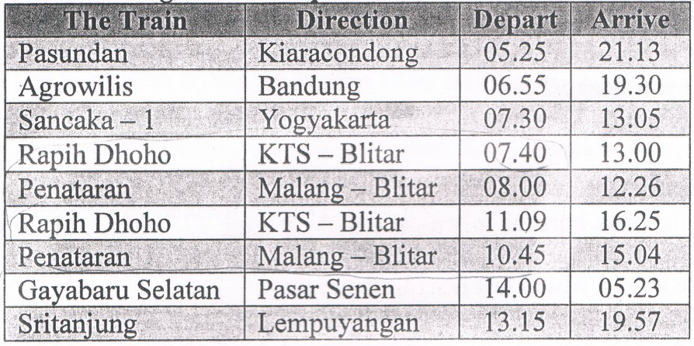

- Which train leaves after Rapih Dhoho train?
A. Sritanjung.
B. Argowilis.
C. Penataran.
D. Pasundan.

- Which train arrives in the morning?
A. Pasundan.
B. Rapih Dhoho.
C. Gayabaru Selatan.
D. Sancaka-1.

The following text is for questions 24 to 26.
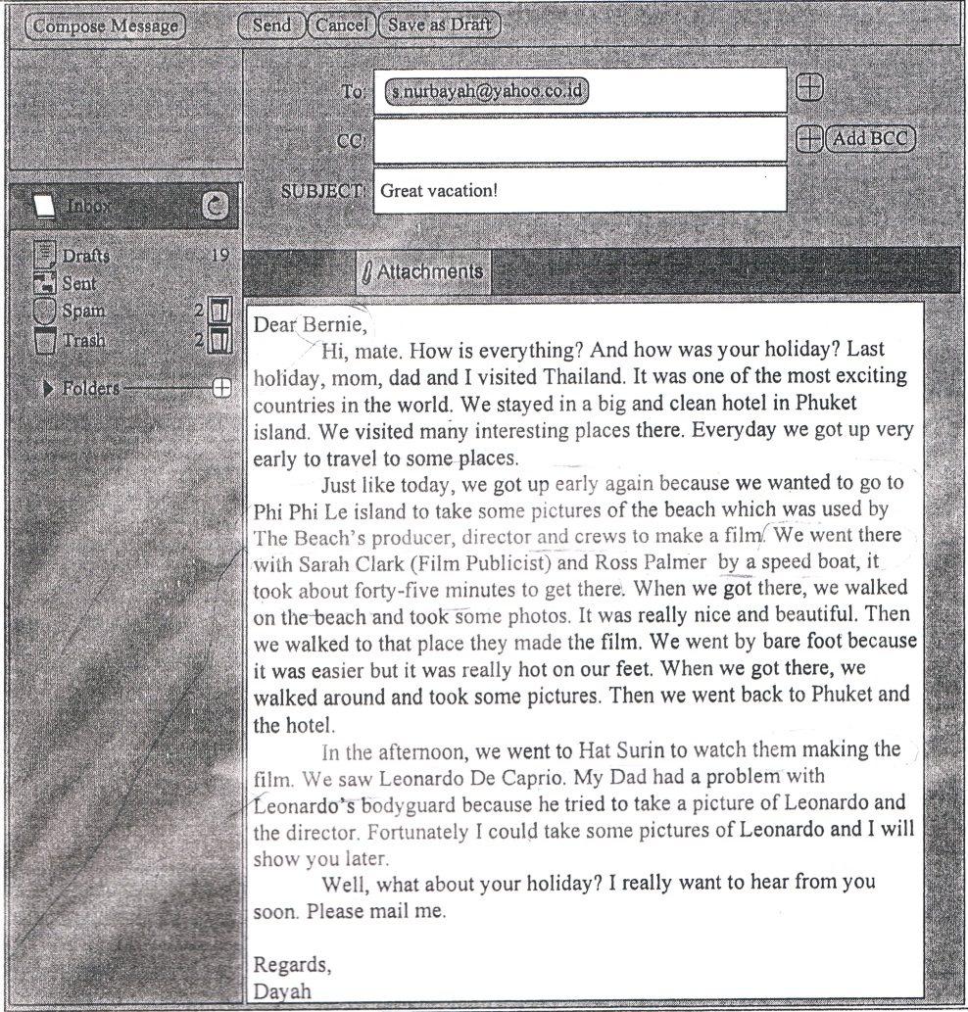

- The text tells us about ………
A. A film by Leonardo Di Caprio
B. Dayah's great holiday in Thailand
C. Bernie's great holiday in Thailand
D. the beauty of Phi Phi Le island

- With whom did the writer and her family go to Phi Phi Le island?
A. The crews.
B. The director.
C. The producer.
D. The parents.

- What did Leonardo do at Phi Phi Le island?
A. He had vacation with his family.
B. He was involved in a film production.
C. He visited some beautiful beaches.
D. He had discussion with movie producer.

The following text is for questions 27 to 30.
Bale Kambang is a small village on the Southern coast of East Java, seventy kilometers from Malang town, two hours' drive from south. It is well-known for its long beautiful white sandy as well as the similarity of its temple to the one of Tanah Lot in Bali.
In Bale Kambang, there are three small rocky islands namely Ismaya island, Wisanggeni island and Anoman island, those names (Java traditional puppets). These islands are surrounded by Indonesian Ocean which huge waves frighten most overseas cruisers.

- What makes Bale Kambang famous?
A. Small rocky islands.
B. Long beautiful beach.
C. Huge waves of ocean.
D. Overseas cruisers.

- What is Bale Kambang7
A. A small village in Southern Coast of Jawa
B. Three small islands in Indonesian ocean
C. Wayang figure from east Jawa, Indonesia
D. A village in Malang, east Jawa

- What is the main idea of the second paragraph?
A. There are many rocky islands in Bale Kambang.
B. Huge waves frighten many overseas cruisers.
C. Names of rocky islands are taken from "wayang" figures.
D. The rocky islands are in the middle of the sea.

- "... on the southern coast: of East Java, ..." (paragraph 1).
The underlined word is closest in meaning with
A. strait
B. peninsula
C. shore
D. bay

The following text is for questions 31 to 34.
There was a little boy who had a bad temper. His father gave him a bag of nails and told him that every time he loses his temper, he must hammer a nail into the fence.
The first day the boy had driven 37 nails into the fence. Over the next few weeks as he learned to control his anger, the number of nails hammered daily, gradually dwindled down. He discovered it was easier to hold his temper than to drive those nails into the fence. Finally the day came when the boy didn't lose his temper at all. He told his father about it and the father suggested that the boy should pull out one nail for each day that he was able to hold his temper.
The days passed and the young boy was finally able to tell his father that all the nails were gone. The father took his son by the hand and led him to the fence. He said "You have done well, my son, but look at the holes in the fence. The fence will never be the same. When you say things in anger, they leave a scar just like this one"
You can put a knife in a man and draw it out. It won't matter how many times you say I'm sorry, the wound is still there.

- What did the boy drive fewer nails into the fence than he did before?
A. The number of nails he got was limited.
B. He had been able to control his anger.
C. He lost his temper when he nailed the fence.
D. His father suggested that he pulled out the nails.

- What is the main idea of paragraph 2?
A. The first day the boy had driven 37 nails into the fence.
B. The boy did not lose his temper after hammering the fence.
C. It was easier to hold temper than to drive the nails.
D. The boy did his father's suggestion to control his temper.

- What can we learn from the story?
A. Do not hurt other people's feeling.
B. Everyone can get angry, so be careful.
C. Do not be angry, because it hurts our heart.
D. Making someone angry will hurt you.

- "... , they leave a scar just like this(paragraph 3)
The underlined word refers to....
A. the thing
B. the scar
C. the fence
D. the hole

The following text is for questions 35 to 38.
How to Make Mango Juice

Materials:
- Some mangoes
- a half glass of water
- a glass of iced cube
- a spoon of sugar
- 3 spoons of condensed milk

Procedures:
First, peel the mango and clean it. Next, cut the mango, into pieces and put them into the juicer. Then, put the water, ice, sugar, and milk. After that, turn on the juicer and wait about 15 seconds.
Finally, pour the mango juice into the glass and it ready to be served.

- What should we do before we put the mango into the juicer?
A. Pour the mango juice into the glass.
B. Add water, ice, sugar, and milk.
C. Cut them into pieces.
D. Turn on the juicer.

- What ingredient do we need as much as 3 spoons?
A. Sugar.
B. Water.
C. Iced Cube.
D. Condensed milk.

- "First, peel the mango and clean it."
What is the synonym of the underlined word?
A. Wash
B. Dry
C. Slice
D. Cut

- "... and put them into the juicer." (Step 2)
The underlined word refers to…………..
A. sugar and mango
B. ice and water
C. sugar and milk
D. pieces of mango

The following text is for questions 39 to 42.
Gardenia plants are popular for the strong sweet scent of their flowers. Gardenia is the national flower in Pakistan. In Japan and China, the flower is called Kuchinashi (Japanese) and Zhi zi (Chinese).
Gardenia plants are evergreen shrubs. Their small trees can grow to 1 - 5 meters tall. The leaves are 5 - 50 centimeters long and 3 - 25 centimeters broad, dark green and glossy with a leathery texture. The flowers are in small groups, white, or pal, yellow, with 5 - 12 lobes (petals) from 5 - 12 centimeters diameter. They usually bloom in mid-spring to mid-summer. Many species have strong-aroma.
To cultivate gardenia as a house plant is not easy. This species can be difficult to grow because it originated in warm humid tropical areas It demands high humidity and bright (not direct) light to thrive. It flourishes in acidic soil with good drainage and thrives on 20°— 23° C during the day and 150 - 16° C in the evening. Potting soils developed specifically for gardenias are available. It grows no larger than 18 inches in height and width when grown indoor. In climates where it can be grown outdoors, it can reach the height of 6 feet. If water hits the flowers, they will turn brown.

- How tall is a gardenia tree?
  - 3 – 25 cm.
  - 5 – 12 cm.
  - 5 – 50 cm.
  - 1 – 5 m.

- What is the main idea of the last paragraph?
A. It is easy to plant a gardenia tree.
B. A gardenia plant needs high humidity.
C. It's not easy to plant gardenia as a house plant.
D. A good drainage is important for gardenia plant.

- From the text we know that....
A. people don't 1e the strong scent of flower
B. Gardenia is widespread in Asia
C. the flower is easy to plant
D. the flower is expensive

- "...because it originated in warm ..." (paragraph 3, line 10)
The underlined word refers to ……………
A. the flower
B. the species
C. the soil
D. the leaf

The following text is for questions 43 to 45.
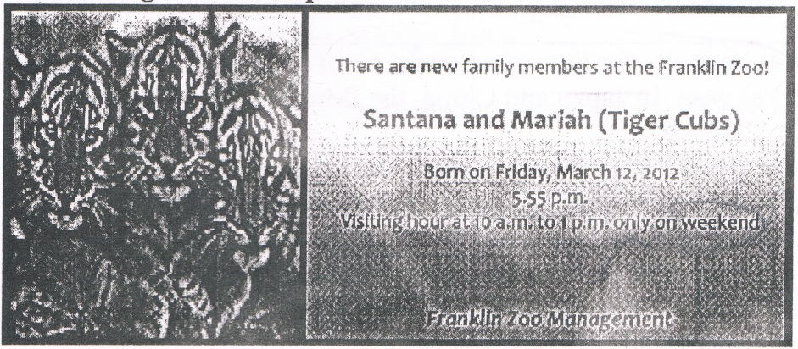

- The text tells us about ………….
A. the management of Franklin Zoo
B. the new member of management
C. the cubs and management
D. the newborn tiger cubs

- What should people do to see the cubs?
A. Come to the zoo weekend
B. Go to the zoo on weekdays
C. Visit them in the afternoon
D. Contact zoo management

- "Santana and Mariah (Tiger Cubs)"
The synonym of the underlined word is
A. families
B. babies
C. mothers
D. fathers

Questions 46 to 48 complete the text with the correct word.
Last weekend, my friends and I went camping. We (46) ….. the camping ground after we walked for about one and a half hours. We built the tents next to a small river. It was getting darker and colder, so we made a (47) …... The next day, we spent our time observing plantation and insects during the day. At night, we sang, danced, read poetry, Waved magic tricks (48) ……….

- A. searched
- reached
C. met
D. examined

- A. tent
B. camp
C. firework
D. fire

- A. greatly
B. happily
C. friendly
D. nicely

- Arrange the sentences bellow into a correct paragraph.
- We left our house at about 5 o'clock in the morning. We took a taxi to the railway station.
- Finally our train came. All of us rushed to get on the train.
- Last Lebaran, my family 'and I went hometown. We decided to take a train because it is more comfortable.
- It took about 5 to 7 hours to get to our hometown. We enjoyed our journey.
- We took the carriage no 3 according to our tickets.
- 6 But without any prior information, our train was late for about fifteen minutes, so we had to wait a bit longer.
- After finding our seats we could sit comfortably.
- We arrived at the station at six; Our train would leave at 6.40.

A. 3-8-6-4-5-1-2-7
B. 3-4-5-8-1-2-6-7
C. 3-1-8-6-2-5-7-4
D. 3-5-4-2-7-8-1-6
- This text is for the following question.
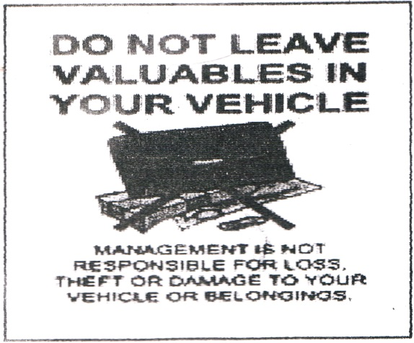
What does the caution above mean?
A. The management forbid you to leave your vehicle.
B. You are prohibited to leave valuables in your vehicle.
C. Your vehicle is valuable for the management.
D. Valuable things will be damaged in your vehicle.

