SOAL : 11 | Bahasa Inggris SMP/MTs

- Arrange the following sentences Into a good paragraph.
1. The place made me feel at home but I had to go home.
2. After that I went to Lamongan.
3. Then I went to Sidoarjo.
4. I visited the famous Jatim Park.
5. it had become famous for its mud.
6. Last summer, I got a fantastic holiday.
7. Next time, I would return to see more of them.
8. I went to the airport and I flew to Surabaya.

A. 6-8-3-5-2-4-1-7
B. 8-6-3-4-5-1-7-2
C. 3-8-6-5-2-7-1-4
D. 3-6-8-4-5-2-7-1

The following text is for Questions 2 and 3.

- How many pieces of treadmill does the company sell in a month?
A. 185
B. 764
C. 1500
D. 1599

- Why should you hurry to buy the product?
A. The stock is limited.
B. The price is very cheap now.
C. You will get more profits.
D. Other buyers are waiting.

For questions 4 to 6, choose the suitable words to fill in the blanks.
Watu Ulo is one of the popular tourist sites in Jember, East Java lies on the Indonesian ocean. This tourist destination is famous famous for its beautiful …….. (4) The visitors can cross the (5) ………. beach to get there. This cave is often used for meditation by visitors.
They usually sit ……….. (6) there for hours. To get there, the visitors can use public transportation or hire a rental car.

- A. picture
B. view
C. stones
D. photos

- A. wide
B. long
C. shady
D. sandy

- A. soundly
B. noisily:
C. cheerfully
D. quietly

The following text is for questions 7 and 8.
My special day is coming
I am 14 years old now.
My parents are having a special party for me.
Your smile and laugh we hope.
So come to the party, and it will be lots of fun
The party will be held at three to five p.m.
Sunday, December 22, 2013
Nini's house
45 Cibinong Street

- Why does Nini write the text?
A. She wants her friends to be happy.
B. She hopes her friends to smile and laugh.
C. Her parents had a special party for her.
D. She wants her friends to come to her party.

- What does the word "it" in the text refer to?
A. Special day
B. Birthday.
C. Party.
D. House.

The following text is for questions 9th 13.
Riding on a canal bus is an enjoyable and relaxed way of getting around Amsterdam canals and it takes you to pass all the city's top sights. You'll see many kinds of buildings, from historic ones to the city's narrowest houses. Canal bus boat also cruise along the most famous canals, bringing-you to Amsterdam's major museums, such as Van Gogh Museum, the Rijkos-Museum and the Ann Frank house.
On Board we provide a multilingual commentary. Our comfortable, boats offer frequent and regular service with 4 routes and 20 stops, including 6 transfer points
The stops are located near the museum shopping district and tourist attractions Your 24 hours ticket allows you to hop and of/as often as you like

- What is the text about?
A. Tourist resorts.
B. City boats.
C. I Amsterdam canals.
D. Canal bus boats.

- How many routes does the canal have?
A. 24
B. 20
C. 6
D. 4

- The passengers of the canal bus boat may hop and off as they like because it ……….
A. provides a multilingual commentary
B. sells tickets for 24 hours
C. has 4 routes and 20 stops
D. has enjoyable regulation

- What is paragraph two about?
A. The schedule of canal bus boat.
B. The canal bus boat services.
C. The cost of canal bus.
D. Routes of the bus.

- From the text, we know that ....
A. the canal bus boat offers only regular service
B. passengers can enjoy the beautiful museums as well
C. passengers are not permitted 'to hop and off as they like'
D. the canal bus boat provides only a bilingual commentary.

The following text is for questions 14 to 17.
The Legend of Toba Lake
There was a handsome man named Batara Guru Sahala, who enjoyed fishing so much. One day, he caught a fish. He was surprised to find out that the fish could talk. The fish begged him to set it free.
Batara Guru Sahala could not bear it. He made the fish free. As soon as it was free, the fish changed into a very beautiful woman. Batara Guru Sahala fell in love with that fish-woman and wanted to marry her. Batara Guru Sahala promised to keep the secret that she had been a fish and would never tell anybody about it.
They were married happily. They had two daughters. One day Batara Guru Sahala got very angry with his daughters. He could not control his temper. He shouted angrily and got the word of fish to his daughters. The daughters were crying. They found their mother and told her about it.
The mother was very angry. Batara Guru Sahala broke his promise. The mother was shouting angrily, then the earth began to shake. Volcanoes started to erupt. The earth formed a very big hole. People believed that the big hole became a lake. To day the lake is known as Toba lake.

- Why was the mother very angry? Because ………….
A. her daughter were crying and found her
B. the earth began to shake and started to erupt
C. Batara Guru Sahala broke his promise
D. Batara Guru Sahala was angry

- What is the main idea of the fourth paragraph?
A. How Toba lake was formed.
B. The daughters found their mother.
C. Their daughters were crying.
D. Batara Guru Sahala had two daughters.

- From the text, we know that....
A. Sahala's wife was a captured fish
B. the daughters changed into fish too
C. Sahala broke his promise to his wife
D. the daughters and father are fish

- What can you learn from the text above? We should ……….
A. promise to our wife
B. promise to our husband
C. break our promise
D. keep our promise

The following text is for questions 18 to 21.
Albert Einstein is a famous scientist. When he was a boy he was not smart, he even failed in his study. When his teacher gave him some works or asked him about the lesson, he could not do the task or answer questions His friends were used to insult him with the calling "stupid boy". It happened in the school.
He was really upset when he was expelled from school and spent most of his day reading in his bedroom. After that he returned to school and stood out as the smartest among other-students. People was amazed at his finding, the theory of quantum of speed (E=Mc²), and his success in creating a very explosive bomb that called atomic bomb. Nevertheless he regretted it, because it killed many lives when dropped in Nagasaki and Hiroshima, Japan in 1945. Even though the same weapons also made them surrender and end the World War II.

- Why did Albert keep himself in his room one day?
A. He was unhappy.
B. He had nothing to do.
C. He liked reading books
D. He wanted to be clever.

- From the text, we know that Albert Einstein ……..
- loved going out with friends
- B had never finished his education
- did not have many friends at school
- worked for the Japan in World War

- What is the main idea of the first paragraph'?
A. Albert has been smart since he was a boy.
B. Albert had never failed in his study at school.
C. Albert's teachers got angry with him.
D. Albert Einstein used to be a stupid boy.

- "His friends were used to insult him'..." paragraph 1)
The word "insult" in the sentence is synonymous to ………
A. praise
B. looked down
C. please
D. looked up

The following text is for questions 22 and 23.
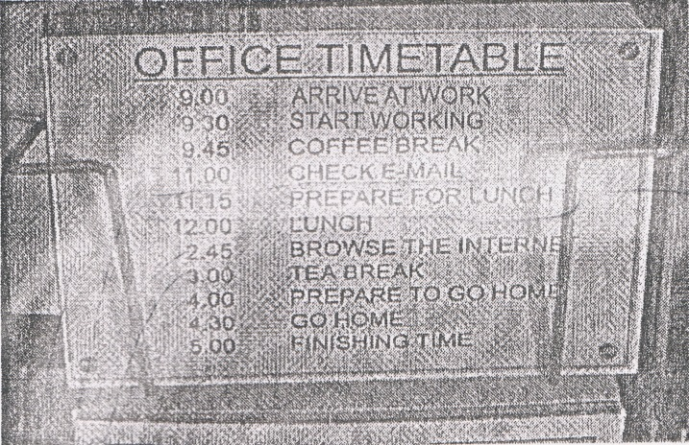

- What will the employees do at eleven fifteen?
A. Have a Coffee break.
B. Check their e-mail.
C. Prepare for 1unch..
D. Browse the Internet.

- From the timetable, we can conclude that
A. the tea break lasts for one hour
B. the busiest work is browsing the Internet
C. the employees arrive home at-six in the afternoon
D. there will be much work after taking the tea break

The following text is for questions 24 to 26.
I Dear Nancy,

We are having a great a holiday here on the Gold Coast. Yesterday we went to the Movie World.
When we got up in the morning, it looked like rain. After a while the aloud disappeared and it became a sunny-day. Then we decided to go to the Movie World.
The first ride I went on was Lethal Weapon. Next, I watch the Police Academy show. After that I had lunch because I was really hungry. Meanwhile, Mum and Kelly queued for the Batman ride.
About one o'clock, we got a light shower of rain but it cleared up soon after. Then we went on all the other rides.
It was a top day. See you when you get back.

Love,
Sam

- What does the text tell you(about
A. The Gold Coast.
B. The Movie World.
C. Sam's holiday.
D. The shower of rain.

- Where did Sam spend all his holiday with his family?
A. In the Movie World.
B. On the Gold Coast.
C. In Lethal Weapon ride.
D. At the Police Academy.

- Why did they decide to go to the Movie World?
A. They were really hungry.
B. It was a sunny day.
C. It was a rainy day.
D. They woke up early.

The following text is for questions 27 to 30.
Raja Ampat Island

Raja Ampat is located in the northwest tip of Bird's Head Peninsula of West Papua. It is an archipelago comprising over 1,500 small pays and shoals surrounding the four main islands of Misool, Salawati, Batanta, and Waigeo, and the smallest island of Kofiau.
Raja Ampat the most bio-diverse location in The world. More than 3000 species of fish and over 300 species of corals have been identified hire. In a single one and half hours dive we can see more than 400 species of fish. Until today, the area is virtually unexplored and unknown due to its size. From mid-June to the end of August, Raja Ampat area has its roughest seas ad lowest visibility. During the rest of the year, the sea is mostly very smooth with good visibility.
The marine natural resources in Raja Ampat make it significantly potential as a tourist destination. Many travel agents place Raja Ampat as one of their top ten diving destinations while it ranks number one in underwater biodiversity. The International Marine Conservation surveys suggest that the marine life diversity in the Raja Ampat area be the highest recorded on Earth. It is greater than any other area sampled in the coral Triangle composed of Indonesia, Malaysia, Philippines, Papua New Guinea, Solomon Islands, and Timor-Leste. The Coral Triangle is the heart of the world's coral reef biodiversity, making Raja Ampat possibly the richest coral reef ecosystems in the world.

- How many species of corals have been identified in Raja Ampat?
A. less than 300.
B. more than 300.
C. more than 400.
D. over 1500.

- Which information is found in the text?
A. Due to the size, the area has been known and explored.
B. The marine life diversity in Raja Ampat is the lowest on earth.
C. The sea is very rough and decreases in visibility every August.
D. The coral triangle is the heart of the world's coral reef bio diversity.

- What is the main idea of the last paragraph?
A. Raja Ampat is a potential tourist destination
B. Raja Ampat is a sampled area in the Coral Triangle
C. Raja Ampat is a bio-diverse location in the world
D. Raja Ampat is an archipelago comprising 1.500 islands

- "...make it significantly potential as tourist destination." (paragraph 3)
The underlined word can be best replaced by....
A. sophisticated
B. important
C. valuable
D. good

The following text is for questions 31 to 34.
Once upon a time, there lived a little girl named Mary She lived with her aunt and uncle because her parents had died.
One day, she heard her uncle' and aunt talking about leaving her because they wanted to go to abroad and they didn't have money to take her with them. She was sad and disappointed at the same time. The next day she ran away from home while her aunt and uncle were having breakfast. She ran away into the woods without looking back. After that she was very tired and thirsty. Then she saw a little hut, she knocked at the door, but no one answered. So she went inside.
Marry was a diligent girl. When she saw the room was dirty, she cleaned it right away. Afterwards, she felt tired and fell asleep.
At night, three women came home from work. They went inside the hut. There they found Mary who was sleeping. They also found that their house was not dirty anymore. Then, Mary woke up and saw the women. Mary told the women her story and they felt sorry for her. One of the women said," if you have nowhere to go, you can stay with us here". Mary was very happy. From that moment she lived with the three women.

- Mary ran away from her uncle's house because her uncle ……..
- planned to take her to Abroad
B. felt disappointed with her
C. wanted to leave her alone
D. did not have much money
- What is the main idea of paragraph 3?
- Mary was a diligent girl
- Cleaning a room is Mary's habit.
- Mary loves to sleep all day long.
- Mary's room was dirty.

- What can youleara4rom the text above?
A. We have to fight to get a better life.
B. No love is like mothers and fathers.
C. We have to sacrifice things for everyone.
D. Be a diligent person to help others.

- "She ran away into the woods without looking back." (paragraph 2)
What does the underlined word refer to?
A. Mary
B. Aunt
C. Woman
D. Girl

The following text is for questions 35 to 38.
Nasi Lemak

Ingredients:
- cup rice
- 3 screw pine leaves
- Salt to taste
- 2 cups thick coconut milk

Method:
- First, clean the rice and drain it.
- Then, add 2 cups of thick coconut milk, screw pine leaves, and salt to the rice.
- If you desire, you can also add in some sliced onions and ginger. • Cook the rice for one hour.
- Finally, serve this rice with sliced hard-boiled eggs, cucumber and sambal
- ikan Bilis.

- What should we do after we clean and drain the rice?
A. Grated the coconut.
B. Add some sliced onions.
C. Add the thick coconut milk.
D. Serve with egg and cucumber.

- How many cups of coconut milk do we need?
A. One
B. Two
C. Three
D. Four

- "... clean the rice and drain it."
The word clean has similar meaning with
A. sweep
B. remove
C. rinse
D. clear

- "... clean the rice and drain it"
The word "it" refers to ………..
A. pine leaves
B. coconut milk
C. rice
D. salt

The following text is for questions 39 to 42.

Gardenia plants are popular for the strong sweet scent of their flowers. Gardenia is the national flower in Pakistan. In Japan and China, the flower is called Kuchinashi (Japanese) and Zhi zi (Chinese).
Gardeniaplants are evergreen shrubs. Their small trees can grow to 1 - 5 meters tall. The leaves are 5 - 50 centimeters long and 3 - 25 centimeters broad, dark green and glossy with a leathery texture. The flowers are in small groups, white, or pale yellow, with 5-12 lobes (petals) from 5-12 centimeters diameter. They usually bloom in mid- spring to mid-summer. Many species have strong aroma.
To cultivate gardenia as a house plant is not easy. This species can be difficult to grow because it originated in warm humid tropical areas. It demands high humidity and bright (not direct) light to thrive. It flourishes in acidic soil with good drainage and thrives on 20°— 23° C during the day and 150 - 16° C in the evening. Potting soils developed specifically for gardenias are available. It grows no larger than 18 inches in height and width when grown indoor. In climates where it can be grown outdoors, it can reach the height of 6 feet. If water hits the flowers, they will turn brown.

- How tall is a tree?
A. 3-25 cm.
B. 5-12 cm.
C. 5-50 cm.
D. 1-5 m.

- What is the main idea of the last paragraph?
A. It is easy to plant a gardenia tree.
B. A gardenia plant needs high humidity.
C. It's not easy to plant gardenia as a house plant.
D. A good drainage is important for gardenia plant.

- From the text we know that ………..
A. people don't like the strong scent of flower
B. Gardenia is widespread in Asia
C. the flower is easy to plant
D. the flower is expensive
- "... because it originated in warm ..." (paragraph 3, line 10)
The underlined word refers to ……….
A. the flower
B. the species
C. the soil
D. the leaf

The following text is for questions 43 to 45.
ANNOUNCEMENT

To all our beloved readers,
We are pleased to announce a short story writing contest.
The participants must agree to the following conditions:
All contest entries must be:
  - Original, never been published before
  - typed in double-spaced
  - free from offensive materials
The Competition will award three prizes:
First Prize : Rp. 5,000,000
Second Prize : Rp. 3,000,000
Third Prize : Rp. 2,000,000
Your name, age, address and phone number must be included, type on a separate paper!
Send your entries to our office no later than December 14th 2013.

For further information, contact:
Secretary's Office of the Remaja Magazine
E-Mail: inforemajamagazine@yahoo.mail

- The text tells you about …………..
A. a short story writing contest
B. an announcement on the secretary's office
C. an entry to get the prizes of competition
D. a participant's condition for telling stories

- From the text, we know that ……………..
A. The writing must be submitted before December.
B. The story can be written in triple spaced.
C. The short story can be a published one.
D. There are many prizes for winners. '

- "... type on a separate paper." T
The underlined word means.
A. different
B. same
C. inclusive
D. similar

For questions 46 to 48, choose the suitable words to fill in the blanks.
Last night, two houses were damaged by a landslide. Fortunately, nobody was (46) ……. but four people were injured All of them were released from the hospital this morning after they were treated by the (47) ....... A group of soldiers were ordered to help local people fix the broken buildings. It was very hard to rebuild the houses (48) …... because they were seriously damaged. However, they promised to fix them in a month.

- A. escaped
B. moved
C. killed
D. shot

- A. teachers
B. villagers
C. soldiers
D. doctors

- A. slowly
B. quickly
C. neatly
D. accurately

- Arrange the sentences bellow into a correct paragraph.
- We left our house at about 5 o'clock in the morning. We took a taxi to the railway station.
- Finally Our train came. All of us rushed to get on the train.
- Last Lebaran, my family and I went hometown. We decided to take a train because it is more comfortable.
- It took about 5 to 7 hours to get to our hometown. We enjoyed our journey.
- We took the carriage no 3 according to our tickets.
- But without any prior information, our train was late for about fifteen minutes, so we had to wait a bit longer.
- After finding our seats we could sit comfortably.
- We arrived at the station at six Our train would leave at 6.40,

A. 3-8-6-4-5-1-2-7
B. 3-4-5-8-1-2-6-7
C. 3-1-8-6-2-5-7-4
D. 3-5-4-2-7-8-1-6

- This text is for the following question.
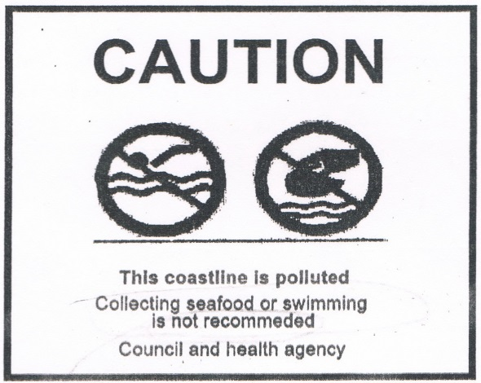

What does the warning above mean?
A. The visitors are not forbidden to collect seafood.
B. You are prohibited to swim at the polluted beach,
C. The coastline is not dangerous to collect seafood,
D. You cannot swim alone at the beach.

