SOAL : 07 | Bahasa Inggris SMP/MTs

- Arrange these sentences below into a good paragraph.
- I had no choice but to go to barber. It was time to be bold.
- So, she started to snip my hair with a scissors.
- My father was overseas. He usually cuts our hair for us.
- It all happened when I noticed that my hair had grown too long.
- But my sister stopped me and said that she can do it for free.
- Halfway through, I came out my guts and panicked.
- I would get a cut from a professional barber, I got ready to go.
- My beautiful hair reduced to nothing more than a haphazard.

A. 3-1-2-8-6-5-7-4
B. 7-4-8-5-6-1-2-3
C. 4-3-7-5-2-6-8-1
D. 8-1-2-5-6-3-4-7

The following text is for questions 2 and 3.
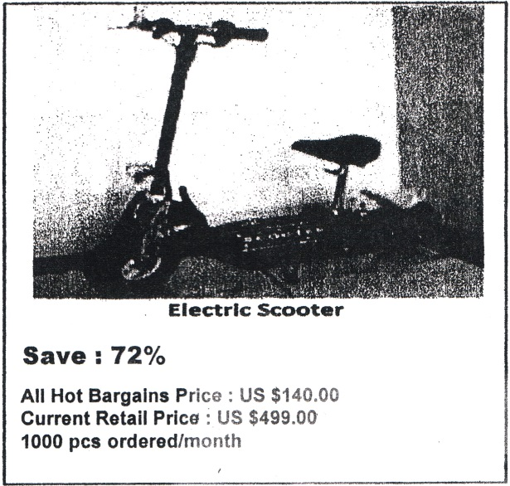
- How much is the retail price of the Electric Scooter?
A. US$ 256.00.
B. US$ 359.00.
C. US$ 499.00.
D. US$ 1.000.00.

- From the text above, we know that?
A. There are 140 orders for electric scooter every month.
B. The advertisement offers 72% discount for the product.
C. The current retail price for public is 140 dollar/pcs.
D. The minimum order for electric scooter is 1000 items.

For questions 4 to 6, choose the most suitable words to fill in the blanks.
Samosir, approximately 50 km long and 15 km wide, is an island in Lake Toba and almost as big as Singapore. It is often described as the heart, of Batak (4) ….. Samosir is a perfect place to relax and cool down. It is beautiful and scenic and very relaxing. Accommodation is extremely (5) ….. but the food is rather expensive. The island is small enough to 'wander about or you can choose to lie in a hammock (6) ………..

- A. village
B. culture
C. hometown
D. costumes

- A. dear
B. easy
C. cheap
D. difficult

- A. con ipletely
B. simply
C. easily
D. comfortably

The following text is for questions 7 and 8.
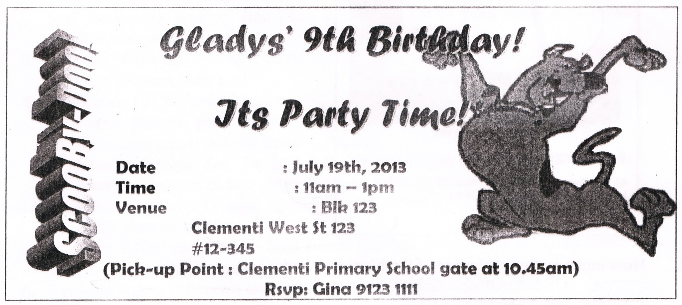

- Which of the following information can we find in the text?
A. The party is at Clementi's house.
B. Gladys will celebrate her friends birthday.
C. The party is from 1 p.m. until 11 p.m.
D. The party will be ended at 1 p.m.

- "Her Party Time"
The underlined word refers to ……….
A. Gladys
B. Gina
C. Clementi
D. Scooby Doo

The following text is for questions 9 to 13.
Becaks were banned within the Jakarta city limits in 1994. At that time, former President Soeharto wanted to eradicate becaks from the city streets because they caused traffic problems. However, you can find an occasional becak driver in certain locations within Jakarta. Becak can also be found at the junction of main roads and smaller country lanes.
Becak arc widely missed by people who live in housing complexes off the main roads and small roads which are not serviced by bus routes - as their means of transportation. A becak seats two passengers. If we want 1:0 ride it with more comfort, choose the one with a plastic sheet that protects passengers during rain. Bargain before you get in and prepare some small change to pay.

- The text tells us about ... in Jakarta.
A. becaks as public transportation
B. the passengers of becaks
C. the new becak fare
D. the way to take a becak

- Who eradicated becak from the city?
A. People in the housing complex.
B. Former President Soeharto.
C. Becak drivers in Jakarta.
D. All people in the city.

- What is the reason to eradicate becaks?
A. There are other transportations to replace them,
B. they operated in country lanes and main roads.
C. They caused many traffic problems on Elie streets.
D. They required bargaining and small change when paying.

- What is the second paragraph about?
A. 1 he reason why people like becak.
B. Tips in riding becaks for women.
C. The becak fare that people have to pay.
D. The routes of becaks in Jakarta.

- From the text, we can conclude that ……..
A. the president eliminated becak successfully
B. many people love to ride becak
C. becak riders were happy to stop
D. people always use becak everywhere

The following text is for uuestions 14 to 17.
LADY WHITE AND LADY YELLOW
Once there were two chrysanthemums growing side by side in a field, one white, one yellow. One day a gardener came and offered to take the yellow flower to his home and make her far more beautiful. The yellow flower jumped at this chance and waved to her sister as she was carried away in the gentle hands of the gardener. Day by day, the yellow flower petals grew long and soft and she looked perfect.
One day a man came saying he was looking for a flower to put on the lord's crest. The gardener showed the man his best flower, the yellow chysanthemum. But the man shook his head and said that the flower had too much style and that he wanted something simpler. The yellow flower was disappointed but tried not to dwell on it.
The man crossed the field of the white chrysanthemum. He came up to her and said, "How would you like to be the object on my lord's crest. We would make sure you have a very nice life." Soon she was planted in a small planter by herself on a windowsill in the lord's mansion. The lord and his family agreed it was perfect for their crest. So artisans came and painted the flower on all of the family's belongings.
As for the yellow chrysanthemum, her luxury was short lived. One day she felt a terrible feeling coming through her leaves and then she fell over and lay on the ground. The white flower was carefully conserved. The gardener were careful not to disrupt her simple beauty for he knew that the family had chosen her instead of the fancy yellow one, which was now dead in the gardener's garden.

- The man preferred the white chrysanthemum to the yellow chrysanthemum because…
A. he wanted to give it to his lord
B. the white flower had too much style
C. he liked the color of the flower
D. the white flower had simple beauty

- What is the third paragraph about?
A. The reason why the white chrysanthemum is put on their crest.
B. The reason why the man choose the white chrysanthemum.
C. What the Lord's family did to the white chrysanthemum.
D. What the man promised to the white chrysanthemum.

- How did the yellow flower feel when the gardener took her home?
A. She felt gloomy.
B. She was very pleased.
C. She felt envy to her sister.
D. She took a pity on her sister.

- What is the moral message of the story?
A. Simplicity leads to a good thing.
B. Misery makes everything better.
C. Simplicity leads to a misery.
D. Misery leads to suffering.

This text is for the questions 18 to 21.
Charles Robert Darwin was an English scientist, who proposed and provided evidence for the scientific theory that all species have evolved through natural selection. This theory became widely accepted by the scientific community in the 1930s, and now become the basic of modern evolutionary theory. -
Darwin developed his interest in natural history at Edinburgh University while studying first medicine, then theology. His five-year voyage on the Beagle established him as a geologist whose observations and theories supported Charles Lyell's uniformitarian ideas, and publication of his journal of the voyage made him famous as a popular author.
His study on the geographical distribution of wildlife that he collected during the voyage, resulting his theory of natural selection in 1838. Having seen other being attacked for similar ideas, he confided only to his closest friends and continued his research. In 1858, Alfred-Russell Wallace sent him an essay describing a similar theory, causing the two to publish their early theories in a joint publication. In 1859 He published his famous book, the Origin of Species.

- What initiated Darwin's theory of natural selection?
A. The researcher's discovery on the natural wildlife.
B. The theory of natural selection that he had developed.
C. The geographical distribution of wildlife he collected.
D. His friend who continued his extensive research in 1838.

- Darwin became a popular author because of.
A. his voyage's journal
B. the geographical distribution
C. a scientific community
D. his study in theology

- The third paragraph is about....
A. Darwin's publications
B. Darwin's research on plants
C. the natural selection
D. Darwin's education

- "..., he confided only to his closest friends ..." (Paragraph 3)
The underlined word is similar in meaning with……….
A. told a secret
B. made a group
C. did observation
D. conducted a research

The following text is for questions 22 and 23.
SEMARANG - SURABAYA RAILWAY TIME TABLE
Train | Departur (Semarang) | Arrival (Surabaya)
Eastern Sun | 7.30 am | 3.00 pm
Arya Triwangsa | 9.30 pm | 5.00 am
Fajar Express | 5.30 am | 1.00 pm
Midnight Express | 10.30 pm | 6.00 am

- Which train travels the earliest from Semarang?
A. Eastern Sun.
B. Arya Triwangsa.
C. Midnight Express.
D. Fajar Express.

- From the text, we can conclude that.
A. three trains leave in the morning
B. Midnight express leaves at midnight
C. Fajar express arrives in the morning
D. two trains arrive in the morning

The following text is for questions 24 to 26.
Dear Mira,
Hi, How are you there? I hope you are fine as usual. Mira, I am writing to tell you my experience as a voluntary worker in school. We cleaned the area around our school, mowed the grass and bushes behind our classroom and repainted walls.
As the chairman of the student’s organization (OSIS), together with our committee members, we planned and discussed the right time to do this voluntary work. After a long discussion, finally we agreed to hold it last Saturday.
On that day, fortunately we did not have to study as we had just finished our final examination. So, while waiting for our teachers who were busy writing our 'report book' and with the help of Pak Bejo we did it. We were having a good time because we could play while we were working. I wished you could join us at that time.
What about you? How do you spend your free time at school? How's your Karate group at school? I hope to hear from you, write me soon, Thanks.

Best Wishes,
Seno

- What is the letter about?
A. Cleaning the school.
B. Writing the report.
C. Final examination.
D. Voluntary work.

- Who was busy writing the report book?
A. Mira.
B. Pak Bejo.
C. Teachers.
D. Seno.

- Why were the students happy while they were working?
A. They could repainted freely.
B. The teachers were busy writing report.
C. They could play while working.
D. The garden was very clean.

The following text is for questions 27 to 30.
Garuda Wisnu Kencana or GWK Culture Park is a tourist destination statue of Lord Vishnu. Located on Jl. Raya Uluwatu, Jimbaran Village, Badung Regency of Bali Province. It is just 25 minutes away from Denpasar airport or Nusa Dua.
Garuda Wisnu Kencana is a prestigious project built in Bali with a 150-meter-tall statue that was planned to be the center of International events of performances, exhibitions, and others.

- Where is the big statue located?
A. In Jimbaran Village.
B. In Nusa Dua district.
C. Near Denpasar airport.
D. In exhibition center.
- GWK considered as prestigious project because
A. it is planned to be the center of international events
B. it has 150 -meter- tall Lord Vishnu Statue
C. it is a tourist destination in Bali island
D. it is visited by many foreign tourists

- What is the first paragraph about?
A. GWK is a tourist destination in Bali.
B. Badung regency is a tourist destination.
C. Denpasar airport has strategic location.
D. A prestigious project is built in Bali.

- "Garuda Wisnu Kencana is a prestigious project built in Bali..." (paragraph 2)
The underlined word means
A. different
B. famous
C. common
D. reputable

The following text is for questions 31 to 34.
In the days when an ice cream sundae cost less, a 10 years old boy entered a hotel coffee shop and sat at a table. A waitress put a glass of water in front of him.
"How much is an ice cream sundae?"
"50 cents," replied the waitress.
The little boy pulled his hand out of his pocket and studied a number of coins in it. "How much is a dish of plain ice cream?" he inquired. Some people were now waiting for a table and the waitress was a bit impatient.
"35 cents," she said brusquely.
The little boy again counted the coins. "I'll have the plain ice cream," he said. The waitress brought the ice cream, put the bill on the table and walked away. The boy ate it, paid the cashier and departed.
When the waitress returned, she began wiping down the table and then swallowed hard at what she saw. There, placed neatly beside the empty dish, were 15 cents - her tip

- What did the boy do after knowing he had less money?
A. He wiped down the table.
B. He swallowed hard.
C. He walked away.
D. He bought a dish of plain ice cream.

- What is the first paragraph about?
A. The waitress' underestimation of the boy.
B. The waitress' appreciation of the boy.
C. The price of ice cream sundae.
D. The hotel coffee shop's ice cream sundae.

- What is the moral message of the story?
A. When there is a will there is a way.
B. Don't judge the book by its cover.
C. Every cloud has a silver lining.
D. Simplicity is the best policy.

- "The boy ate it ……" (Paragraph 3)
The underlined word refers to ………….
A. ice cream
B. empty dish
C. the bill
D. the table

The following text is for questions 35 to 38.
A Basic Recipe for Fried Rice
Ingredients:
• 2 large eggs
• 1 teaspoon salt
• salt and, pepper to taste
• 4 tablespoons cooking oil or as needed
• 3 cups cooked rice
• 1 - 2 tablespoons light soy sauce or oyster sauce, as desired

Steps:
- Lightly beat the eggs with salt and pepper.
- Heat a wok and add 2 tablespoons of cooking oil. When the oil is hot, pour the eggs. Stir, until it is lightly scrambled but not too dry. Remove the eggs and clean out the wok.
- Add another 2 tablespoons of cooking oil. Add the rice and stir-fry for a few minutes, using a wooden spatula. Put soy sauce as desired.
- Add the scrambled egg back-into the pan. Mix thoroughly. Serve hot.

- How should you serve the fried rice best? By...
A. adding the scrambled egg.
B. stirring it for a few minutes.
C. adding 2 tablespoons oil
D. serving the fried rice hot.

- How much rice do we need in this recipe?
A. 1 teaspoon.
B. 2 tablespoons.
C. 3 cups.
D. 4 tablespoons.

- "Lightly beat the eggs..." (step 1)
The underlined word means....
A. crack
B. mix
C. fry
D. cook

- "...until it is lightly scrambled..." (step 2)
The underlined word refers to....
A. oil
B. salt
C. rice
D. egg

The following text is for questions 39 to 42.
Gardenia plants are popular for the strong sweet scent of their flowers. Gardenia is the national flower in Pakistan. In Japan and China, the flower is called Kuchinash (Japanese) and Zhi zi (Chinese).
Gardenia plants are evergreen shrubs. Their small trees can grow to 1 - 5 meters tall. The leaves are 5 - 50 centimeters long and 3 - 25 centimeters broad, dark green and glossy with a leathery texture. The flowers are in small groups, white, or pale yellow, with 5 - 12 lobes (petals) from 5 -2 centimeters diameter. They usually bloom in mid-spring to mid-summer. Many species have strong aroma.
To cultivate gardenia as a house plant's not easy This species can be difficult to grow because it originated in warm humid tropical areas it demands high humidity and bright (not direct) light to thrive. It flourishes in acidic soil with good drainage and thrives on 20°— 23° C during the day and 15° - l6° C in the evening. Potting soils developed specifically for gardenias are available. It grows no larger than 18 inches in height and width when grown indoor. In climates where it can be grown outdoors, it can reach the height of 6 feet. If water hits the flowers, they will turn brown.

- How tall is a gardenia tree?
A. 3 - 25 cm.
B. 5 - 12 cm.
C. 5 - 50 cm.
D. 1 – 5 m.

- What is the main idea of the last paragraph?
A. It is easy to plant a gardenia tree.
B. A gardenia plant needs high humidity.
C. It's not easy to plant gardenia as a house plant.
D. A good drainage is important for gardenia plant.

- From the text we know that …………
A. people don't like the strong scent of flower
B. Gardenia is widespread in Asia
C. the flower is easy to plant
D. the flower is expensive

- "... because it originated in warm ..." (paragraph 3, line 10)
The underlined word refers to
A. the flower
B. the species
C. the soil
D. the leaf

The following text is for questions 43 to 45.
ANNOUNCEMENT
Merauke High School is looking for diving coach for the 2012 season. Please contact Merauke High School if you are interested and have a lot of experiences in diving.

For more information please visit http://www.facebook.com/asaa.org or follow us on Twitter at http://www.twitter.com/asaa_org.

PS:
201243 Basketball and Cheerleading Season and State Championship is rescheduled a week later due to a conflict with the Sullivan Arena and UAA Hockey schedule.

- What is the announcement about?
A. Tournament schedule change and coach vacancy.
B. Sports program and vacancy in twitter account.
C. Some school activities on a new Facebook page.
D. A conflict in basketball championship schedule.

- Why was the basketball championship rescheduled?
A. Merauke High School was looking for a coach. 7
B. The readers were interested in diving.
C. They changed the hockey schedule.
D. There was a conflict schedule.

- "…… is looking for diving coach for the 2012 season,"
The underlined word has similar meaning with………..
A. trainer
B. participant
C. employee
D. spectator

For questions 46 to 48, choose the most suitable words to fill in the blanks.
Last Monday was a busy day for me. J spent my time to do a lot of activities both at school and at home. First, in the morning, I did my homework with my friend, Nurhalizah. It took one hour. Then we (46) ….. to school together. But, (47) ….. said that our task would be collected the following week. It made us disappointed. The class (48)….. finished at 12.30.

- A. left
B. sat
C. were
D. went

- A. the student
B. the teacher
C. friends
D. the principal

- A. quickly
B. finally
C. slowly
D. rarely
- Arrange the sentences bellow into a correct paragraph.
- We left our house at about 5 o'clock in the morning. We took a taxi to the railway station.
- Finally our train came. All of us rushed to get on the train.
- Last Lebaran, my family and I went hometown. We decided to take a train because it is more comfortable.
- It took about 5 to 7 hours to get to our hometown. We enjoyed our journey.
- We took the carriage no 3 according to our tickets.
- But without any prior information, our train was late for about fifteen minutes, so we had to wait a bit longer.
- After finding our seats we could sit comfortably.
- We arrived at the station at six. Our train would leave at 6.40.

A. 3-8-6-4-5-1-2-7
B. 3-4-5-8-1-2-6-7
C. 3-1-8-6-2-5-7-4
D. 3-5-4-2-7-8-1-6

- This text is for the following question.
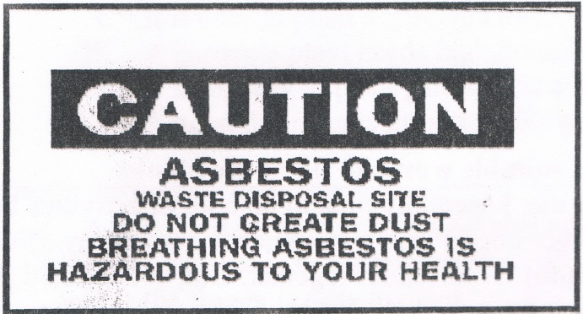
What does the caution mean?
A. It is hazardous if we create dust from the asbestos.
B. Asbestos can create dust when we dispose it.
C. It is dangerous for our health to breathe asbestos.
D. Disposing asbestos is bad for our health.

