SOAL : 06 | Bahasa Inggris SMP/MTs

- Arrange these sentences below into a good paragraph.
- I looked to the mirror to find out why.
- I woke up late and rushed to school.
- I had a bad experience at school this morning.
- They were pointing at my face. I wondered why.
- When I entered my classroom, everybody was staring at me.
- I had just celebrated my 5th birthday last night.
- I was surprised to see, that I still put on my make up.
- I felt embarrassed and ran to the rest room.

A. 2-5-3-8-4-7-6-1
B. 3-2-5-4-8-1-7-6
C. 6-2-3-5-4-8-1-7
D. 6-3-2-7-1-8-5-4

The following text is for questions 2 and 3.

- How much will you pay for the foot Massager?
A. US$61.00
B. US $72.50
C. US $117.95
D. US $189.95

- What should we do to order the product?
A. Send them email or letter.
B. Call them on the number given.
C. Come directly to the place.
D. Send them a facsimile.

For questions 4 to 6, choose the suitable words to fill in the blanks.
Mr. Bambang is an English teacher. He speaks English fluently. His wife, Mrs. Vanya is a (4) ........... She helps sick people. She doesn't speak English. Mr. Bambang has two children. They study English not only at school but also at home. They are (5) ……… students. Their father teaches them every night, so they can speak English (6) ….. He is very proud of them.

- A. teacher
B. janitor
C. doctor
D. chef
- A. lazy
B. proud
C. stupid
D. diligent

- A. fluently
B. silently
C. slowly
D. badly

The following text is for questions 7 and 8.
Northeastern  University | Center for Academic Services  Arts and Sciences Department
September 23, 2012
Center for Academic Student Services  Meserve Hall  617 373 3980  cas@ncu.cdu  Visit Our Website  www.northeastern.edu | To all undergraduate and graduate students of  Arts and Sciences Department  There will be an open dialogue for students and members of the committee discussing  Arts and Sciences Department and Academic Research Journal  on  September 26th, 4:30 - 6:00 p.m., in 31B  Currie Student Center  Attached is a list of published Academic Journals.  For more information, please visit our website:  http://www.northeastern.eduIcollegestructire/  by attending this dialogue, hopefully you will understand more  about Academic Journal.  (This meeting has been rescheduled from September 21st)

- From the text, we can see that ............
A. the committee will not attend the dialogue
B. every student of the department is invited
C. the dialogue is only for special students only
D. there has not been any change on the dialogue schedule

- "..., hopefully you will understand..."
The underlined word refers to all ……………..
A. students in the Arts and Sciences Department
B. students in Northeastern University
C. undergraduates in Arts and Sciences Department
D. students of Arts and Sciences and committee

The following text is for questions 9 to 13.
The Bangkok Tuk Tuk (pronounced took-took) is probably every visitor's favorite means of transport. They have an undeniable appeal and quality that makes them irresistible to everyone who come to Bangkok or Thailand.
The Tuk Tuk is a three wheeled, motorized rickshaw and can seat two adults comfortably, but it is common to see 6 to 7 students crammed in it. All of them share the fare.
Bangkok Tuk Tuks are a great way of traveling short distances if you are not expecting any sightseeing along the way. We say this because the canopy hat covers the Tuk Tuk slants downwards towards at exactly eye level so that the passengers are losing their chances to see what is going on around unless one sits on another person's lap.

- The text is about
A. Tuk-tuks in Bangkok
B. Bangkok traditional transportation
C. all means of transportation in Bangkok
D. visitors' favourite transportation

- How many grown-ups can be carried restfully in a tuk-tuk?
A. One.
B. Two.
C. Six.
D. Seven.

- Passengers of tuk-tuk cannot set, what is going on around them, because …….
- the covers of tuk tuk slant downwards
- their positions during the journey is great
- the sight along the way is not good enough
- their views are blocked by tuk tuk's canopy

- What is the first paragraph about?
A. The reason why tourists like tuk-tuk in Bangkok.
B. Quality that makes Bangkok irresistible for people.
C. The undeniable transportation that all Thai people like.
D. The visitors use tuk-tuk as a means of transportation.

- From the text, we know that tuk-tuk ………
A. doesn't attract visitors to travel with it
B. is a good transportation for all journeys
C. is one of students' favourite transports
D. is the only way for sightseeing in Bangkok

The followine text is for uuestions 14 to 17.
Once upon a time, a giant named Kebo Iwo lived in Bali. He helped people building tempels and village, digging ditches, and cutting terrace out of the hillsides for rice paddies. All he asked for his help was food to satisfy his huge appetite.
One day, poor harvest made the people barely feed themselves, much less a giant. This made Kebo Iwo angry so much that he rampaged across the island, killing and destroying everything in sight until all houses, rice fields, and temples were ruined. The people were very angry with Kebo Iwo and gathered together to decide how to stop him. They planned to make friends with the giant and then kill him.
The people begged Kebo Iwo to rebuild the temples, houses, and rice fields which he had destroyed in his rampage. The giant agreed and worked at replacing everything he had destroyed. The Balinese people then asked him to build a well. As he dug, the earth piled high next to the well. The pile was as high as a mountain.
Tired from the hard work, he fell asleep. While he was sleeping, the people poured huge amounts of lime (a sticky substance) down to the well. The lime set around the giant and when he woke up, he was unable to escape.
The well then began to fill with water and it soon overflowed to become a, lake. Today, many people believe that the lake is Lake Batur, Bali's largest lake. The pile of earth that Kebo Iwo dug out of the well was believed to be Mount Batur, Bali's third-volcanic mountain.

- How did people kill Kebo Iwo?
A. By giving him no food.
B. By keeping him in a well.
C. By helping him escape.
D. By burying him in a well.

- The first paragraph tells us about
A. the characteristic of Kebo Iwo
B. the story of Kebo Iwo in Bali
C. Kebo Iwo when he was angry
D. Kebo Iwo's appetite killed him

- From the text, we know that Kebo Iwo ... when he helped people.
A. was very bad at working
B. was as strong as a mountain
C. always asked something in return
D. liked to destroy anything

- What moral message do you get from the story?
A. Don't be bad tempered.
B. Don't be greedy.
C. Be generous.
D. Be friendly.

The following text is for questions 18 to 21.
Jessica Cox suffered a rare birth defect and was born without any arms. None of the prenatal tests her mother took showed there was anything wrong with her. Not only she was born with this rare congenital disease but also with a great spirit.
The psychology graduate can write, type, drive a car, brush her hair and talk on her phone simply using her feet. Ms. Cox, from Tuscon, Arizona, USA, is also a former dancer and double black belt in Tai Kwon-Do. She has a no-restrictions driving license, she flies planes and types 25 words a minute.
The plane she is flying is called an Ercoupe and it is one of the few airplanes to be made and certified pedals. Without rudder pedals Jessica is free to use her feet as hands. She took three years, instead of the unusual six months to complete her lightweight aircraft license, had three flying instructors and practiced 9 hours of flying, becoming the first pilot with no arms.

- What makes Jessica's airplane different 'from common planes?
A. It has been certified and practiced for 89 hours.
B. It is one of the best airplanes in the world.
C. Jessica can fly it without using arms.
D. Jessica can fly it without any license.

- What subject did Jessica Cox study fotmally
A. Psychology.
B. Pilot school.
C. Flying school.
D. Dancing.

- What is the main idea of paragraph 2?
A. Jessica Cox can drive like a normal person.
B. Jessica Cox has good skills in Tai Kwon-Do.
C. Jessica Cox does everything differently from normal people.
D. Jessica Cox uses her feet to do her daily activities.

- "Jessica Cox suffered a rare birth defect. ..." (paragraph I)
The underlined word is similar in meaning to …………..
A. imperfection
B. suffering
C. handicap
D. disability

The following text is for questions 22 and 23.
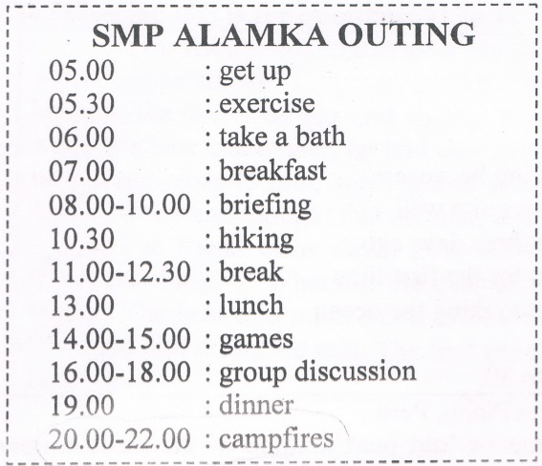

- What time will the students have campfire?
A. 8 a.m.
B. 1 p.m.
C. 4 p.m.
D. 8 p.m.

- What kind of schedule is it?
- Daily activities
- Camping agendas
- Scout itinerary
- Holiday plan

The following text is for question 24 to 26.
Hawaii Excelsior Hotel
August 4th, 2012

Dear Marry,
How are you? Have you finally found a new flat? And how was your holiday?
I'm writing to you from Hawaii. I came a week ago and stayed with my friend, Caroline, in a luxurious hotel called Excelsior Hotel. We had a spacious, comfortable room with a large terrace overlooking the ocean.
Yesterday, we started learning surfing. We really enjoyed it and the instructor said we were doing quite well. I started scuba diving course three days ago and tomorrow I'm going to dive in the ocean for the first time. I'm very excited about it!
That's all for now, I must rush for a spectacular party tonight.

Take care,
Jessica

- The text mostly talks about ……………
A. Hawaiian people
B. luxurious hotel
C. holiday in Hawaii
D. diving and surfing

- What did Jessica do three days ago?
A. Arrived in Hawaii.
B. Stayed in a hotel.
C. Decided to learn surfing.
D. Started scuba diving course.

- The writer is very excited about scuba diving because....
- the instructor said she was doing quite well
- she started scuba diving course three days ago
- she's going to dive in the ocean for the first time
- the hotel has a large terrace overlooking the ocean

This text is for the following question 27 to 30.
Machu Pichu, Peru
Machu Picchu in Peru, which means 'old peak' is one of the most ancient sites in the world. According to the legend, Machu Picchu was a sac The extraordinary city was created by Inca people. They erected many stones and turned the place into a work of art.
Two thousand feet above the Lirubamba river, these ruins consist temples and about 150 houses, all very well preserved. These gray granite s some of which weigh more than 50 tons, are perfectly sculpted that they are not than works of architectural genius. They were rediscovered by a Yale archeologist 1911. The ethereal beauty, workmanship, and history of the place attract mu tourists each year.

- What can we see in Machu Picchu in Peru?
A. Granite structure.
B. Beautiful scenery.
C. Inca people.
D. Ancient statues.

- Which one of the following is stated in the text?
A. Only the history of the place attracts millions of tourist each year.
B. According to the legend, Machu Picchu was considered to be a sacred place
C. All the gray granite structures are more than 50 tons weigh.
D. The granite structure was discovered by a Yale archeologist recently.

- What is the main idea of paragraph two?
A. The scenery is very attractive.
B. The description of Machu Picchu,
C. Machu Picchu is a sacred place.
D. The temples were discovered in 1911.

- "... one of the most enigmatic ancient sites." (paragraph 1)
The underlined word has similar meaning with…………..
A. ugly
B. new
C. old
D. recent

The following text is for questions 31 to 34
Two friends talked and sang merrily as they walked through the forest. Suddenly, a bear appeared. The first man quickly climbed a tree. The second one was very scared because the bear was big and strong. It can also easily kill him. He thought hard and when the bear came near, he laid very still on the ground and controlled his breath. The bear came close to him, sniffing and smelling his body all over. Surprisingly, the bear walked away and thought that the man was dead.
The friend came down from the tree when the bear went away. He asked his friend mockingly, "What did the bear tell you?". The second friend was silenced for a while. "The bear told me to never trust a friend who escapes and leaves you alone when you need him most," he said. The first friend realized his mistake and was ashamed of his behavior.

- How did the second man escape from the bear's attack?
A. By climbing a tree.
B. By running through the forest.
C. By laying on the ground.
D. By singing together.

- What is the main idea of the first paragraph?
A. Two friends walked through the forest.
B. The first friend climbed a tree.
C. Two friends met a bear, in the forest.
D. The second man laid down on the ground.

- What is the moral value of the above story?
A. We should learn to climb a tree.'
B. We should never be afraid of anything.
C. We should always listen to our heart.
D. We should never leave our friend behind.

- "... never trust a friend who escapes and leaves you alone..." (last paragraph)
The underlined word refers to ………
A. the bear
B. the second man
C. the first man
D. a friend

This text is for the 35 to 38.
Corn Flour Pudding
Ingredients:
2000 ml milk
200 gr corn flour
500 gr brown sugar
4 tbs water to dissolve the sugar
1 stick of 10 cm cinnamon
1 tbs butter
3 tbs cinnamon for sprinkling

Method:
- Thoroughly mix milk and corn flour until smooth.
- Boil brown sugar and water until sugar dissolved, then sieve.
- Mix brown sugar with the milk, corn flour mixture and cinnamon stick. Add butter and simmer whilst stiffing u1 corn flour become thick
- Pour into a suitable mould and let it cool.
- When serving sprinkle with ground cinnamon
Makes: 10-15 portions, best served when cold.

- Based on the text, we pour the mixture into mould ……….
- before we mix all the mixtures
- after the corn flour become thick
- after the mixtures get cool
- when the pudding is ready

- How many ingredients are needed to make Corn flour pudding?
A. 6.
B. 7.
C. 8.
D. 10.

- "Mix brown sugar with the milk, corn flour mixture..." (step 3)
The underlined word is similar in meaning with
A. put
B. combine
C. pour
D. shake

- The word “it” in step 4 refers to ….. of corn flour pudding.
- the cinnamon
- the mixture
- the brown sugar
- the milk

The following text is for questions 39 to 42.
Gardenia plants are popular for the strong sweet scent of their flowers. Gardenia is the national flower in Pakistan. In Japan and China, the flower is called Kuchinashi (Japanese) and Zhi zi (Chinese).
Gardenia plants are evergreen shrubs. Their small trees can grow to 1 - 5 meters tall. The leaves are 5 - 50 centimeters long and 3 - 25 centimeters broad, dark green and glossy with a leathery texture. The flowers are in small groups, white, or pale yellow, with 5 - 12 lobes (petals) from 5 - 12 centimeters diameter. They usually bloom in mid-spring to mid-summer. Many species have strong aroma.
To cultivate gardenia as a house plant is not easy. This species can be difficult to grow because it originated in warm humid tropical areas. It demands high humidity and bright (not direct) light to thrive. It flourishes in acidic soil with good drainage and thrives on 20° - 23° C during the day and 15° - 16° C in the evening. Potting soils developed specifically for gardenias are available. It grows no larger than 18 inches in height and width when grown indoor. In climates where it can be grown outdoors, it can reach the height of 6 feet. If water hits the flowers, they will turn brown.

- How tall is a gardenia tree?
A. 3-25 cm.
B. 5-12cm.
C. 5-50cm.
D. 1-5m.

- What is the main idea of the last paragraph?
A. It is easy to plant a gardenia tree.
B. A gardenia plant needs high humidity.
C. It's not easy to plant gardenia as a house plant.
D. A good drainage is important for gardenia plant.

- From the text we know that ……………..
A. people don't like the strong scent of flower
B. Gardenia is widespread in Asia
C. the flower is easy to plant
D. the flower is expensive

- "... because it originated in warm ..." (paragraph 3, line 10)
The underlined word refers to
A. the flower
B. the species
C. the soil
D. the leaf

The following text is for questions 43 to 45.
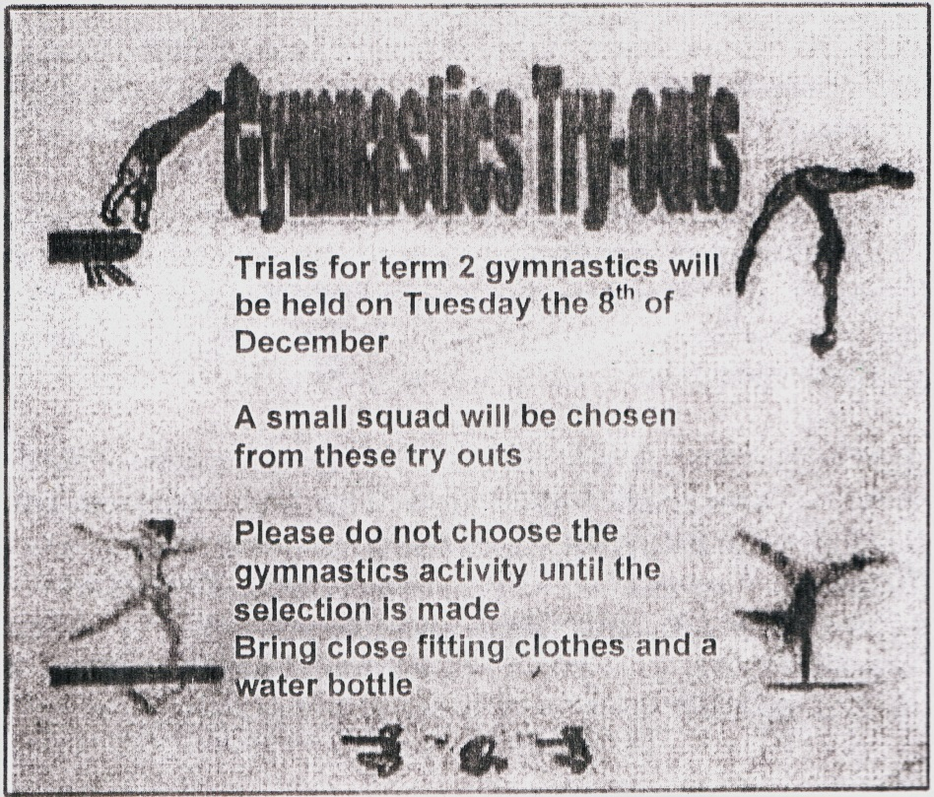

- What is the announcement about?
A. Squads practice.
B. Squads try-outs.
C. Gymnastics try-outs.
D. Gymnastic selection.

- What is the statement found in the text?
A. We should not bring a water bottle.
B. The try-outs will choose a small squad.
C. The gymnastics try-out is held on Thursday.
D. We should wear loose fitting clothes.

- "A small squad will be chosen"
The underlined word has similar meaning with
A. group
B. member
C. troop
D. unit

For questions 46 to 48, complete the text with suitable words.
1(46) ….. my adolescence when I was thirteen. It started with acne that showed right on top of my pointed (47) ….. It was very annoying. It made me self-conscious about my look. Fortunately, my Mom treated me (48) ….. in three weeks. The acnes started to vanish. That was my experience during adolescence.

- A. reached
B. learned
C. stayed
D. stopped

- A. cheek
B. nose
C. face
D. head

- A. slowly
B. regularly
C. patiently
D. weekly

- Arrange the sentences bellow into a correct paragraph.
  - We left our house at about 5 o'clock in the morning. We took a taxi to the railway station.
  - Finally our train came. All of us rushed to get on the train.
  - Last Lebaran, my family and I went hometown. We decided to take a train because it is more comfortable.
  - It took about 5 to 7 hours to get to our hometown. We enjoyed our journey
  - We took the carriage no 3 according to our tickets.
  - But without any prior information, our train was late for about fifteen minutes, so we had to wait a bit longer.
  - After finding our seats we could sit comfortably.
  - We arrived at the station at six. Our train would leave at 6.40.

A. 3-8-6-4-5-1-2-7
B. 3-4-5-8-1-2-6--7
C. 3-1-8-6-2-5-7-4
D. 3-5-4-2-7-8-1-6

- This text is for the following question.
Please
Keep the lavatory
Clean
For the next user

What does the notice mean?
A. We should keep the lavatory.
B. The lavatory must be kept clean by any user.
C. We have to clean the lavatory.
D. The lavatory user is pleased to clean it.

