SOAL : 04 | Bahasa Inggris SMP/MTs

- Arrange these sentences below into a good paragraph.
- I had no choice but to go to barber, It was time to be bold.
- So, she started to snip my hair with a scissors,
- My father was overseas. He usually cuts our hair for us.
- It all happened when I noticed that my hair had grown too long.
- But my sister stopped me and said that she can do it for free,
- Halfway through, I came out my guts and panicked.
- I would get a cut from a professional barber, I got ready, to go.
- My beautiful hair reduced to nothing more than a haphazard.

A. 3-1-2-8-6-5-7-4
B. 7-4-8-5-6-1-2-3
C. 4-3-7-5-2-6-8-1
D. 8-1-2-5-6-3-4-7

The following text is for questions 2 and 3.

- How many pieces of treadmill does the company sell in a month?
A. 185
B. 764
C. 1500
D. 1599

- Why should you hurry to buy the product?
A. The stock is limited.
B. The price is very cheap now.
C. You will get more profits.
D. Other buyers are waiting.

For questions 4 to 6, choose the correct words to complete the text.
My cat name is Pussy. She is a beautiful gray Persian cat. She has a small body and smooth (4) ………… She spends most of her time watching television, eating and growing (5)……..... Pussy is picky about her food, (6)………... she refuses to eat food that does not suit her taste.

- A fur
B. hair
C. feather
D. quill

- A. fat
B. fame
C. strong
D. smart

- A. hardly
B. rarely
C. seldom
D. usually

The tollowing text is tor questions 7 and 8.
STUDENT ORGANIZATION OF SMP NEGERI 4
Jl. Samoja 5 Bandung 40275 Tlp. 022-7312394

To : Fino of class 11B

Would you please attend our meeting that will be held :
  - Day/date : Saturday, March 11th 2013
  - Time : 11 a.m.
  - Place : Multimedia room
  - Agenda : Final Preparation for Wall Magazine Competition 2013

Please come on time, see you there!

Andy  Chairperson | Devina  Secretary

- From the text, we know that
A. the meeting is held in Jl. Samoja, Bandung
B. the meeting will discuss about Multimedia Room
C. Fino is expected not to be late in the meeting
D. Devina is the chairperson of the student organization

- ".... see you there."
The underlined word refers to ………………
A. Devina
B. Chairperson
C. Fino
D. Andy
The following text is for questions 9 to 13.
Transjakarta is one of the Jakarta's mass transportation system. The, problem with Transjakarta begins with the stations. The flat top steel and glass enclosures have no ventilation at all. By the time the bus arrives, you will be drenched in sweat. It's hard to imagine how one could design a bus station to be any more uncomfortable.
When the bus finally stops, it will be packed to the gills; A few people may get off and a few may get on. If you are lucky enough to push your way on to the bus, you need to hang on, because it's like a sardine can. The buses are air conditioned, but it doesn't help much when the bus is over capacity. Pickpockets abound so you should be very careful with your belongings.
The best time to use the busway is between 10 a.m and 7 p.m on Sunday. There is a downloadable map on their website. The fare is Rp. 3.500 and there are no transfer fees.

- The text above tells us about ... Transjakarta.
A. the fare of
B. the station of
C. the problem of
D. the best time to use

- Where can we download the map of Transjakarta?.
A. On their website.
B. In their buses.
C. At the bus stop.
D. At the bus station.

- Why does of Transjakarta's station become a problem?
A. It is made of steel and glass.
B. It has no ventilation at all.
C. It does not have good roofs.
D. It is in the shape of an enclosure.

- What does the second paragraph tell us?
A. The situation when the bus stops at the station.
B. The people on the station are packed to the gills.
C. The way passengers of the bus leave the station.
D. Many people like to get on and off the bus.

- From the text, we know that ....
A. Transjakarta provide a downloadable map on its website.
B. Transjakarta's station is very small but comfortable.
C. riding Transjakarta during office hour is irresistible.
D. Transjakarta charges Rp. 3.500 for its transfer fee.

The following text is for questions 14 to 17
The Legend of Toba Lake
There was a handsome man named Batara Guru Sahala, who enjoyed fishing so much. One day, he caught a fish. He was surprised to find out that the fish could talk. The fish begged him to set it free.
Batara Guru Sahala could not bear it. He made the fish free. As soon as it was free, the fish changed into a very beautiful woman. Batara Guru Sahala fell in love with that fish-woman and wanted to marry her. Batara Guru Sahala promised to keep the secret that she had been a fish and would never tell anybody about it.
They were married happily. They had two daughters. One day Batara Guru Sahala got very angry with his daughters. He could not control his temper. He shouted angrily and got the word of fish to his daughters. The daughters were crying. They found their mother and told her about it.
The mother was, very angry. Batara Guru Sahala broke his promise. The mother was shouting angrily, then the earth began to shake. Volcanoes started to erupt. The earth formed a very big hole. People believed that the big hole became a lake. Today the lake is known as Toba lake.

- Why was the mother very angry? Because ………….
A. her daughter were crying and found her
B. the earth began to shake and started to erupt
C. Batara Guru Sahala broke his promise
D. Batara Guru Sahala was angry

- What is the main idea of the fourth paragraph?
A. How Toba lake was formed.
B. The daughters found their mother.
C. Their daughters were crying.
D. Batara Guru Sahala had two daughters.

- From the text, we know-that .
A. Sahala's wife was a captured fish
B. the daughters changed into fish too
C. Sahala broke his promise to his wife
D. the daughters and father are fish

- What can you learn from the text above? We should …………..
A. promise to our wife -
B. promise to our husband
C. break our promise
D. keep our promise

Read the text and answer questions 18 to 21.
Picasso was one of the most outstanding and important artists of the 1900's. He was best known for his paintings. Almost every style in modern art was represented in Picasso's works.
Picasso was born in 1881 in Malaga, Spain, as the son of an art teacher. He studied painting with his father and also in Madrid.
From 1895 to 1901, he painted realistic works in a traditional style. Then he entered what was called the Blue period. During this time, he only used shades of blue in his paintings to show poverty in Barcelona.
After 1907, he entered the style of cubism. Among his well-known cubist paintings are "The Three Musicians" and "The man with a guitar" which depicted the destruction of Spanish town. Picasso died in France in 1973.

- Picasso used shades of blue in his painting during the Blue Period, because ……….
A. he was sad to live in a traditional Barcelona
B. the blue was to show poverty in Barcelona
C. the blue represented modern art of this painting
D. blue was Picasso's favorite color in his paintings

- From the text, we know that ………….
A. Picasso used his paintings to describe his environment
B. Picasso loved listening to the music and playing guitar
C. Picasso was born, raised, and died in Malaga, Spain
D. Picasso only used blue paint in all his paintings

- What is the main idea of paragraph three?
A. Picasso used shades of blue in his paintings.
B. Picasso died in France on 1973.
C. Picasso was born in Malaga, Spain.
D. Picasso was taught by his father.

- "... which depicted the destruction of Spanish town." (Paragraph 4)
The underlined word has the same meaning as …………..
A. drawed
B. described
C. painted
D. presented

The following text is for questions 22 and 23.
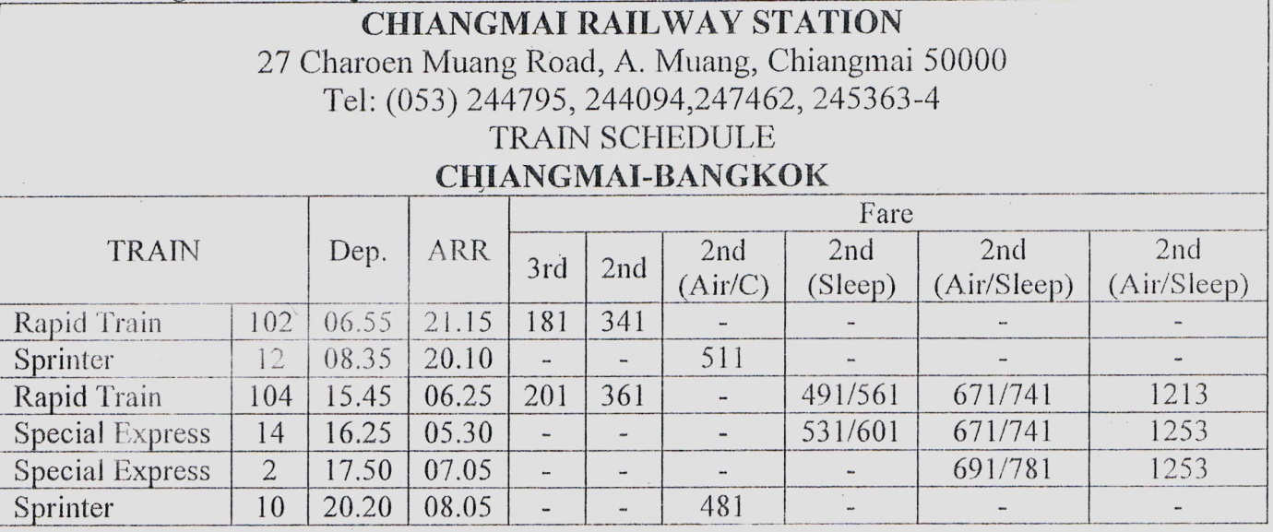

- Which train leaves Chiangmai the earliest for Bangkok?
A. Special Express 2
B. Rapid Train 104
C. Sprinter 10
D. Rapid Train 102

- Which train goes to Bangkok in the evening?
A. Special Express 2
B. Rapid Train 104
C. Sprinter 10
D. Sprinter 12

The following text is for questions 22 and 23.
Jl. Merpati 56 Jakarta
Januari 10th , 2013

Dear Mely,
I'm sorry, I haven't written for so long. My family and I have just returned from an interesting holiday at Lake Maninjau near Padang. The lake was a crater surrounded by densed forests and rice fields. We swam in the lake, ate fish from the lake arid enjoyed the cool breezes.
After that, we had a two hour trip to Bukit Tinggi, a small hill top town which was clean, cool and friendly Our trip around the hill took us to the coffee, clove and cinnamon plantation. The traditional Minangkabau houses, with the roof shaped like a buffalo's horn can be seen everywhere.
I really enjoy my vacation. Do come over and have a look sometime.

Love,
Tiara

- What does the text tell you about?
A. Traditional Minangkabau houses.
B. Traveling guidance for visitors.
C. The amazing view of West Sumatera.
D. A trip throughout West Sumatera.

- Where did the writer and his family go after visiting Lake Maninjau?
- Country side.
- Bukit Tinggi.
- West Sumatra.
- A small hill.

- From the text, we know that ....
A. it took 3 hours from Lake Maninjau to Bukit Tinggi
B. the journey to Bukit Tinggi could only be done by plane
C. Maninjau lake was situated far away from the forests and rice fields
D. the writer and his family visited an interesting place during their holiday

The following-text is. for questions 27 to 30.
Garuda Wisnu Kencana or GWK Culture Park is a tourist destination statue of Lord Vishnu Located on Jl. Raya Uluwatu, Jimbaian Village, Badung Regency of Bali Province. It is just 25 minutes away from Denpasar airport or Nusa Dua.
Garuda Wisnu Kencana is a prestigious project built in Bali with a 150-meter-ta1l statue that was planned to be the center of International events of performances, exhibitions, and others.

- Where is the big statue located?
A. In Jimbaran Village.
B. In Nusa Dua district.
C. Near Denpasar airport.
D. In exhibition center.

- GWK considered as prestigious project because.
A. it is planned to be the center of international events
B. it has 150 -meter- tall Lord Vishnu Statue
C. it is a tourist destination in Bali island
D. it is visited by many foreign tourists

- What is the first paragraph about?
A. GWK is a tourist destination in Bali.
B. Badung regency is a tourist destination.
C. Denpasar airport has strategic location.
D. A prestigious project is built in Bali.

- "Garuda Wisnu Kencana is a prestigious project built in Bali..." (paragraph 2)
The underlined word means ………
A. different
B. famous
C. common
D. reputable

The following-text is for questions 31 to 34.
In the days when an ice cream sundae cost less, a 10 years old boy entered a hotel coffee shop and sat at a table. A waitress put a glass of water in front of him.
"How much is an ice cream sundae?"
"50 cents," replied the waitress.
The little boy pulled his hand out of his pocket and studied a number of coins in it. "How much is a dish of plain ice cream?" he inquired. Some people were now waiting for a table and the waitress was a bit impatient.
"35 cents," she said brusquely.
The little boy again counted the coins. "I'll have the plain ice cream," he said. The waitress brought the ice cream, put the bill on the table and walked away. The boy ate it, paid the cashier and departed.
When the waitress returned, she began wiping down the table and then swallowed hard at what she saw. There, placed neatly beside the empty dish, were 15 cents - her tip.

- What did the boy do after knowing he had less money?
A. He wiped down the table.
B. He swallowed hard.
C. He walked away.
D. He bought a dish of plain ice cream.

- What is the first paragraph About?
A. The waitress' underestimation of the boy.
B. The waitress' appreciation of the boy.
C. The price of ice cream sundae.
D. The hotel coffee shop's ice cream sundae.

- What is the moral message of the story?
A. When- there is a will there is away.
B. Don't judge the book by its cover.
C. Every cloud has a silver lining.
D. Simplicity is the best policy.

- "The boy ate it, ..." (Paragraph 3)
The underlined word refers to ……..
A. ice cream
B. empty dish
C. the bill
D. the table

The following text is for questions 35 to 28.
Nasi Lemak

Ingredients:
1 cup rice
3 screw pine leaves
Salt to taste
2 cups thick coconut milk

Method:
- First, clean the rice and drain it:
- Then, add 2 cups of thick coconut milk, screw pine leaves, and salt to the rice.
- If you desire, you can also add in some sliced onions and ginger.
- Cook the rice for one hour.
- Finally, serve this rice with sliced hard-boiled eggs, cucumber and sambal ikan Bilis.

- What should we do after; we clean and drain the rice?
A. Grated the coconut.
B. Add some sliced onions.
C. Add the thick coconut milk.
D. Serve with egg and cucumber.

- Flow many cups of coconut milk do we need?
A. One
B. Two
C. Three
D. Four

- "... clean the rice and drain it."
The word clean has similar meaning with
A. sweep
B. removes
C. rinse
D. clear

- "... clean the rice and drain it"
The word "it" refers to ………
A. pine leaves
B. coconut milk
C. rice
D. salt

The following text is for questions 39 to 42.
Gardenia plants are popular for the strong sweet scent of their flowers. Gardenia is the national flower in Pakistan. In Japan and China, the flower is called Kuchinashi (Japanese) and Zhi zi (Chinese).
Gardenia plants are evergreen shrubs. Their small trees can grow to 1 - 5 meters tall. The leaves are 5 - 50 centimeters long and 3 - 25 centimeters broad, dark green and glossy with a leathery texture. The flowers are in small groups, white, or pale yellow, with 5 - 12 lobes (petals) from 5 - 12 centimeters diameter. They usually bloom in mid- spring to mid-summer. Many species have strong aroma.
To cultivate gardenia as a house plant is not easy. This species can be difficult to grow because it originated in warm humid tropical areas. It demands high humidity and bright (not direct) light to thrive. It flourishes in acidic soil with good drainage and thrives on 20° - 23° C during the day and 150 - 16° C in the evening. Potting soils developed specifically for gardenias are available. It grows no larger than 18 inches in height and width when grown indoor. In climates where it can be grown outdoors, it can reach the height of 6 feet. If water hits the flowers, they will turn brown.

- How tall is a gardenia tree?
A. 3-25cm.
B. 5-12cm.
C. 5-50cm.
D. 1-5m.

- What is the main idea of the last paragraph?
A. It is easy to plant a gardenia tree.
B. A gardenia plant needs high humidity.
C. it's not easy to plant gardenia as a house plant.
D. A good drainage is important for gardenia plant.

- From the text we know that,....
A. people don't like the strong scent of flower
B. Gardenia is widespread in Asia
C. the flower is easy to plant
D. the flower is expensive

- "... because it originated in warm ..." (paragraph 3, line 10)
The underlined word refers to ………
A. the flower
B. the species
C. the soil
D. the leaf

The following text is for questions 43 to 45.
ANNOUNCEMENT
Merauke High School is looking for diving coach for the 2012 season. Please contact Merauke High School if you are interested and have a lot of experiences in diving.

For more information please visit http://www.facebook.com/asaa.org or follow us on Twitter at http://www.twitter.com/asaaorg.

PS:
2012-13 Basketball and Cheerleading Season and State Championship is rescheduled a week later due to a conflict with the Sullivan Arena and UAA Hockey schedule.

- What is the announcement about?
A. Tournament schedule change and coach vacancy.
B. Sports program and vacancy in twitter account.
C. Some school activities on anew Facebook page.
D. A conflict in basketball championship schedule.

- Why was the basketball championship rescheduled?
A. Merauke High School was looking for a coach.
B. The readers were interested in diving.
C. They changed the hockey schedule.
D. There was a conflict schedule.

- "... is looking for diving coach for the 2012 season."
The undelined word has similar meaning with……..
A. trainer
B. participant
C. employee
D. spectator

For questions 46 to 48, complete the text with the correct word.
When I was at the 8th grade of Junior High School, my family and I went to Bali for three days. I (46) ..... many experiences during the vacation. First day, we visited Sanur Beach in the early morning. We saw the beautiful (47) ….. together. On the second day, we spent the day on Tanjung Benoa beach. We spent our last day in Sangeh. We enjoyed the green and shady forest (48) ..... In the afternoon, we had to check out from the hotel. We went back home bringing so many amazing memories of Bali.

- A. had
B. spent
C. pulled
D. wanted

- A. stars
B. moon
C. sunrise
D. sunset

- A. strangely
B. curiously
C. quickly
D. pleasantly

- Arrange the sentences bellow into a correct paragraph.
- We left our house at about 5 o'clock in the morning. We took a taxi to the railway station.
- Finally our train came. All of us rushed to get on the train.
- Last Lebaran, my family and I went hometown. We decided to take a train because it is more comfortable..
- It took about 5 to 7 hours to get to our hometown. We enjoyed our journey.
- We took the carriage no 3 according to our tickets.
- But without any prior information, our train was late for about fifteen minutes, so we had to wait a bit longer.
- After finding our seats we could sit comfortably.
- We arrived at the station at six. Our train would leave at 6.40.

A. 3-8-6-4-5-1-2-7
B. 3-4-5-8-1-2-6-7
C. 3-1-8-6-2-5-7-4
D. 3-5-4-2-7-8-1-6

- This text is for the following question.
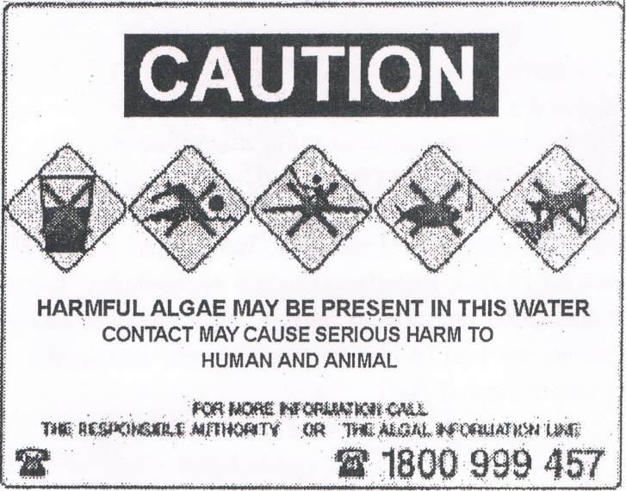
What does the caution above mean?
A. We must be careful because harmful algae grow in this water.
B. Swimming in this water may harm the algae that grow in it.
C. The algae cannot cause serious harm to the animals.
D. Harmful algae does not grow well in this water.

