**TES PENDALAMAN MATERI POKJA MLATI**

**SEKOLAH MENENGAH PERTAMA**

**TAHUN PELAJARAN 2018/2019**

Mata Pelajaran : Bahasa Inggris

Kelas : IX (Sembilan)

Hari/Tanggal : Selasa, 05 Maret 2019

Waktu : 120 menit

**SELAMAT MENGERJAKAN**

Pilihlah satu jawaban yang Anda anggap paling benar dengan menyilangkan pada huruf A,B, C atau D yang paling benar pada lembar jawaban yang tersedia!

*Text for numbers 1-2*

Dear Aini,

Dude, I’ve just received news from Tata. This afternoon Mrs.Sari wants us to finish our projects at school. Please don’t come late. Our group presentation must be good next week!

Yani

1. What is the writer’s intention in writing the text?
2. To hold a group appointment
3. To show a group presentation
4. To remind Aini to finish project
5. To get a new project from Mrs. Sari
6. What should Aini do after reading the message? She will …
7. go to school
8. finish the project
9. have lunch at home
10. present her project

*Text for numbers 3-4*

**School Announcement**

What : Book Fair

When : 6th-8th July 2017

When : school Auditorium

Why : All money from the sale will be donated to orphans.

Many great books to choose from!

So, don’t miss it!

1. What does the text talk about?
2. the book sale
3. the school’s book fair
4. the school auditorium
5. the donation to orphans
6. “Many great books to choose from!”

The word “great” has closest meaning to … .

1. good
2. mad
3. bad
4. sad

Text for numbers 5-6

To: Gabriel

I’m really sorry. I can’t accompany you and Dayu to Gubug.

My mother is sick. My father and I have to accompany her to the hospital.

Deva

1. The message is addressed to …
2. You and Dayu
3. Gabriel
4. Mother
5. Father
6. “My father and I have to accompany her to the hospital”

The underlined word refers to …

1. Dayu
2. Gabriel
3. Deva’s mother
4. Gabriel’s mother

*Text for numbers 7-8*

**ATTENTION**

To apply for a new driver’s license, come to BRI to buy a form then bring the completed form to the license office Monday through Friday at 8.00 a.m. until 2.30 p.m. You will take a written test and a driving test after you fill in other forms from the license office. There will be a fee but not much

1. Where can we find such an announcement?
2. At the police station
3. At the post office
4. At school
5. At the Bank
6. What will readers probably do after reading the announcement?
7. complete the form soon
8. apply for driving test
9. take the written test
10. buy the form in BRI

*Text for numbers 9-11*



1. What is the writer’s intention in writing the text? She wants to … .
2. To inform her friends about her home address
3. To persuade her friends to bring a sleeping bag
4. To invite her friends to prepare her birthday party
5. To request her friends attendance on her birthday party
6. When will the activity be held?
7. Morning
8. Afternoon
9. Evening
10. Late at night
11. What should we do if we want to come?
12. Bring sleeping bag
13. Go before Saturday
14. Call Rebbeca first
15. Contact Jasmine

*Text for numbers 12-15*



1. Whom is the advertisement intended to?
2. All of the readers
3. All of the customers
4. The people who need a place to stay
5. The people who find a house for their family
6. What is the advertisement about?
7. A plaza
8. Hotel rate
9. Hakaya brand
10. Hakaya Plaza Hotel
11. Which of the followings is NOT mentioned in the ads above?
12. We should stay there for 2 nights to meet the promo
13. The rate can be more than RP 900.000,-
14. We get discount on every benefit
15. The rate is available 3 days only
16. What does the word access in “free internet access” mean?
17. right of all
18. right to use
19. right to egress
20. right of way out

*Text for numbers 16-18*

J. K. Rowling is a British novelist who writes the phenomenal fantasy book series of Harry Potter. The books have got worldwide attention. They have become the bestselling book series in history. The books were sold more than 400 million copies.

Joanne Rowling was born on 31th July 1965 in Yate, Gloucestershire, England. So, she is 52 years old by 2017. About her physical appearance, her height is 165 centimeters and weight 54 kilograms. She has blonde hair and blue eyes. She has married two times. Now, she has got three children.

JK. Rowling is a terrific and successful novelist that becomes the richest woman in England. In fact, once she had become unemployed with a destitute life. By writing Harry Potter books which are loaded with spectacular magic and high imagination, she turns to be very famous and wealthy.

1. What does the text tell us about?
2. the phenomenal novelist from England
3. the richest woman in the world
4. Gloucestershire
5. Harry Potter
6. What is the main idea of the last paragraph?
7. Rowling was unemployed with a poor life
8. Rowling became the richest woman in world.
9. Rowling was successful since she had become unemployed.
10. Rowling was the richest woman since her writing Harry Potter books.
11. The books have got worldwide attention. (paragraph 3)

The underlined word is closest in meaning to … .

1. general
2. common
3. local reach
4. international

*Text for numbers 19-22*

Easter Island is in the South Pacific, 3,700 kilometres from the coast of Chile. On the island, there are 600 large statues. We don’t know who built them but they were probably constructed between 1150 and 1500. We don’t really know why they are there, the Easter Island.

Norwegian explorer, Thor Heyerdahl, believed that they were built by people from South America. To prove this, he made a simple raft and sailed there, all the way from Peru.

Archaeologists think that the statues represent dead tribal leaders. We don’t know why the statues left alone on the island. Perhaps they were killed by disease or war. Perhaps the builders used all the natural resources on the island. There are many unanswered questions about Easter Island.

1. What is the topic of the text?
2. The large statues
3. the Easter Island
4. the Island explorer
5. the coast of Chile island
6. What makes the statues mysterious?
7. They represent dead tribal leaders
8. They were built by South American.
9. There are many unanswered questions
10. We don’t know who built the 600 large statues.
11. What encouraged Thor Heyerdahl to make a simple raft?
12. to prove that the statues were built by South American people
13. to find the answer about Easter Island.
14. to know why the statues are there
15. to sail all the way from Peru
16. “… they were killed by disease or war” (paragraph 3)

What does the underlined word refer to?

1. dead tribal leaders
2. Archaeologists
3. builders
4. statues

*Text for number 23 – 26*

|  |
| --- |
| When I was seven years old, I was given a small wallet to keep my pocket-money in. I felt so happy and I put it in my hip pocket.  One day, during break time in school, I discovered that my wallet was missing. I checked it but I could not find it. There was some money in the wallet and without it I could not buy anything to eat. I was close to tears. It was not because of losing my precious wallet but because I might get a scolding from my parents. Anyhow I went hungry that day.  At class I could not concentrate well to study at all. I kept thinking about how I lost my wallet and what my parents would react. How was I going to explain the loss? I did not know whether someone had taken it from my pocket or it had merely fallen out. I hoped that someone would find it and return it to me.  When I told my mother about my loss, she was angry. She told me that it would not happen if I was careful. When my father came home, I got another anger. He said so many words to me. Then he told me that there would not be any more wallets for me until I got older.  Luckily, I still got pocket-money from my parents. I am glad to say that I never lost any money again. I had learned to be more careful. It is not pleasant to lose something and then get scolded for losing it.  *Source: http://www.englishdaily626.com/* |

1. What is the text about?
2. An unforgettable experience of lossing precious wallet.
3. A great anger of the writer because of loosing wallet.
4. A memorable experience of having a nice wallet.
5. Asking for pocket money from parents.
6. Why could not the writer concentrate to study? Because . . .
7. he lost his wallet.
8. his father said so many words to him
9. he still got pocket-money from his parents.
10. he kept thinking about how his parents would react.
11. When did the writer lose his wallet?
12. When he was seven years old.
13. During break time in school.
14. When he was at the canteen.
15. During the lesson.
16. “. . . losing my precious wallet but because . . . .” ( second paragraph ).

The underlined word has closest meaning to . . .

1. advantageous
2. important
3. valuable
4. effective

*Text for number 27 – 29*

|  |
| --- |
| Cell phones don’t have unlimited batteries that will keep running for weeks and years before needing a charge. If you use your phone once or twice a day, it is likely you will need to charge it after about a week of use.  What should do :   1. Find a charger that fits your cell phone. They usually come with the phone. If you have lost yours, see if you have another one that works with your phone or go to the place you bought the phone and see about getting a new one 2. Check the battery on your phone. If it’s four or three bars, you don’t need to charge it. But once it is down to two, one, or even no bars of power, it needs to be charged. 3. Plug your charger into an outlet and slid the smaller part into your phone. Don’t just shove it in, as this could damage the phone. 4. If your phone doesn’t beep or pop up with a message, check your phone. It should be flashing if your phone is charging or a different color. 5. Leave your phone to charge for two hours |

1. The writer’s intention of writing the text is to . . .
2. describe the readers how to use a cell phone.
3. explain the readers how to charge a cell phone.
4. tell the readers where we can charge a cell phone.
5. inform the readers how to operate a cell phone charger.
6. How can we know that our cell phone needs to be charged?
7. The bar is down to two, one, or no bars.
8. The cell phone does not beep.
9. The phone light turns bright.
10. The phone is flashing.
11. “ . . . , it is likely you will need to charge it after about a week of use. “

What does the underlined word refer to?

1. electrical outlet
2. phone battery
3. phone charger
4. cell phone

*Text for number 30 – 33*

|  |
| --- |
| Cure for Sorrow  (by Brian Cavanaugh)  There is an old Chinese tale about a woman whose only son died. In her grief, she went to the holy man and said, ”What prayers, what magical incantations do you have to bring my son back to life?”  Instead of sending her away or reasoning with her, he said to her, ”Fetch me a mustard seed from a home that has never known sorrow. We will use it to drive the sorrow out of your life.” The woman went off at once in search of that magical mustard seed.  She came first to a splendid mansion, knocked at the door and said, ”I am looking for a home that has never known sorrow. Is this such a place? It is very important to me.”  They told her, ”You’ve certainly come to the wrong place,” and began to describe all the tragic incidents that recently had befallen them.  The woman said to herself, ” Who is better able to help these poor, unfortunate people that I, who have had misfortune of my own?” She stayed to comfort them, then went on in search of a home that had never known sorrow. However wherever she turned, in hovels and other places, she found one tale after another of sadness and misfortune. She became so involved in minstering to other people’s grieves that ultimately she forgot about her quest for magical mustard seed, never realizing that it had, in fact, driven the sorrow out of her life.  *Adapted from* [*http://www*](http://www)*.Inspirationalstories.com/1/130.html. (4th October 2016)* |

1. What is the text about?
2. An old woman who would like to recover from sorrow.
3. An old woman who lived with her only son.
4. A holy man who helped an old woman.
5. A medicine for a sick old woman.

31. What happened to the old woman in finding a mustard seed?

1. She found a home that had never known sorrow.
2. She had to help all unfortunate people.
3. She met some unfortunate people.
4. She forgot about the way home.

32. What did the old woman do after realizing her son was dead?

1. She went to a home of sadness.
2. She went to a splendid mansion.
3. She went to a holy man.
4. She went to a hovel.

33. According to the text, we can conclude that the woman was a . . . person.

1. happy
2. tough
3. diligent
4. patient

*This text is for no 34 to 37*.

River flood can be caused by many factors. First, flood is caused by the duration. Deposition of rain or snow that is melt quickly exceeds the capacity of the river channel. Caused by torrential monsoon rains, hurricanes and tropical depressions, outdoor wind and rain affect snow heat. Drainage unexpected obstacles such as landslides, ice, or debris can result in flooding slowly upstream obstacles. Second, river flood is caused by the speed. It is included inundation from convective precipitation (large thunderstorms) or sudden release of upstream sediment that is formed behind the dam, landslide, or glacier

Floods can bring many benefits, such as replenishing groundwater, nourish and provide nutrients to the soil. The flood waters provide enough water in the dry and semi-dry erratic rainfall throughout the year. The flood waters bargaining plays an important role in balancing the ecosystem in the river corridor and a major factor in balancing the diversity of living things on the plains. Flood adds a lot of nutrients to lakes and rivers which are increasingly promoting the fishing industry in the coming years. It is also because it matches the flood plains for breeding fish (little predation and nutrients).

34. What does the text mainly talk about?

A. Rain

B. Flood

C. Glacier

D. Landslide

35. What is the main idea of first paragraph?

A. Floods can bring many benefits.

B. Flood is caused by the duration.

C. River flood can be caused by many factors.

D. Flood adds a lot of nutrients to lakes and rivers.

36. The word “flood” means ….

1. land without water on it
2. a wide area covered by water
3. water flows on rivers, seas, and oceans
4. an overflow of water that submerges land that is usually dry

37. which is not the advantage of flood?

1. Flood provides enough water in the dry and semi-dry erratic rainfall throughout the year.
2. Flood waters bargaining plays an important role in balancing the ecosystem in the river
3. Flood adds a lot of nutrients to lakes and rivers
4. Flood causes a lot of damage and disease.

*This text is for no 38 to 40.*

Komodo dragon is a member of the monitor family, Varanidae. It is the world’s largest living lizards. It grows to be 10 feet (3 meters) long and weighs up to 126 kg and belongs to the most ancient group of lizards still living.

It is found mainly in the island of Komodo and on other small islands Rinca, Padar, and Flores. The natives call the dragon, ora, or buaya darat (land crocodile).

The Komodo dragon has a long heavy tail, short, strong legs, and rough skin. It is covered with small dull, colored scales. It can sprint at up 18 km per hours, but only for short distances. When it opens its wide red mouth, it shows row of teeth like the edge of a saw.

Komodo dragons are good swimmers and may swim the long distance from one island to another. Like other lizards, they swim by undulating their tails, and their legs held against their body.

The Komodo dragon is totally carnivorous. It hunts other animals during the day. It hunts deer, wild pigs, water buffaloes, and even horses. While smaller komodo have to be content with eggs, other lizards, snakes, and rodents. Komodo dragons are cannibals. The adult will prey on the young one as well as the old and sick dragons.

38. The is written to .…

1. text inform about classification of komodo
2. persuade reader to keep komodo habitat
3. entertain reader with the story of komodo
4. describe about Komodo dragon in general

39. Which of the following is not the characteristic of a komodo dragon?

1. Rough skin
2. Short, strong legs
3. Row of red teeth
4. A long heavy tail

40. Komodo dragons are cannibals because ….

1. they eat anything they meet
2. they feed on eggs, other lizards, snakes, and rodents
3. they hunt deer, wild pigs, water buffaloes and even horses
4. they prey on the young ones as well as the old and sick dragons.

### *This text is for no 41 and 42.*

Last holiday, my friends and I went to the beach near from our city. We went early in the morning and arrived there at 8 a.m. luckily, that day was sunny. The beach seemed so beautiful under the blue sunny sky. It was great to feel the sand grains beneath our feet and the breeze blowing our hair gently.

At noon, we started to feel hungry, so we decided to head to the nearest food stall. The fish looked fresh and there were a lot of seafood menu listed here. We ordered grilled fishes. The dishes were delicious since it made from fresh ingredients. We filled our bellies to our heart’s content.

We stayed until the sun set because many people said the view was so outstanding. We took great photos as a keepsake of our beautiful moments here. We went home happily and fully recharged, ready for our daily routine, going to school the next day.

41. After reading the text we know that ….

1. eating a lot of seafood makes us happy
2. we have to prepare our own food in the food stall
3. going picnic is good to refresh our mind from daily routine
4. we have to leave early in the morning if we want to go to the beach

42. Why did the writer and his friends stay at the beach until the sun set?

1. Because they didn’t want to go to school the next day.
2. Because the view was beautiful when the sun set.
3. Because they wanted to spend the night there.
4. Because they missed the bus.

*Read the text and answer questions 43 - 45*

One beautiful spring morning, a merchant loaded his donkey with bags of salt to go to the market, in order to sell the salt. The merchant and his donkey were walking along together. They had not walked far when they reached a river on the way.

Unfortunately, the donkey slipped and fell into the river. As it scrambled up the bank of the river, it noticed that the bags of salt loaded on his back had become lighter.

There was nothing the merchant could do except return home, where he loaded his donkey with more bags of salt. As they reached the slippery riverbank again, the donkey fell into the river, this time deliberately. Thus the salt was wasted again.

By now the merchant knew the donkey’s trick. He wanted to teach the animal a lesson. As he returned home the second time with the donkey, the merchant loaded bags of sponges on its back.

The duo set out on their trip to the market a third time. On reaching the river, the donkey very cleverly fell into the water again. But now, instead of the load becoming lighter, it became heavier.

The merchant laughed at the donkey and said, “You foolish donkey, your trick has been discovered. You should know that you cannot fool anyone too many times.”

<http://www.kidsworldfun.com/shortstories>

1. What is the writer’s intention in writing the text?
2. to describe characters in a story.
3. to teach moral value with a story.
4. to argue why the story is important.
5. to tell what happened with the characters in a story
6. In the story above, the writer wants to say that …
7. The best friend will always help each other.
8. The bad action will return to you.
9. The good plan will be repaid.
10. The quiet one will be lucky.
11. “But now, instead of the load becoming lighter, it became heavier.” (paragraph 4)

The word ‘it’ refers to ….

1. river
2. water
3. salt
4. load

*The following text is for 46 to 48*

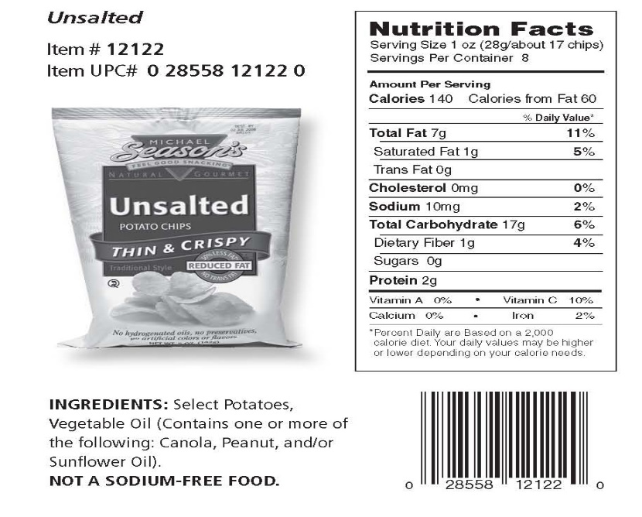

1. What is the advantage of reading the label?
2. Knowing the details of the product.
3. Sharing information about the drug.
4. Recognizing the name of the product.
5. Understanding the ingredients of the tablets.
6. How much protein does the product contain?
7. 1g.
8. 2g.
9. 7g.
10. 17g.
11. “Thin and Crispy”

The underlined word could be best replaced by….

1. Crunchy
2. Yummy
3. Chewy
4. Salty

*This text is for questions 49 and 50*

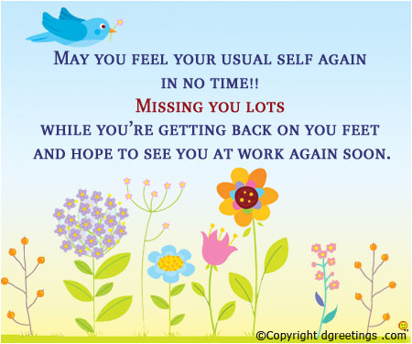

1. What is the writer’s intention to write the card above?
2. To support his friend on his sickness
3. To remind his friend to work again
4. To share his missing of his friend
5. To ask his friend to go to work
6. “May you feel your usual self again.”

We can infer from this statement that the writer hopes his friend ….

1. Feel good
2. Be healthy
3. Walk again
4. Back to work