SOAL : 19 | Bahasa Inggris SMP/MTs

- Arrange these sentences into a good paragraph.
- On the first day, the tour guide told them to check their travel documents.
- Mr. and Mrs. Kevin were on a tour to Indonesia.
- They were traveling on a guided tour.
- Such as their passports, and visas.
- He told them to keep those safely.
- Sometimes, they stopped at a famous hotel for the night.
- The tour guide was an Indonesian.
- The tour guide explained about interesting and historical places to them.

A. 2-3-7-1-4-5-6-8
B. 2-3-7-1-4-5-8-6
C. 2-3-5-4-1-6-8-7
D. 2-7-1-4-5-8-6-3

The following text is for questions 2 and 3.
G570 4334DDU Laptop with large screen. The laptop also comes with a spatial experience of the screen an it has advance function features that work efficiently. It is more user friendly than ever.

G570 433DDU 15.6-Inch Laptop Feature:
- 15.6-Inch Screen; Integrated Intel HD 3000 Graphic
- Windows 7 Home Premium 64-bit 4 hours Battery Life
- 2.5 GHz Intel Core i5-2450M
- 4 GB DIMM RAM
- 500 GB 5400 rpm Hard Drive

- Normally, this laptop can be used for …... hours
- two and half
- four
- seven
- sixty four

- From the text we know that………..
- The laptop is as user friendly as the previous edition
- The laptop has advance function features
- The battery can be used for 6 hours
- The screen of the laptop is small

For questions 4 to 6. choose the correct words to complete the text.
We have known Grand Canyon. It is a large steep (4) ….. in America bi. Ciamis, West Java there is natural tourism object named Green Canyon. It is located village Kertayasa, Ciamis, 31 km from Pangandaran. During dry season, the water ir river is (5) ….. may be that is how the place get its name. Visitors can enjoy the (6) ….. scenery of the trees and the strong stony wall at the bank of the river.

- A. town
B. valley
C. village
D. country:

- A. dirty
B. muddy
C. greenish
D. brownish

- A. usual
B. amazing
C. common
D. inspiring

The tollowing text is for questions 7 and 8
Dear Andy,

You and one of your friends are invited to attend Alice Corbet' s 15th birthday

At the Cocino Green House
On August 24th2013 at 7.00 PM.

RSVP.
Ilham, HP 03124964286

- What should the invitee do to come to the party?
- Do not ask other person to join the party.
- Call Ilham to confirm their coming.
- Bring capucino drink to the party.
- Come to the party in the morning.

- The word "you" in the text refers to the ... of the invitation.
A. sender
B. addressee
C. maker
D. writer

The following text is for questions 9 to 13.
Becaks were banned within the Jakarta city limits in 1994. At that time, former President Soeharto wanted to eradicate becaks from the city streets because they caused traffic problems. However, you can find an occasional becak driver in certain locations within Jakarta. Becak can also be found at the junction of main roads and smaller country lanes.
Becak arc widely missed by people who live in housing complexes off the main roads and small roads which are not serviced by bus routes - as their means of transportation. A becak seats two passengers. If we want 1:0 ride it with more comfort, choose the one with a plastic sheet that protects passengers during rain. Bargain before you get in and prepare some small change to pay.

- The text tells us about ... in Jakarta.
A. becaks as public transportation
B. the passengers of becaks
C. the new becak fare
D. the way to take a becak

- Who eradicated becak from the city?
A. People in the housing complex.
B. Former President Soeharto.
C. Becak drivers in Jakarta.
D. All people in the city.

- What is the reason to eradicate becaks?
A. There are other transportations to replace them,
B. they operated in country lanes and main roads.
C. They caused many traffic problems on Elie streets.
D. They required bargaining and small change when paying.

- What is the second paragraph about?
A. 1 he reason why people like becak.
B. Tips in riding becaks for women.
C. The becak fare that people have to pay.
D. The routes of becaks in Jakarta.

- From the text, we can conclude that ……..
A. the president eliminated becak successfully
B. many people love to ride becak
C. becak riders were happy to stop
D. people always use becak everywhere

The followine text is for uuestions 14 to 17.
Once upon a time, a giant named Kebo Iwo lived in Bali. He helped people building tempels and village, digging ditches, and cutting terrace out of the hillsides for rice paddies. All he asked for his help was food to satisfy his huge appetite.
One day, poor harvest made the people barely feed themselves, much less a giant. This made Kebo Iwo angry so much that he rampaged across the island, killing and destroying everything in sight until all houses, rice fields, and temples were ruined. The people were very angry with Kebo Iwo and gathered together to decide how to stop him. They planned to make friends with the giant and then kill him.
The people begged Kebo Iwo to rebuild the temples, houses, and rice fields which he had destroyed in his rampage. The giant agreed and worked at replacing everything he had destroyed. The Balinese people then asked him to build a well. As he dug, the earth piled high next to the well. The pile was as high as a mountain.
Tired from the hard work, he fell asleep. While he was sleeping, the people poured huge amounts of lime (a sticky substance) down to the well. The lime set around the giant and when he woke up, he was unable to escape.
The well then began to fill with water and it soon overflowed to become a, lake. Today, many people believe that the lake is Lake Batur, Bali's largest lake. The pile of earth that Kebo Iwo dug out of the well was believed to be Mount Batur, Bali's third-volcanic mountain.

- How did people kill Kebo Iwo?
A. By giving him no food.
B. By keeping him in a well.
C. By helping him escape.
D. By burying him in a well.

- The first paragraph tells us about
A. the characteristic of Kebo Iwo
B. the story of Kebo Iwo in Bali
C. Kebo Iwo when he was angry
D. Kebo Iwo's appetite killed him

- From the text, we know that Kebo Iwo ... when he helped people.
A. was very bad at working
B. was as strong as a mountain
C. always asked something in return
D. liked to destroy anything

- What moral message do you get from the story?
A. Don't be bad tempered.
B. Don't be greedy.
C. Be generous.
D. Be friendly.

The following text is for questions 18 to 21.
Jessica Cox suffered a rare birth defect and was born without any arms. None of the prenatal tests her mother took showed there was anything wrong with her. Not only she was born with this rare congenital disease but also with a great spirit.
The psychology graduate can write, type, drive a car, brush her hair and talk on her phone simply using her feet. Ms. Cox, from Tuscon, Arizona, USA, is also a former dancer and double black belt in Tai Kwon-Do. She has a no-restrictions driving license, she flies planes and types 25 words a minute.
The plane she is flying is called an Ercoupe and it is one of the few airplanes to be made and certified pedals. Without rudder pedals Jessica is free to use her feet as hands. She took three years instead of the unusual six months to complete her lightweight aircraft license, had three flying instructors and practiced 89 hours of flying, becoming the first pilot with no arms.

- What makes Jessica's airplane different from common planes?
A. It has been certified and practiced for 89 hours.
B. It is one of the best airplanes in the world.
C. Jessica can fly it without using arms.
D. Jessica can fly it without any license.

- What subject did Jessica Cox study formally?
A. Psychology.
B. Pilot school.
C. Flying school.
D. Dancing.

- What is the main idea of paragraph 2?
A. Jessica Cox can drive like a normal person.
B. Jessica Cox has good skills in Tai Kwon-Do.
C. Jessica Cox does everything differently from normal people.
D. Jessica Cox uses her feet to do her daily activities.

- "Jessica Cox suffered a rare birth defect ……...." (paragraph 1)
The underlined word is similar in meaning to …………..
A. imperfection
B. suffering
C. handicap
D. disability

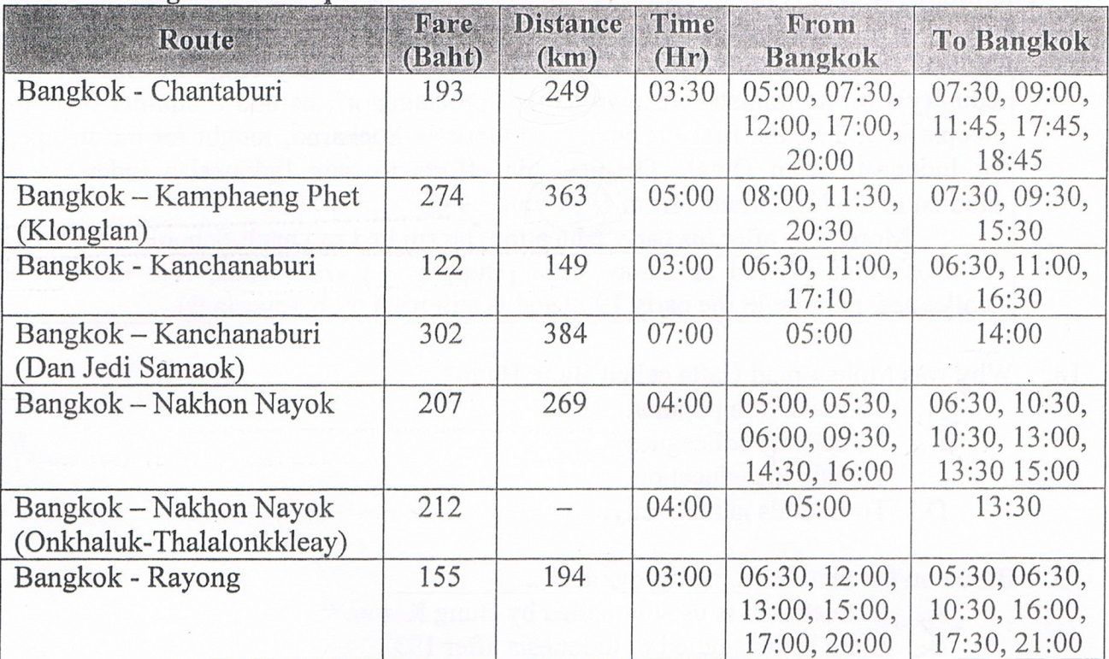
- The route that has thee earlies tim to Bagkok is .........
A. Bangkok - Chantaburi
B. Bangkok - Rayong
C. Bangkok - Kanchanaburi
D. Bangkok - Kamphaeng phet

- The timetable showed that ………….
A. the route Onkhaluk - Thalalorikkleay, has one trip
B. there are eight routes from Bangkok to other cities
C. the longest distances is Bangkok - Chantaburi
D. the cheapest fare is route Bangkok - Rayong

The following text is for questions 24 to 26.
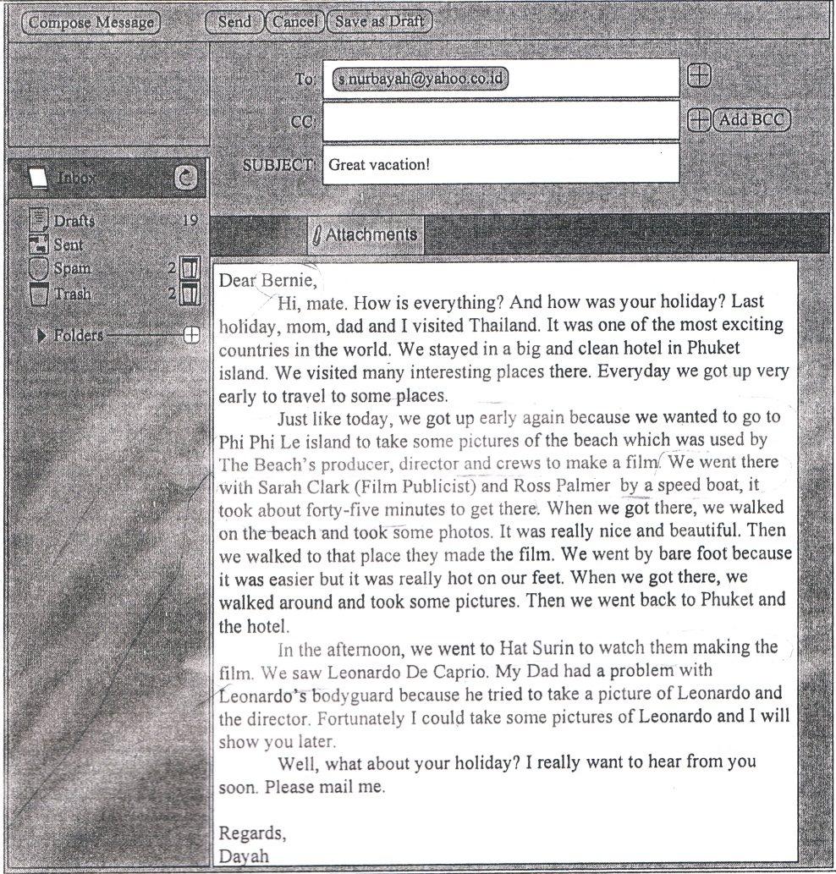

- The text tells us about ………
A. A film by Leonardo Di Caprio
B. Dayah's great holiday in Thailand
C. Bernie's great holiday in Thailand
D. the beauty of Phi Phi Le island

- With whom did the writer and her family go to Phi Phi Le island?
A. The crews.
B. The director.
C. The producer.
D. The parents.

- What did Leonardo do at Phi Phi Le island?
A. He had vacation with his family.
B. He was involved in a film production.
C. He visited some beautiful beaches.
D. He had discussion with movie producer.

The following-text is. for questions 27 to 30.
Garuda Wisnu Kencana or GWK Culture Park is a tourist destination statue of Lord Vishnu Located on Jl. Raya Uluwatu, Jimbaian Village, Badung Regency of Bali Province. It is just 25 minutes away from Denpasar airport or Nusa Dua.
Garuda Wisnu Kencana is a prestigious project built in Bali with a 150-meter-ta1l statue that was planned to be the center of International events of performances, exhibitions, and others.

- Where is the big statue located?
A. In Jimbaran Village.
B. In Nusa Dua district.
C. Near Denpasar airport.
D. In exhibition center.

- GWK considered as prestigious project because.
A. it is planned to be the center of international events
B. it has 150 -meter- tall Lord Vishnu Statue
C. it is a tourist destination in Bali island
D. it is visited by many foreign tourists

- What is the first paragraph about?
A. GWK is a tourist destination in Bali.
B. Badung regency is a tourist destination.
C. Denpasar airport has strategic location.
D. A prestigious project is built in Bali.

- "Garuda Wisnu Kencana is a prestigious project built in Bali..." (paragraph 2)
The underlined word means ………
A. different
B. famous
C. common
D. reputable

The following text is for questions 31 to 34.
In the days when an a soda float costed less, a 9 year old girl entered a coffee shop and sat at a table. A waiter put the menu in front of her.
"How much is a soda float?"
"One dollar," replied the waiter.
The little girl pulled her hand out of her cute little pink purse and studied a number of coins in it.
"How much is a bottle of soda?" she inquired. Some people were now waiting for a table and the waiter was a bit impatient.
"75 cents," he said brusquely.
The little girl again counted the coins. "I'll have a bottle of soda," she said. The waiter brought the soda bottle, put the bill on the table and walked away. The girl finished the soda, paid the cashier and departed.
When the waiter returned, he began wiping down the table and then swallowed hard at what he saw. There, placed neatly beside the empty dish, were 25 cents - his tip

- Why did the waiter swallow hard?
A. The girl didn't have enough money.
B. He drank a bottle of soda.
C. He drank a soda float.
D. The girl left tip for the waiter.

- The main idea of the last paragraph?
A. The girl cleaned the table patiently.
B. The girl left her tip for the waiter.
C. The waiter swallowed the soda hard.
D. The waiter left an empty dish.

- What can we learn from the story?
A. Never underestimate other people.
B. Surprises happen anywhere.
C. Be patient in serving other people.
D. Be kind to other people.

- "... and studied a number of coins in it" (Paragraph 2) The underlined word refers to
A. the menu
B. coffee shop
C. the purse
D. the girl's hand

The following text is for questions 35 to 38.
How to Make Mango Juice

Materials:
- Some mangoes
- a half glass of water
- a glass of iced cube
- a spoon of sugar
- 3 spoons of condensed milk

Procedures:
First, peel the mango and clean it. Next, cut the mango, into pieces and put them into the juicer. Then, put the water, ice, sugar, and milk. After that, turn on the juicer and wait about 15 seconds.
Finally, pour the mango juice into the glass and it ready to be served.

- What should we do before we put the mango into the juicer?
A. Pour the mango juice into the glass.
B. Add water, ice, sugar, and milk.
C. Cut them into pieces.
D. Turn on the juicer.

- What ingredient do we need as much as 3 spoons?
A. Sugar.
B. Water.
C. Iced Cube.
D. Condensed milk.

- "First, peel the mango and clean it."
What is the synonym of the underlined word?
A. Wash
B. Dry
C. Slice
D. Cut

- "... and put them into the juicer." (Step 2)
The underlined word refers to…………..
A. sugar and mango
B. ice and water
C. sugar and milk
D. pieces of mango

The following text is for questions 39 to 42.
Gardenia plants are popular for the strong sweet scent of their flowers. Gardenia is the national flower in Pakistan. In Japan and China, the flower is called Kuchinashi (Japanese) and Zhi zi (Chinese).

Gardenia plants are evergreen shrubs. Their small trees can grow to 1 - 5 meters tall. The leaves are 5 - 50 centimeters long and 3 —25 centimeters broad, dark green and glossy with a leathery texture. The flowers are in small groups, white, or pale yellow, with 5-12 lobes (petals) from 5-12 centimeters diameter. They usually bloom in mid- spring to mid-summer. Many species have strong aroma.

To cultivate gardenia as a house plant is not easy. This species can be difficult to grow because it originated in warm humid tropical areas. It demands high humidity and bright (not direct) light to thrive. It flourishes in acidic soil with good drainage and thrives on 20°— 23° C during the day and 150 - 16° C in the evening. Potting soils developed specifically for gardenias are available. It grows no larger than 18 inches in height and width when grown indoor. In climates where it can be grown outdoors, it can reach the height of 6 feet. If water hits the flowers, they will turn brown.

- How tall is a gardenia tree?
A. 3-25 cm.
B. 5-12cm.
C. 5-50cm.
D. 1-5m.

- What is the main idea of the last paragraph?
A. It is easy to plant a gardenia tree.
B. A gardenia plant needs high humidity.
C. It's not easy to plant gardenia as a house plant.
D. A good drainage is important for gardenia plant.

- From the text we know that
A. people don't like the strong scent of flower
B. Gardenia is widespread in Asia
C. the flower is easy to plant
D. the flower is expensive

- "... because it originated in warm ..." (paragraph 3, line 10)
The underlined word refers to …………
A. the flower
B. the species
C. the soil
D. the leaf

The following text is for questions 43 to 45.
AUDITIONS
for
"PROOF"
A Play in Two Act
by David Auburn
Winner of the 2001 Pulitzer Prize
and Tony Award for BEST PLAY
WEDS. Sept. 7th
THURS. Sept 8th
McDoweil High Auditorium
3:30 pm to 5:00 pm
Open to any McDowell
County Student grades 9 thru 12

No prepared text needed

- What does the text about?
A. Search for a movie actors.
B. The winner of Pulitzer Prize
C. The audition for Proof play.
D. McDowell School auditorium.

- Which statement can be found in the text?
A. The audition is only for students grade 12.
B. The students can bring the texts with them.
C. David Auburn is the winner of 2001 Pulitzer Prize.
D. McDowell won the Tony Award for Best Play.

- Thomas Edison (46) ….. two thousand different materials in search of a proper filament for the light (47) ...... His assistant complained, "Alt our work is useless Edison replied (48) ….. "Oh we have come a long way and we have learned a lot. We know that there are two thousand elements which we cannot use to make a good light bulb.

- A. brought
B. tried
C. played
D. showed

- A. baloon
B. flash
C. bulb
D. glass

- A. surprisingly
B. accidentally
C. perfectly
D. confidently
- Arrange the sentences bellow into a correct paragraph.
- We left our house at about 5 o'clock in the morning. We took a taxi to the railway station.
- Finally our train came. All of us rushed to get on the train.
- Last Lebaran, my family and I went hometown. We decided to take a train because it is more comfortable.
- It took about 5 to 7 hours to get to our hometown. We enjoyed our journey.
- We took the carriage no 3 according to our tickets.
- But without any prior information, our train was late for about fifteen minutes, so we had to wait a bit longer.
- After finding our seats we could sit comfortably.
- We arrived at the station at six. Our train would leave at 6.40.

A. 3-8-6-4-5-1-2-7
B. 3-4-5-8-1-2-6-7
C. 3-1-8-6-2-5-7-4
D. 3-5-4-2-7-8-1-6

- This text is for the following question.
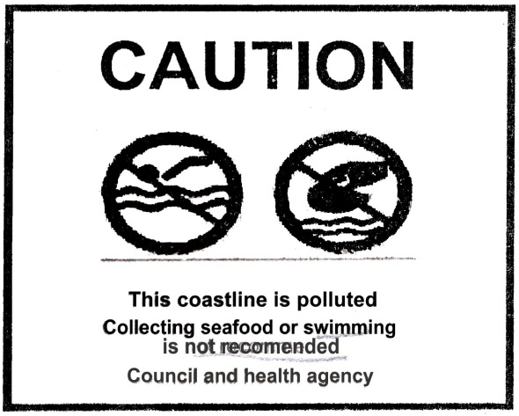

What does the warning above mean?
- The visitors are not forbidden 10 collect seafood.
- You are prohibited to swim at the polluted beach
- The coastline is not dangerous to collect seafood.
- You cannot swim alone the beach.

