SOAL : 18 | Bahasa Inggris SMP/MTs

- Arrange the following sentences into a good paragraph.
- The place made me feel at home but I had to go home.
- After that I went to Lamongan.
- Then I went to Sidoarjo.
- I visited the famous Jatim Park.
- It had become famous for its mud.
- Last summer, I got a fantastic holiday.
- Next time, I would return to see more of them.
- I went to the airport and I flew to Surabaya.

A. 6-8-3-5-2-4-1-7
B. 8-6-3-4-5-1-7-2
C. 3-8-6-5-2-7-1-4
D. 3-6-8-4-5-2-7-1

The following text is for questions 2 and 3.

- The text shows us that Western Electronics ... certain electronic products.
A. repairs
B. sells
C. buys
D. displays

- If you need western Electronic's service, .....
A. you ought to bring your warranty
B. you should buy a TV set from them
C. you can e-mail them
D. you cannot call them

For questions 4 to 6, choose the most suitable words to fill in the blanks.
Samosir, approximately 50 km long and 15 km wide, is an island in Lake Toba and almost as big as Singapore. It is often described as the heart of Batak (4) …… Samosir is a perfect place to relax and cool down. It is beautiful and scenic and very relaxing. Accommodation is extremely (5) ….... but the food is rather expensive. The island is small enough to wander about or you can choose to lie in a hammock (6).....

- A. village
B. culture
C. hometown
D. costumes

- A. dear
B. easy
C. cheap
D. difficult

- A. completely
B. simply
C. easily
D. comfortably

The following text is for questions 7 and 8.
STUDENT ORGANIZATION OF SMP NEGERI 4
Jl. Samoja 5 Bandung 40275 Tlp. 022-7312394

To: Fino of class 11B

Would you please attend our meeting that will be held:
• Day/date : Saturday, Match 11th 2013
• Time : 11 a.m.
• Place : Multimedia room
• Agenda : Final Preparation for Wall Magazine Competition 2013

Please come on time, see you there!

Andy Devina
Chairperson Secretary

- From the text, we know that ……….
A. the meeting is held in Jl. Samoja, Bandung
B. the meeting will discuss about Multimedia Room
C. Fino is expected not to be late in the meeting
D. Devina is the chairperson of the student organization

- “…. se you there.”
The underlined word refer to ……
A. Devina
B. Chairperson
C. Fino
D. Andi

The following text is for questions 9 to 13.
The Bangkok Tuk Tuk (pronounced took-took) is probably every visitor's favorite means of transport. They have an undeniable appeal and quality that makes them irresistible to everyone who come to Bangkok or Thailand.
The Tuk Tuk is a three wheeled, motorized rickshaw and can seat two adults comfortably, but it is common to see 6 to 7 students crammed in it. All of them share the fare.
Bangkok Tuk Tuks are a great way of traveling short distances if you are not expecting any sightseeing along the way. We say this because the canopy hat covers the Tuk Tuk slants downwards towards at exactly eye level so that the passengers are losing their chances to see what is going on around unless one sits on another person's lap.

- The text is about
A. Tuk-tuks in Bangkok
B. Bangkok traditional transportation
C. all means of transportation in Bangkok
D. visitors' favorite transportation

- How many grown-ups can be carried restfully in a tuk-tuk?
A. One.
B. Two.
C. Six.
D. Seven.

- Passengers of tuk-tuk cannot set, what is going on around them, because …….
- the covers of tuk tuk slant downwards
- their positions during the journey is great
- the sight along the way is not good enough
- their views are blocked by tuk tuk's canopy

- What is the first paragraph about?
A. The reason why tourists like tuk-tuk in Bangkok.
B. Quality that makes Bangkok irresistible for people.
C. The undeniable transportation that all Thai people like.
D. The visitors use tuk-tuk as a means of transportation.

- From the text, we know that tuk-tuk ………
A. doesn't attract visitors to travel with it
B. is a good transportation for all journeys
C. is one of students' favourite transports
D. is the only way for sightseeing in Bangkok

The following text is for questions 14 to 17.
Once upon a time, Roro Anteng and Joko Seger lived on the foot of Mount Bromo. After six years of marriage, they had not had any children. They prayed, pleaded to Gods for children. Their prayer was granted in one condition. They should sacrifice their youngest son to the Bromo crater.
After sometime, Roro Anteng gave birth to a child, and it happened every year until they had 25 children. They lived happily and forgot about the agreement. The mount Bromo erupted signaling that the Gods asked the couple to fulfill their promise. But they didn't want their youngest son, Raden Kusunia, to be sacrificed to the crater.
Raden Kusuma learned about the deal his parents had made. Meanwhile the lava from the crater had made the people living near the mountain suffered. Since Raden Kusuma was a kind and noble man, be didn't want his siblings and other people suffered because of him. Therefore he went to Mount Bromo and sacrificed himself to the crater. The eruption suddenly stopped.
After that day, the Tengger people have given offerings to the crater, as Raden Kusuma had sacrificed himself before.

- Why did Roro Anteng and Joko Seger have to sacrifice their youngest son?
A. The youngest son was a noble man.
B. The son could stop the, eruption.
C. They have promised to do that.
D. They have 25 children already.

- What is the main idea of paragraph?
A. The eruption of the mount stopped instantly.
B. Raden Kusuma sacrificed himself.
C. The crater of mount Bromo was dangerous.
D. Raden Kusuma made people angry.

- The text shows that Roro Anteng and Joko Seger....
A. really loved Raden Kusuma
B. disliked their youngest son
C. let their son kill himself
D. agreed to their son's behavior

- The moral of the story is ....
A. keeping our promise is unnecessary
B. parents must not promise to do anything
C. all parents love their children
D. we have to fulfill our promise

Read the text and answer questions 18 to 21.
Picasso was one of the most outstanding and important artists of the 1900's. He was best known for his paintings. Almost every style in modern art was represented in Picasso's works.
Picasso was born in 1881 in Malaga, Spain, as the son of an art teacher. He studied painting with his father and also in Madrid.
From 1895 to 1901, he painted realistic works in a traditional style. Then he entered what was called the Blue period. During this time, he only used shades of blue in his paintings to show poverty in Barcelona.
After 1907, he entered the style of cubism. Among his well-known cubist paintings are "The Three Musicians" and "The man with a guitar" which depicted the destruction of Spanish town. Picasso died in France in 1973.

- Picasso used shades of blue in his painting during the Blue Period, because ……….
A. he was sad to live in a traditional Barcelona
B. the blue was to show poverty in Barcelona
C. the blue represented modern art of this painting
D. blue was Picasso's favorite color in his paintings

- From the text, we know that ………….
A. Picasso used his paintings to describe his environment
B. Picasso loved listening to the music and playing guitar
C. Picasso was born, raised, and died in Malaga, Spain
D. Picasso only used blue paint in all his paintings

- What is the main idea of paragraph three?
A. Picasso used shades of blue in his paintings.
B. Picasso died in France on 1973.
C. Picasso was born in Malaga, Spain.
D. Picasso was taught by his father.

- "... which depicted the destruction of Spanish town." (Paragraph 4)
The underlined word has the same meaning as …………..
A. drawed
B. described
C. painted
D. presented

The following text is for questions 22 and 23.
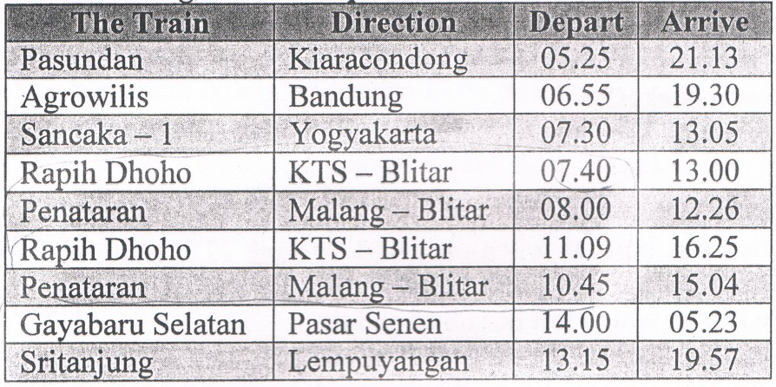

- Which train leaves after Rapih Dhoho train?
A. Sritanjung.
B. Argowilis.
C. Penataran.
D. Pasundan.

- Which train arrives in the morning?
A. Pasundan.
B. Rapih Dhoho.
C. Gayabaru Selatan.
D. Sancaka-1.

The following text is for questions 24 to 26.
Dear Nancy,

We are having a great a holyday here on the Gold Coast. Yesterday we went to the Movie World.
When we got up in the morning, it looked like rain. After a while the cloud disappeared and it became a sunny day. Then we decided to go to the Movie World.
The first ride I went on was Lethal Weapon. Next, I watch I Police Academy show. After that I had lunch because I was really hungry. Meanwhile, Mum and Kelly queued for the Batman ride.
About one o'clock, we got a light shower of rain but it cleared up soon after. Then we went on all the other rides.
It was a top day. See you when you get back.

Love,
Sam

- What does the text tell you about?
A. The Gold Coast.
B. The Movie World.
C. Sam's holiday.
D. The shower of rain.

- Where did Sam spend all his holiday with his family?
A. In the Movie World
B. On the Gold Coast.
C. In Lethal Weapon ride.
D. At the Police Academy.

- Why did they decide to go to the Movie World?
A. They were really hungry.
B. It was a sunny day.
C. It was a rainy day.
D. They woke up early.

This text is for the following question 27 to 30.
Machu Pichu, Peru;
Machu Picchu in Peru. which means 'old peak' is one of the most enigmatic ancient sites in the world. According to legend, Machu Picchu was a sacred place. The extraordinary city was created by Incas people. They erected many stones structured and turned the place into a work of art.
Two thousand feet above the Lirubamba river, these ruins consist of baths, temples and about 150 houses, all very well preserved. These gray 'granite structures, some of which more than 50 tons, are perfectly sculpted that they are nothing less than works of architectural genius. They were rediscovered by a Yale archeologist in 1911. The ethereal beauty, workmanship, and history of the place attract millions of tourists each year.

- What can we see in Machu Picchu in Peru?
A. Granite structure.
B. Beautiful scenery.
C. Inca people
D. Ancient statues.

- Which one of the following is stated in the text?
A. Only the history of the place attracts millions of tourist each year.
B. According to the legend, Machu Picchu was considered to be a sacred place.
C. All the gray granite structures are more than 50 tons weigh.
D. The granite structure was discovered by a Yale archeologist recently.

- What is the main idea of paragraph two?
A. The scenery is very attractive.
B. The description of Machu Picchu.
C. Machu Picchu is a sacred place.
D. The temples were discovered in 1911.

- "... one of the most enigmatic ancient sites." (paragraph 1)
The underlined word has similar meaning with……
A. ugly
B. new
C. old
D. recent

The following text is for question 31 to 34.
Sand and Stone

Ikhwan and Arif were walking through the desert. During some point of the journey, they had an argument and Ikhwan slapped Arif in the face. Arif was hurt, but he said nothing and wrote in the sand : "TODAY MY BEST FRIEND SLAPPED ME IN THE FACE."
They kept on walking and finally found an oasis. They decided to take a bath. Suddenly, Arif slipped on moss, hit his head and started drowning, but Ikhwan saved him. After Arif gained his consciousness, he carved on a stone" "TODAY MY BEST FRIEND SAVED MY LIFE."
Ikhwan asked Arif, "After I hurt you, you wrote in the sand and now, you carved on a stone, why ?
Arief replied, "when someone hurt us, we should write it down in sand where winds of forgiveness would blow it away and when someone does something good for us, we must engrave it in stone where no wind can ever erase it.

- Why did Arif carve on a stone? Because ……………
A. they have an argument
B. his friend had hurt him
C. he wanted to forget it
D. he wanted to remember it

- What is the main idea of the second paragraph?
- They kept on walking until they found an oasis.
- Arif slipped on moss and started drowning.
- They slipped on moss and started drowning.
- They like to write on the stone and sand. ..

- What can you learn from the text above?
A. Forgive people and remember one's kindness
B. Learn to carve your benefits in stone
C. Learn to write your hurts in the sand
D. Do everything well for everyone

- "…….... but Ikhwan saved him.” (paragraph 2)
The underlined word refers to …………
A. the friend of the writer
B. the friend who saved his friend
E. the one who had been slapped
D. one of the reader's friends

The following text is for questions 35 to 38.
A Basic Recipe for Fried Rice
Ingredients:
    - 2 large eggs
    - 1 teaspoon salt
    - salt and pepper to taste
    - 4 tablespoons cooking oil or as needed
    - 3 cups cooked rice
    - 1 - 2 tablespoons light soy sauce or oyster sauce, as desired

Steps:
  - Lightly beat the eggs with salt and pepper.
  - Heat a wok and add 2 tablespoons of cooking oil. When the oil is hot, pour the eggs. Stir, until it is lightly scrambled but not too dry. Remove the eggs and clean out the wok.
  - Add another 2 tablespoons of cooking oil. Add the rice and stir-fry for a few minutes, using a wooden1spatula. Put soy sauce as desired.
  - Add the scrambled egg back into the pan. Mix thoroughly. Serve hot.

- How should you serve the fried rice best? By...
A. adding the scrambled egg.
B. stirring it for a few minutes.
C. adding 2 tablespoons oil.
D. serving the fried rice hot.

- How much rice do we need in this recipe?
A. 1 teaspoon.
B. 2 tablespoons.
C. 3 cups.
D. 4 tablespoons.

- "Lightly beat the eggs...". (step 1)
The underlined word means...
- crack
- mix
- fry
- cook

- "... until it is lightly scrambled ..." (step 2)
The underlined word refers to....
A. oil
B. salt
C. rice
D. egg

The following text is for questions 39 to 42.
Gardenia plants are popular for the strong sweet scent of their flowers. Gardenia is the national flower in Pakistan. In Japan and China, the flower is called Kuchinashi (Japanese) and Zhi zi (Chinese).

Gardenia plants are evergreen shrubs. Their small trees can grow to 1 - 5 meters tall. The leaves are 5 - 50 centimeters long and 3 —25 centimeters broad, dark green and glossy with a leathery texture. The flowers are in small groups, white, or pale yellow, with 5-12 lobes (petals) from 5-12 centimeters diameter. They usually bloom in mid- spring to mid-summer. Many species have strong aroma.

To cultivate gardenia as a house plant is not easy. This species can be difficult to grow because it originated in warm humid tropical areas. It demands high humidity and bright (not direct) light to thrive. It flourishes in acidic soil with good drainage and thrives on 20°— 23° C during the day and 150 - 16° C in the evening. Potting soils developed specifically for gardenias are available. It grows no larger than 18 inches in height and width when grown indoor. In climates where it can be grown outdoors, it can reach the height of 6 feet. If water hits the flowers, they will turn brown.

- How tall is a gardenia tree?
A. 3-25 cm.
B. 5-12cm.
C. 5-50cm.
D. 1-5m.

- What is the main idea of the last paragraph?
A. It is easy to plant a gardenia tree.
B. A gardenia plant needs high humidity.
C. It's not easy to plant gardenia as a house plant.
D. A good drainage is important for gardenia plant.

- From the text we know that
A. people don't like the strong scent of flower
B. Gardenia is widespread in Asia
C. the flower is easy to plant
D. the flower is expensive

- "... because it originated in warm ..." (paragraph 3, line 10)
The underlined word refers to …………
A. the flower
B. the species
C. the soil
D. the leaf

The following text is for questions 43 to 45.
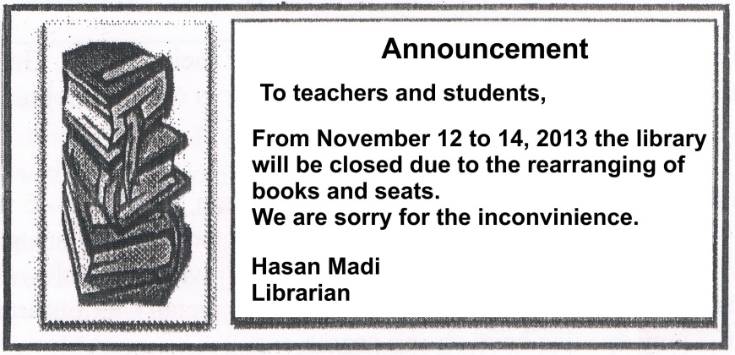

- The text tells us about
A. the librarian's books and seats
B. the renovation of the library in November.
C. the temporarily closing of the library
D. the librarian's inconvenience

- Why is the library closed?
A. The librarian will have vacation.
B. There have been some inconveniences.
C. The students will arrange the books.
D. The books will be rearranged.

- "...we are sorry for the inconvenience"
The underlined word is similar in meaning to
A. disruption
B. inappropriacy
C. unsuitability
D. difficulty

For questions 46 to 48, choose the correct words to complete the text.
Yesterday was a terrible day for me. I ….. (46) up late. So I went to school in a hurry. I rode my ….. (47) fast so that I could come on time to school. I arrived at school as soon as the bell rang. However, when the teacher asked us to submit our homework, I remember that I left mine at home. To prove my word, the teacher asked me to give the homework ….. (48) after school. So, when the bell rang, I went back home to get my homework.

- A. picked
B. stood
C. woke
D. took

- A. ponny
B. bike
C. feet
D. cart

- A. accidently
B. correctly
C. directly
D. finally,

- Arrange the sentences bellow into a correct paragraph.
- We left our house at about 5 o'clock in the morning. We took a taxi to the railway station.
- Finally our train came. All of us rushed to get on the train.
- Last Lebaran, my family and I went hometown. We decided to take a train because it is more comfortable.
- It took about 5 to 7 hours to get to our hometown. We enjoyed our journey,
- We took the carriage no 3 according to our tickets,
- But without any prior information, our train was late for about fifteen minutes, so we had to wait a bit longer,
- After finding our seats we, could sit comfortably.
- We arrived at the station at six. Our train would leave at 6.40,

A. 3-8-6-4-5--1-2-7
B. 3-4-5-8-1-2-6-7
C. 3-1-8-6-2-5-7-4
D. 3-5-4-2-7-8-1-6

- This text is for the following question.
CAUTION
Unpredictable Waves and Currents, Rocks and
Coral in Water May Be a Hazard
Dangerous Shorebreak

SWIM AT YOUR OWN RISK

What does the caution above mean?
A. Swimming in the area is dangerous.
B. The swimming activity causes no risk.
C. The wave in the area is unpredictable.
D. Rocks and coral can be found in the area.

