SOAL : 10 | Bahasa Inggris SMP/MTs

- Arrange these sentences below into a good paragraph.
1. He had booked one week tour.
2. Mr. Adiputra's family was on vacation
3. They went to Bali
4. That included accommodation and tour around Bali
5. They boarded a large Airbus.
6. They had a very pleasant flight.
7. He booked four tickets at the travel agent.
8. On the plane the cabin crews gave them food and drink.

A. 1-4-5-8-6-2-3-7
B. 2-3-7-1-4-5-8-6
C. 7-2-3-8-4-6-5-1
D. 3-7-1-4-5-8-6-2

The following text is for questions 2 and 3

- What does the AMSEC EST Series Safety box have?
A. Finger print safe.
B. Featuring Card.
C. Biometric Lock.
D. Touch Screen Lock

- Which one of the following information is found in the ads?
A. None of the AMSEC Safety boxes has biometric lock.
B. AMSEC Safety box of IRC 1412 has electronic lock.
C. AMSEC Biometric Lock cannot be installed on most AMSEC Safety.
D. The new AMSEC EST Series Safes have electronic lock.

For questions 4 to 6, complete the text with the correct word.
The island, of Sangalaki in Kalimantan was opened for diving in 1993. Its shallow reef system extends over 200 meters from the (4) ...... It is (5) ..... as Indonesian Marine Park. The island is also a breeding ground for green turtles. At night female turtles come ashore and lay their eggs. Baby turtles hatch and they (6) ... struggle their way to the sea while avoiding hungry birds.

- A. land
B. island
C. continent
D. archipelago

- A. boring
B. famous
C. luxurious
D. uninteresting

- A. lazily
B. carelessly
C. differently
D. desperately

The following text is for questions 7 and 8.
Dear Andy,

You and one of your friends are invited to attend Alice Corbet's 15th birthday

At the Cocino Green House
On August 24th 2013 at 7.00 PM;

RSVP.
Ilham. HP 03124964286

- What should the invitee do to come to the party?
A. Do not ask other person to join the party.
B. Call Ilham to confirm their coming.
C. Bring capucino drink to the party.
D. Come to the party in the morning.

- The word "you" in the text refers to the ... of the invitation.
A. sender
B. addressee
C. maker
D. writer

The following text is tor questions 9 to 13.
The Boeing 787 Dreamliner is a long-range, mid-size wide body twin engine-jet airliner developed by Boeing Commercial Air Planes It seats 210 to 290 passengers. It is the most fuel-efficient airliner. It consumes- 20 % less fuel than similarly size 767. It shares with larger 777.
The aircraft's initial designation was 7E7, prior to its renaming in January 2005. The first 787 was unveiled in a roll-out ceremony on July 8, 2007, by which time it had reached 677 orders. By October 2011, the 787 program had logged 873 orders from 57 customers.
The 787 developments and production have involved a large-scale collaboration with numerous suppliers around the globe. Final assembly is at Boeing Everett factory in Everett, Washington. Assembly is also taking place at a new factory in North Charleston, South Carolina.

- What is the text about?
- Boeing 7E7
- Boeing 787
- Boeing 777
- Boeing 767

- How many passengers can 787 seat?
- 57
- 290
- 677
- 873

- The 787 airliner is called the most efficient plane because………..
A. it needs 20 % less fuel than the others
B. it has a small body and twin engine
C. there is many customers who want to buy it
D. it involves a large-scale collaboration

- The first paragraph tells us about ... of 787 Dreamliner.
A. the selling price
B. the description
C. the number
D. the fuel consumption

- From the text, we know that
A. the plane is not for commercial service
B. it has reached 677 orders in October 2011
C. it is the biggest plane in world
D. 787 assembly is not only in Everett

The following text is tor questions 14 to 17.
One day, Rahwana kidnapped Sinta and took her to his palace in Alengka. Rama was so sad. He tried many efforts to save his wife. He sent his best troops to search for his beloved wife but Sinta remained unfound.
After four months, Hanoman, the king of white monkeys found Sinta's crown in the bushes. It was a clue that led them to Alengka. Rama thanked his best friend, Hanoman, and soon they went to Alengka with thousands of troops.
The battle was unavoidable. Rahwana's troops were very powerful giants. They made many of Rama's soldiers wounded. The battle took two months. Yet, after Rama got involved in the battle, the problem solved. It was also because of Rama's power. Rahwana, the very powerful king of giants was killed.
Rama was so happy to see his beloved wife. They returned to Ayoda and lived happily forever.

- Rama thanked Hanoman because
A. he wanted to go to Alengka
B. he found Shinta's crown
C. he killed thousands of troops
D. he told him an important secret

- What is the main idea of the second paragraph?
A. Hanoman found a clue of Sinta existence.
B. Rama got his wife's crown in the bush.
C. Alengka had thousands of troops to fight.
D. The king of white monkey went to the bushes.

- From the text, we know that.
A. Rahwana killed a lot of Rama's troops
B. it took months for Rama to kill Rahwana
C. Rahwana's troop could not be defeated
D. Rama was more powerful than Rahwana

- What is the moral value of the story?
A. All husbands love their wives very much.
B. A good friend brought happiness into our lives.
C. One must save his/her endanger beloved one.
D. A husband must be powerful to defeat evil.

The following text is for questions 18 to 21.
Dr. Mohammad Haifa was born in Bukittinggi, West Sumatera, Dutch East Indies (now Indonesia). He was Indonesia's first Vice President, later also served as the country's prime minister. Known as the 'proclamator', he and a number of Indonesian people including the first President of Indonesia Soekarno, fought for the independence of Indonesia from Dutch. Despites his efforts to gain Indonesian independence, he studied in the Netherlands from 1921 until 1932.
Moreover, after his early education, he studied in Dutch Schools in Indonesia. He is more remembered as Bung Hatta (Bung is an affectionate title used to address colleagues. popular in the early 1900 and is still used by Indonesians).

- Why was Mohammad Haifa called Bung Hatta?
A. To make him popular.
B. To address colleagues.
C. To gain his education.
D. To find his name easily.

- Based on the text above, we know that….
A. Jr. Soekamo is usually called by Bung Karno
B. Bung Haifa studied in Indonesia after 1932
C. Bung Karno and Bung Haifa were close friends
D. Bung Hatta was the first President of Indonesia

- The first paragraph is about.
A. A short biography of Dr. Mohammad Hatta
B. The struggle of Mohammad Haifa against the Dutch
C. The education of Mohammad Haifa in Dutch School
D. The story of the struggle of Indonesian people

- "Known as the ‘proclamator', he..." (paragraph 1)
The underlined word means a person who …………
A. announces officially and publicly
B. is popular in Indonesia
C. helps President duty
D. leads a country and nation

The following text is for questions 22 and 23.
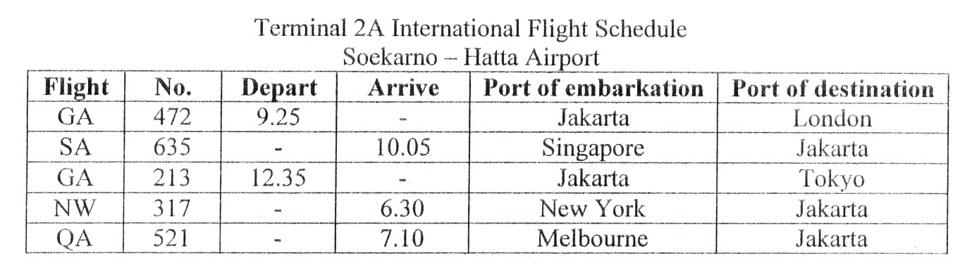
- Which Flight departs from New York?
A. SA 635
B. GA 472
C. NW 317
D. QA 521

- Based on the text, ... comes to Jakarta earliest of all the flights.
A. GA 472
B. NW 317
C. QA 521
D. SA 635

The following text is for questions 24 to 26.
Jl. Kebon Kopi No 17, Jambi
July 6th, 2013

Dear Amy,
My family and I went on trip to Solo. We went on Monday by car and stayed at my grandparents' house.
On Tuesday we went to Tawangmangu. We enjoyed the scenic view of its waterfall and had lunch there. They served traditional cuisine like wedang ronde, tempe bacem, fried fish, and fried chicken. After that, we continued our journey to Taman Jurug.
The next day we went to Kasunanan Palace. We saw a lot of historical heritages in the palace. After that, we went shopping to Klewer market and Solo Grand Mall. I bought some souvenirs for my cousins. In the evening, we went sightseeing the town.
On Thursday morning, we said goodbye to our grandparents and went home. I really enjoyed my holiday. It was fun. Do come over and have a look sometime.

Love,
Lia

- What does the text tell you?
A. Traditional cuisines of Solo.
B. Lia's grandparents' house.
C. The Kasunanan Palace.
D. Fun holiday in Solo.

- Where did Lia go on Wednesday?
A. Taman Jurug
B. Tawangmangu
C. Grandparents' house
D. Kasunanan Palace

- From the text, we know that the writer
A. stayed in a hotel with her grandparents
B. went shopping to Klewer market on Tuesday
C. saw many kinds of historical heritage on Wednesday
D. drove her grandparents' home on Thursday morning

The following text is for questions 27 to 30.
It's like a zoo but the animal are not caged. Giraffes, monkeys, hippopotamus, even lions and tigers wander around freely. Perhaps you may think, what if these animals attack? No, they won't, because you look at them from inside your car or bus. Here, it is the difference. At the zoo, the animals are locked in the cage. At the Safari Park you are the ones locked inside your vehicle.

- What are usually locked in a cage?
A. Visitors
B. Officers
C. Animals
D. Readers

- Why the animals cannot attack the visitors?
A. The animals are always fed everyday.
B. The animals are well locked in the cage.
C. The visitors see animals from inside the car.
D. All the animals at the park are very tame.

- What is the main idea of the paragraph?
A. Animals at the Safari Park are not caged.
B. A zoo is the same as a Safari Park.
C. Wild animals wander freely at the park.
D. Visitors can see animals outside the car.
- "...even lions and tigers wander around freely" (line 2)
The underlined word means
A. live
B. rest
C. feed
D. move

The following text is for questions 31 to 34.
The Old Man and the Durian Tree
In a very quiet little village, lived an old man whose age was over 80 years old. He was planting a durian tree when a neighbor observed him. The neighbor asked the old man, "Do you expect to eat durian from that tree? The durian tree will take about 8 years to bear fruit."
The old man rested on his spade and smiled. He said, "No, at my age I know I won't. All my life I have been enjoying durians, but never from a tree I have planted before. I wouldn't have had durians if other men haven't done what I'm doing now. I am just trying to pay the other men who have planted durians for me." No wonder he looked so happy.
We should give first and can get something in return. We will not only get what we want but will actually be really happy in the end, because we need to sow first before we can reap.

- The neighbor wondered about the old man because.
A. the old man loved planting durian tree
B. he planted a tree that took time to bear fruit
C. the old man planted a tree to sell the fruit
D. the old man enjoyed eating durian so much

- Paragraph three mainly talks about?
A. The reason the old man planted the tree.
B. The neighbor wondered about the old man.
C. The neighbor asked question to the old man.
D. The old man made his neighbor observe him.

- What can we learn from the text?
A. We can reap after we sow.
B. Giving is better than getting.
C. Planting is a good activity.
D. Be a curious person in everything.

- "... when a neighbor observed him (paragraph 1)
The underlined word refers to…………….
A. the old man
B. the neighbor
C. the other man
D. the writer

The following text is for questions 35 to 38.
How to Make Patty Cakes

Ingredients:
- 3 tablespoons of butter
- ¼ cup castor sugar
- 1 egg
- ¼ teaspoon of vanilla
- 1 cup self-raising flour
- Pinch salt
- ¼ cup milk
- Butter icing

Methods:
1. Beat butter and sugar until creamy.
2. Add lightly egg and vanilla. Beat them well.
3. Sift flour and salt together.
4. Fold in dry ingredients alternately with milk. Mix well.
5. Drop heaped teaspoonful’s of mixture into well-greased patty tins or papers.
6. Bake in a moderately hot oven for 10 to 15 minutes.
7. Cool on wire rack. Then decorate it with butter icing.

- What is the last step you should do in making the cake?
A. Bake in a moderately hot oven for 10 to 15 minutes.
B. Ice with butter icing when the cakes are cool.
C. Beat butter and sugar to cream.
D. Sift flour and salt together.

- How much sugar do we need to make Patty cakes?
A. ¼ teaspoon.
B. 3 tablespoons.
C. ¼cup.
D. icup.

- "Fold in dry ingredients alternately with milk." (step 4)
The underlined word is similar in meaning to……….
A. add
B. drop
C. beat
D. mix

- "Beat them well." (step 2)
The word 'them' in the sentence refers to……….
A. butter and sugar
B. beaten egg and vanilla
C. cream, beaten egg and vanilla
D. beaten egg, vanilla, butter and sugar

The following text is for questions 39 to 42.
Gardenia plants are popular for the strong sweet scent of their flowers. Gardenia is the national flower in Pakistan. In Japan and China, the flower is called Kuchinashi (Japanese) and Zhi zi (Chinese).
Gardenia plants are evergreen shrubs. Their small trees can grow to 1 - 5 meters tall. The leaves are 5 - 50 centimeters long and 3 - 25 centimeters broad, dark green and glossy with a leathery texture. The flowers are in small groups, white, or pale yellow, with 5-12 lobes (petals) from 5 - 12 centimeters diameter. They usually bloom in mid- spring to mid-summer. Many species have strong aroma.
To cultivate gardenia as a house plant is not easy. This species can be difficult to grow because it originated in warm humid tropical areas. It demands high humidity and bright (not direct) light to thrive. It flourishes in acidic soil with good drainage and thrives on 20°— 23° C during the day and 150 - 16° C in the evening. Potting soils developed specifically for gardenias are available. It grows no larger than 18 inches in height and width when grown indoor. In climates where it can be grown outdoors, it can reach the height of 6 feet. If water hits the flowers, they will turn brown.

- How tall is a gardenia tree?
A. 3-25 cm.
B. 5-12 cm.
C. 5-50 cm.
D. 1- 5 m.

- What is the main idea of the last paragraph?
A. It is easy to plant a gardenia tree:
B. A gardenia plant needs high humidity.
C. It's not easy to plant gardenia as a house plant.
D. A good drainage is important for gardenia plant.

- From the text we know that…………..
A. people don't like the strong scent of flower
B. Gardenia is widespread in Asia
C. the flower is easy to plant
D. the flower is expensive

- "...because it originated in warm ..." (paragraph 3, line 10)
The underlined word refers to ………………
A. the flower
B. the species
C. the soil
D. the leaf

The following text is for questions 43 to 45.
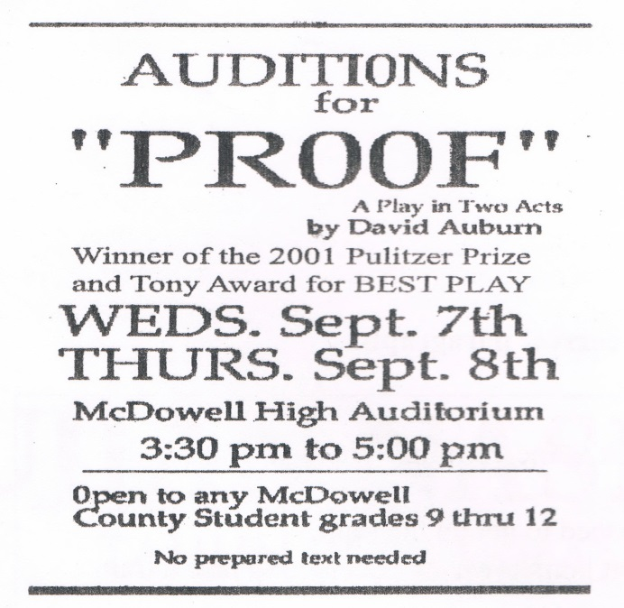

- What does the text about?
A. Search for a movie actors.
B. The winner of Pulitzer Prize
C. The audition for Proof play.
D. McDowell School auditorium.

- Which statement can be found in the text?
A. The audition is only for students grade 12.
B. The students can bring the texts with them.
C. David Auburn is the winner of 2001 Pulitzer Prize.
D. McDowell won the Tony Award for Best Play.

- "Tony award for best play"
The underlined word is similar in meaning to ……………
A. drama
B. game
C. theater
D. performance

For questions 46 to 48, complete the text with the correct word.
Ki Hajar Dewantara is named as Bapak Pendidikan Indonesia because of his brilliant ideas in Indonesian education. Although he was (46) ….. during colonial times, he had modem views. He also thought that everybody had the right to get (47) ..... He was also chosen as the minister of Indonesian education under President Soekarno's Administration. He did his job (48) ….. and was bestowed Bintang Mahaputra.

- A. worked
B. raised
C. studied
D. stayed

- A. ambition
B. education
C. independence
D. honesty

- A. simply
B. quickly
C. carelessly
D. responsibly

- Arrange the sentences bellow into a correct paragraph.
  - We left our house at about 5 o'clock in the morning. We took a taxi to the railway station.
  - Finally our train came. All of us rushed to get on the train.
  - Last Lebaran, my family and I went hometown. We decided to take a train because it is more comfortable.
  - It took about 5 to 7 hours to get to our hometown. We enjoyed our journey.
  - We took the carriage no 3 according to our tickets.
  - But without any prior information, our train was late for about fifteen minutes, so we had to wait a bit longer.
  - After finding our seats we could sit comfortably.
  - We arrived at the station at six. Our train would leave at 6.40.

A. 3-8-6-4-5-1-2-7
B. 3-4-5-8-1-2-6-7
C. 3-1-8-6-2-5-7-4
D. 3-5-4-2-7-8-1-6

- This text is for the following question.
CAUTION

Unpredictable Waves and Currents, Rocks and
Coral in Water May Be a Hazard
Dangerous Shore break

SWIM AT YOUR OWN RISK

What does the caution above mean?
A. Swimming in the area is dangerous.
B. The swimming activity causes no risk.
C. The wave in the area is unpredictable.
D. Rocks and coral can be found in the area.

