SOAL : 01 | BahasaInggris SMP/MTs

- Arrange these sentences below into a good paragraph.
1. It was long.
2. My holiday was great.
3. My family and I visited my grandparents.
4. We stayed at my grandparent's house for five days.
5. We did a lot of things together.
6. After that we ate them.
7. We traveled by car.
8. We cooked and prepared our meals.
A. 1-4-5-8-6-2-3-7
B. 1-3-7-2-4-5-6-8
C. 2-1-3-7-4-5-8-6
D. 1-7-3-4-5-6-8-2

The following text is for questions 2 and 3.

- What is preloaded into the phone?
A. Hindi movie
B. A user manual
C. Expandable memory
D. Service center directory

- How can people buy the item ?
- They should come directly to the shop.
- They can call, text, or send an e-mail.
- They contact the service center.
- They can leave a message for them

For questions 4 to 6, choose the correct words to complete the text !
My cat name is Pussy. She is a beautiful gray Persian cat. She has a small body and smooth (4) ........ She spends most of her time watching television, eating and growing (5) …….. Pussy is picky about her food, (6) ….... she refuses to eat food that does not suit her taste.

- A. fur
B. hair
C. feather
D. quill

- A. fat
B. fame
C. strong
D. smart

- A. hardly
B. rarely
C. seldom
D. usually

The following text is for questions 7 and 8.
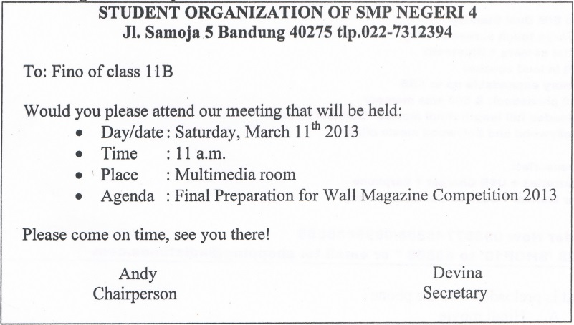

- From the text, we know that.
A. the meeting is held in Jl. Sainoja, Bandung
B. the meeting will discuss about Multimedia Room
C. Fino is expected not to be late in the meeting
D. Devina is the chairperson of the student organization
- “ …… see you there.”
The underlined word refers to …………
A. Devina
B. Chairperson
C. Fino
D. Andy

The following text is for questions 9 to 13.
Transjakarta is one of the Jakarta's mass transportation system. The problem with Transjakarta begins with the stations. The flat top steel and glass enclosures have no ventilation at all. By the time the bus arrives, you will be drenched in sweat. It's hard to imagine how one could design a bus station to be any more uncomfortable.
When the bus finally stops, it will be packed to the gills. A few, people may get off and a few may get on. If you are lucky enough to push your way on to the bus, you need to hang on, because it's like a sardine can. The buses are air conditioned, but it doesn't help much when the bus is over capacity. Pickpockets abound so you should be very careful with your belongings.
The best time to use the busway is between 10 a.m and 7 p.m on Sunday. There is a downloadable map on their website. The fare is Rp.3 .500 and there are no transfer fees.

- The text above tells us about ... Transjakarta.
A. the fare of
B. the station of
C. the problem of
D. the best time to use

- Where can we download the map of Transjakarta?
A. On their website.
B. In their buses.
C. At the bus stop.
D. At the bus station.

- Why does of Transjakarta's station become a problem?
A. It is made of steel and glass.
B. It has no ventilation at all.
C. It does not have good roofs.
D. It is in the shape of an enclosure.

- What does the second paragraph tell us?
A. The situation when the bus stops at the station.
B. The people on the station are packed to the gills.
C. The way passengers of the bus leave the station.
D. Many people like to get on and off the bus.

- From the text, we know that
A. Transjakarta provide a downloadable map on its website.
B. Transjakarta's station is very small but comfortable.
C. Riding Transjakarta during office hour is irresistible.
D. Transjakarta charges Rp. 3.500 for its transfer fee.

The following text is tor questions 14 to 17.
Once upon a time, RoroAnteng and JokoSeger lived on the foot of Mount Bromo. After six years of marriage, they had not had any children. They prayed, pleaded to Gods for children. Their prayer was granted in one condition. They should sacrifice their youngest son to the Bromo crater.
After sometime, RoroAnteng gave birth to a child, and it happened every year until they had 25 children. They lived happily and forgot about the agreement. The mount Bromo erupted signaling that the Gods asked the couple to fulfill their promise. But they didn't want their youngest son, RadenKusuma, to be sacrificed to the crater.
RadenKusuma learned about the deal his parents had made. Meanwhile the lava from the crater had made the people living near the mountain suffered. Since RadenKusuma was a kind and noble man, he didn't want his siblings and other people suffered because of him. Therefore he went to Mount Bromo and sacrificed himself to the crater. The eruption suddenly stopped.
After that day, the Tengger people have given offerings to the crater, as RadenKusuma had sacrificed himself before.

- Why did RoroAnteng and JokoSeger have to sacrifice their youngest son?
A. The youngest son was a noble man.
B. The son could stop the eruption.
C. They have promised to do that.
D. They have 25 children already.

- What is the main idea of paragraph 3?
A. The eruption of the mount stopped instantly.
B. RadenKusuma sacrificed himself.
C. The crater of mount Bromo was dangerous.
D. RadenKusuma made people angry.

- The text shows that Roro Anteng and Joko Seger
A. really loved Raden Kusuma
B. disliked their youngest son
C. let their son kill himself
D. agreed to their son's behaviour

- The moral of the story is.
A. keeping our promise is unnecessary
B. parents must not promise to do anything
C. all parents love their children
D. we have to fulfill our promise

The following text is for questions 18 to 21.
Marie Curie was born in Poland in 1867. She was the only person who gained two Nobel prizes at that time. She achieved one on physics and one on chemistry. She was born as Marie Sklodowska, the daughter of a chemistry professor. She was the first woman who attended University of Sorbonne in Paris. As a poor student, she lived in Paris on only ten cents a day for 3 years. In 1895, she married Pierre Currie, a chemist. They had two daughters: Irene and Eve. Marie managed three lives as a researcher, a wife and a mother.
In 1898, Marie discovered radium. Later she developed a concept of radioactivity, which marked the beginning of the atomic age. During World War I, Marie and her daughter completed a new medical tool - the X - ray. Marie died in 1934, only a year before her daughter Irene won the Nobel Prize in chemistry.

- What is Marrie Currie's achievement during World War 1?
A. She married to her husband and had two daughters.
B. She lived with only ten cents a day for three years.
C. She completed the X- ray machine with her daughter.
D. She was the first woman to study in Sorbonne University.

- From the text, we know that.
A. Marrie Currie's passion for chemistry was followed by her daughter
B. Pierre Currie was a Chemistry professor in Sorbonne University
C. Irene Currie was Marie Currie's sister and had similar passion
D. Pierre Currie lived in Paris and went to Sorbonne University

- What is the main idea of paragraph 2?
A. Marie Currie and her Nobel prizes.
B. Marie's daughters are Irene and Eve.
C. Marie's family background.
D. Marie's achievement as a scientist.

- "In 1898, Marie discovered radium". (paragraph 2) The underlined word means
A. had
B. met
C. got
D. found

The following text is for questions 22 and 23.
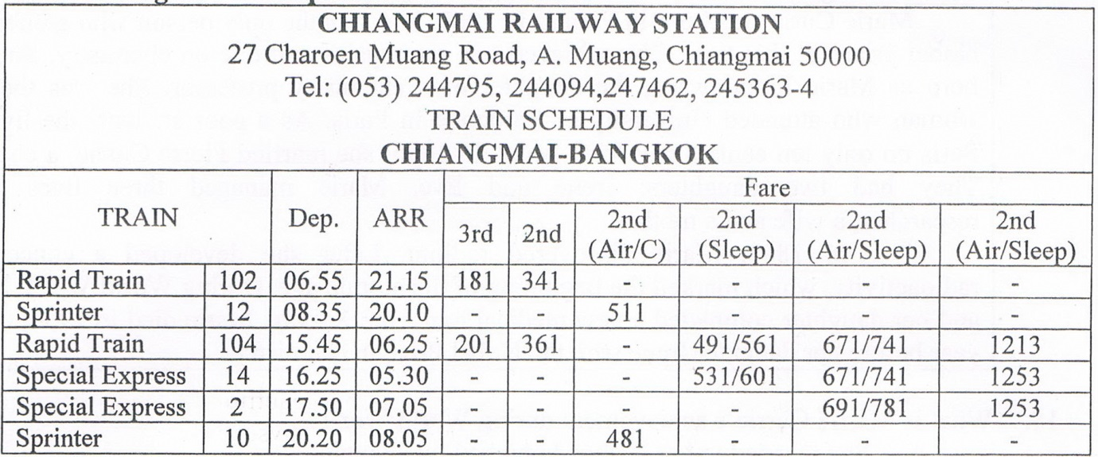

- Which train leaves Chiangmai the earliest for Bangkok?
A. Special Express 2
B. Rapid Train 104
C. Sprinter 10
D. Rapid Train. 102
- Which train goes to Bangkok in the evening?
A. Special Express 2
B. Rapid Train 104
C. Sprinter 10
D. Sprinter 12

The following text is for questions 24 and 26.
January 12th, 2013

Hi Martina,

How are things? I am very glad to read your last letter telling that you spent your holiday in Spain. Now I want to tell you about my holiday, too.
It was an exciting holiday. I spent the holiday with my family. We went to Huatulco, Iceland and New York. We chose those places since the climate and the tourist spots are different very much from the others.
In Huatulco, the climate is very hot because it is on the pacific coast. Completely different with Huatulco, Iceland has cold climate. There are many lands covered with ice. While in New York, the climate is between the other two.
For tourist objects, Huatulco and Iceland have fewer interesting places that can attract tourists compared to New York. We saw many beautiful places, like volcanos, geysers, etc. While in New York, there are many amazing skyscrapers buildings.
I hope we can visit them together on our next holiday, can't we?

miss you much,
Virda

- What does the letter tell us about?
A. The writer wishes to go with her friend.
B. Spending holiday in three places.
C. The Iceland climate during winter.
D. The hot pacific coast of Mexico.

- Where did the writer's friend spend the holiday?
A. In Huatulco.
B. In New York.
C. In Iceland.
D. In Spain.

- Why did the writer and her family go to the three places?
A. The climate of the places are hot.
B. The three places have many deserts.
C. There are many lands covered with ice.
D. They have different climates and tourist objects.

The following text is for questions 27 to 30.
Phuket is the largest island in Thailand, a 540 square kilometers’ it's about the same size as Singapore. Just over an hour by jet from Bangkok or Singapore, and with daily connections to most major Asian airports, Phuket is ideally situated for a short break or a relaxing vacation.
Phuket covers land and many sandy beaches. It is a diverse and fascinating island to explore. A rich culture, a beautiful coastline, spectacular natural sights, loads of outdoor sports and activities, shopping, nightlife and dining are just a few of its attractions. Just offshore are dozens of smaller islands, easily reached by boat. The natural wonders of the mainland, found just beyond Phuket over the bridge to the north of the island, are also closed at hand. Many tourists come to Phuket every year to see the beautiful view of it. One of the beautiful beaches had been displayed in a film, "The Beach", which was acted by the Hollywood actor, Leonardo Di Caprio in 1999.

- People come to Phuket to see,
A. a famous film
B. the major airport
C. the Holywood actor
D. the beautiful view

- Phuket was chosen for the shoot because
A. it has lively night life
B. it has diverse culture
C. it is famous for its beautiful beach
D. it is close to the mainland

- What is the main idea of the second paragraph?
A. Phuket covers land and many sandy beaches.
B. Phuket has spectacular natural view.
C. Beautiful beach film had been displayed in Phuket.
D. Dozens of smaller islands can be reached by the boats.

- "A rich culture, a beautiful coastline....." (paragraph 2) What is the synonym of the underlined word?
A. Sea
B. Lake
C. River
D. Shore

The following text is for questions 31 to 34.
In the days when an a soda float costed less, a 9 year old girl entered a coffee shop and sat at a table. A waiter put the menu in front of her.
"How much is a soda float?"
"One dollar," replied the waiter.
The little girl pulled her hand out of her cute little pink purse and studied a number of coins in it.
"How much is a bottle of soda?" she inquired. Some people were now waiting for a table and the waiter was a bit impatient.
"75 cents," he said brusquely.
The little girl again counted the coins. "I'll have a bottle of soda," she said. The waiter brought the soda bottle, put the bill on the table and walked away. The girl finished the soda, paid the cashier and departed.
When the waiter returned, he began wiping down the table and then swallowed hard at what he saw. There, placed neatly beside the empty dish, were 25 cents - his tip

- Why did the waiter swallow hard?
A. The girl didn't have enough money.
B. He drank a bottle of soda.
C. He drank a soda float.
D. The girl left tip for the waiter.

- The main idea of the last paragraph?
A. The girl cleaned the table patiently.
B. The girl left her tip for the waiter.
C. The waiter swallowed the soda hard.
D. The waiter left an empty dish.

- What can we learn from the story?
A. Never underestimate other people.
B. Surprises happen anywhere.
C. Be patient in serving other people.
D. Be kind to other people.

- "... and studied a number of coins in it" (Paragraph 2) The underlined word refers to
A. the menu
B. coffee shop
C. the purse
D. the girl's hand

The following text is for questions 35 to 38.
Banana Bread Recipe
Ingredients:
• 3 or 4 ripe bananas, mashed
• 1/3cup melted butter
• 1 cup sugar
• 1 egg, beaten
• 1 teaspoon vanilla
• 1 teaspoon baking soda
• pinch of salt
• 1 ½ cups of all-purpose flour

Method:
Preheat the oven to 350⁰ F (175⁰ C). With a wooden spoon, mix butter with the mashed bananas in a large mixing bowl, add sugar, egg and vanilla. Sprinkle the baking soda and salt over the mixture and mix them. Add the flour, then mix it. Pour mixture into a buttered 4 x 8 inch loaf pan. Bake for 1 hour. Cool on rack then remove it from pan and slice to serve.

- What should we do before we sprinkle the baking soda to the mashed bananas?
A. Add flour and butter.
B. Sprinkle salt to the mixture.
C. Add sugar, egg and vanilla.
D. Pour the mixture into a loaf pan.

- How much vanilla do we need to make Banana Bread?
A. 1/3 cup
B. 1½ cup
C. 1 teaspoon
D. 3 teaspoons

- "..., mix butter into mashed bananas..."
The underlined word has similar meaning with ……….
A. crushed
B. damaged
C. ripen
D. failed

- "... then remove it from the pan..."
The word "it" refers to ....
A. mixture
B. flour
C. cake
D. rack

The following text is for questions 39 to 42.
Gardenia plants are popular for the strong sweet scent of their flowers. Gardenia is the national flower in Pakistan. In Japan and China, the flower is called Kuchinashi (Japanese) and Zhizi (Chinese).

Gardenia plants are evergreen shrubs. Their small trees can grow to 1 - 5 meters tall. The leaves are 5 - 50 centimeters long and 3 —25 centimeters broad, dark green and glossy with a leathery texture. The flowers are in small groups, white, or pale yellow, with 5-12 lobes (petals) from 5-12 centimeters diameter. They usually bloom in mid- spring to mid-summer. Many species have strong aroma.

To cultivate gardenia as a house plant is not easy. This species can be difficult to grow because it originated in warm humid tropical areas. It demands high humidity and bright (not direct) light to thrive. It flourishes in acidic soil with good drainage and thrives on 20°— 23° C during the day and 150 - 16° C in the evening. Potting soils developed specifically for gardenias are available. It grows no larger than 18 inches in height and width when grown indoor. In climates where it can be grown outdoors, it can reach the height of 6 feet. If water hits the flowers, they will turn brown.

- How tall is a gardenia tree?
A. 3-25 cm.
B. 5-12cm.
C. 5-50cm.
D. 1-5m.

- What is the main idea of the last paragraph?
A. It is easy to plant a gardenia tree.
B. A gardenia plantneeds high humidity.
C. It's not easy to plant gardenia as a house plant.
D. A good drainage is important for gardenia plant.

- From the text we know that
A. people don't like the strong scent of flower
B. Gardenia is widespread in Asia
C. the flower is easy to plant
D. the flower is expensive

- "... because it originated in warm ..." (paragraph 3, line 10)
The underlined word refers to …………
A. the flower
B. the species
C. the soil
D. the leaf

The following text is for questions 43 to 45.
ATTENTION
Due to the fact that the next two days are national holidays of Christmas and followed by the first semester holiday; all students are requested to study at home during those days starting on tomorrow; School will begin on January 5th, 2014.
Merry Christmas and Happy Holiday.

Principle

- What does the text tell about?
A. Christmas celebration
B. Studying at home
C. National holiday
D. School holiday

- Why does the Principal make the announcement?
A. To celebrate the Christmas with students.
B. To let students know about national holiday.
C. To inform the students about the holiday.
D. To ask students to study at home.

- "Due to the fact . . ." (first line).
The underlined phrase is similar in meaning to ………………
A. the result of
B. scheduled for
C. as a consequence of
D. in view of

For questions 46 to 48, choose the correct words to complete the text.
Thomas Edison (46)... two thousand different materials in search of a proper filament for the light (47) ... . His assistant complained, "All our work is useless." Edison replied (48) ..., "Oh we have come a long way and we have learned a lot. We know that there are two thousand elements which we cannot use to make a good light bulb."

- A. brought
B. tried
C. played
D. showed

- A. baloon
B. flash
C. bulb
D. glass

- A. surprisingly
B. accidentally
C. perfectly
D. confidently

- Arrange the sentences bellow into a correct paragraph.
- We left our house at about 5 o'clock in the morning. We took a taxi to the railway station.
- Finally our train came. All of us rushed to get on the train.
- Last Lebaran, my family and I went hometown. We decided to take a train because it is more comfortable.
- It took about 5 to 7 hours to get to our hometown. We enjoyed our journey.
- We took the carriage no 3 according to our tickets.
- But without any priorinformation, our train was late for about fifteen minutes, so we had to wait a bit longer.
- After finding our seats we could sit comfortably.
- We arrived at the station at six. Our train would leave at 6.40.

A. 3-8-6-4-5-1-2-7
B. 3-4-5-8-1-2-6-7
C. 3-1-8-6-2-5-7-4
D. 3-5-4-2-7-8-1-6

- This text is for the following question.
What does the text mean?
A. Watch out! This tool can be corrosive if you touch it.
B. Remember! This material is made of corrosive substance.
C. Be careful! The material can harm you.
D. Don't touch the hand! It can damage your property.

