BANK SOAL MKKS KABUPATEN SLEMAN
MATERI PENGAYAAN UN BAHASA INGGRIS SMP 2015-2016

PAKET 4
Text for question 1
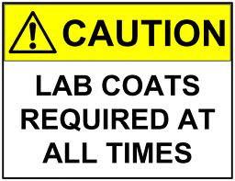
- The caution means that we should always … our lab coats.
- put off
- leave
- wear
- lay
Text for question 2 and 3

- Why does the writer write the text?
- To ask the readers to consume the product
- To promote the product to the readers
- To give information about the product
- To tell the readers about the brand

- What should we do before consuming the product?
- Shake it well.
- Refrigerate it.
- Preserve it.
- Purify it.

Text for questions 4 and 5
May your new home be filled with love and laughter, good fortune, sunshine and happiness
Congratulations!

- “ … with love and laughter …” The underlined word has similar meaning to … .
- enjoyment
- merriment
- excitement
- amusement

- Why is the text written?
- To wish someone to buy a new home.
- To congratulate someone on her new house.
- To invite someone to come to her new house.
- To give someone opportunities to have a new home.

Text for questions6 to 8
Dear Sir,
I am really very disappointed by your shop. I recently bought a sofa and it just was not right. It was terribly mad and a complete waste of money. When I went back to complain, a shop assistantwas very rude to me and she said she couldn't deal with the complaint.
The shop assistant told me that I should write to the manager. I think that I am entitled to my money back, so what I want is a full refund or if you cannot manage that, a credit note for the full amount. I also want an apology, plus an explanation of why I was treated so badly.
Thank you for your attention. Sorry to bring this matter up.
Yours sincerely,
Timothy

- “I think that I am entitled to my money back, …” The underlined words mean …
- have a right
- have an order
- have a reason
- have an excuse

- “…she couldn't deal with the complaint there.” What does the underlined word refer to?
- The shop assistant.
- The manager.
- The citizen.
- The writer.

- What is the main idea of the first paragraph?
- The writer just bought a sofa.
- The writer wasted her money.
- The writer met the shop assistant.
- The writer complained about the sofa.

Text for questions 9 and 10
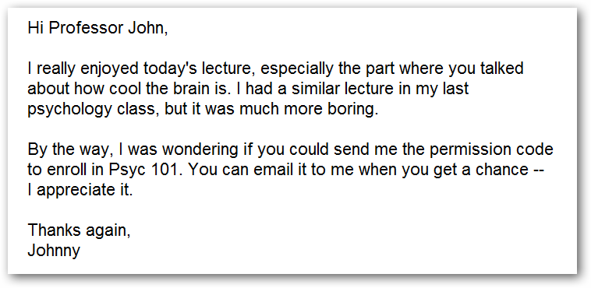

- What should Professor John send to Johnny?
- The enrollment in Psyc 101.
- The psychology lecture.
- The cool of the brain.
- The permission code.

- “… toenroll in Psyc 101” What is the synonym of the underlined word?
- Attend.
- Appear.
- Register.
- Record.

Text for questions 11 and 12.
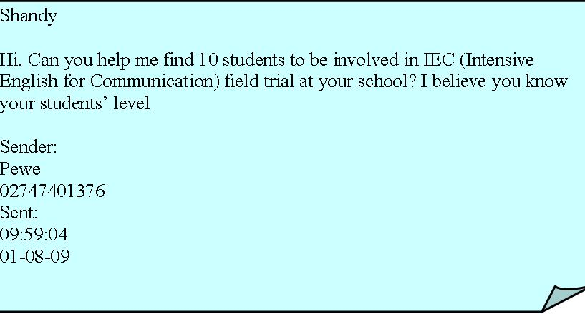

- What does Pewe ask Shandy to do?
- have IEC field trial
- go to Pewe’s school
- know the students’ level
- find 10 students for IEC field trial

- “ Intensive English Course” What is the synonym of the underlined word?
- serious
- thorough
- concentrated
- comprehensive
Text for questions 13 and 14.

- What should you do if you are interested?
- See Zulkifli Yusuf.
- Dial 085656895045.
- Send letter to Zulkifli.
- Send email to the shop.

- The word “feature“ in the text above has the same meaning as … .
- requisite
- qualification
- requirement
- characteristic
Text for questions 15 and 16..
ANNOUNCEMENT
Considering the importance of leadership for young generation, OSIS will hold leadership training on Saturday at one o’clock at the school hall. All students may participate in it. For further information and registration, please contact the committee.

Chairperson,
George, Class IXA

- What is the text about?
- Leadership training.
- The importance of leadership.
- The leadership of young generation.
- The committee of leadership training

- Why is the text written?
- To tell the importance of leadership.
- To invite someone to join the training.
- To give information about the training.
- To remind young generation to have training.

Text for questions17 and 18

- On what occasion is the invitation above?
- A workshop.
- An exhibition.
- A computer fair.
- A business meeting.

- Why does the writer write the text?
- To give opportunity to the students.
- To promote some computer programs.
- To ask people to come to an exhibition.
- To make some works related to computer.
Text for questions19and 21
Lake Toba is a lake and super volcano. The lake is 100 kilometers long, 30 kilometers wide, and up to 505 meters (1,666 feet) deep. Located in the middle of the northern part of the Indonesian island of Sumatra with a surface elevation of about 900 meters (2,953 feet). It is the largest lake in Indonesia and the largest volcanic lake in the world.
Lake Toba is the site of a massive super volcanic eruption estimated at VEI 8 that occurred 69,000 to 77,000 years ago, representing a climate-changing event.
It is the largest known explosive eruption on Earth in the last 25 million years. According to the Toba catastrophe theory, it had global consequences for human populations: it killed most humans living at that time and is believed to have created a population bottleneck in central east Africa and India, which affects the genetic make-up of the human world-wide population to the present.
This hypothesis is not widely accepted because evidence is lacking for a decline or extinction of other animals, including species that are sensitive to changes in the environment. It has been accepted that the eruption of Toba led to a volcanic winter with a worldwide decrease in temperature between 3 to 5 °C (5.4 to 9.0 °F), and up to 15 °C (27 °F) in higher latitudes.

- The text is about … .
- the largest known explosive eruption
- a massive super volcanic eruption
- the Toba catastrophe theory
- the largest lake in Indonesia.

- What is the main idea of the last paragraph?
- The eruption of Toba led to a volcanic winter.
- Some species are sensitive to changes in the environment.
- The temperature decrease between 3 to 5 °C and up to 15°C.
- The hypothesis is not accepted because it is lack of evidence.

- “…evidence is lacking for …” (par 4) The underlined word has the same meaning as … .
- spot
- stain
- proof
- symbol

Text for questions 22 to 25
Many years ago a fierce tiger lived on a mountain in north China. It chased any man, woman or child who passed by. The local magistrate offered a reward to anyone who could kill it. Many tried but lost their lives. At last, the magistrate sent for a famous tiger hunter living in a nearby village.
When the hunter arrived, everyone came out to have a good look at him. They were disappointed to find that he was a small, old man with a bent back. There was a boy of about twelve or thirteen with him. “Where is the tiger?” the old man asked. No one answered. “Let’s go and catch the big cat in the mountain before doing anything else,” the old man said. Again no one replied. He knew that no one wanted to help him so he waited until the next morning. He then told the magistrate what had happened. The magistrate ordered ten young men to take the old man and his boy to the mountain. When they reached the bottom of the mountain, they were afraid to go any further. “Come on!” cried the old man “Don’t be afraid! I will show you how to kill the tiger.” Short Story
Just before they reached the tiger’s cave, the old man told them to stop. “Dig a deep hole in front of me,” he ordered. “Cover it with leaves.” When they had done this he said, “I shall now tell the boy to roar like a tiger. When the tiger comes out of his cave, you must all hide behind the nearest rock. I shall face the tiger alone.” Short Story
He then ordered the boy to roar like a tiger. The tiger came leaping out of his cave. It ran towards the old man who stood waiting for it with a long spear in his hand. Just before it reached him. It fell into the deep hole which had been dug in the ground. The old man leant over the hole and stabbed the tiger with his spear many times. Short Story
“It is dead!” he cried. “It will never cause you any more trouble.”
The villagers living in that place praised the old man for his bravery and skill. They asked him to become their leader.

- What does the text tell us about?
- The villagers and the tiger.
- The old man and the tiger.
- The magistrate and the tiger.
- The ten young men and the tiger.

- “Many years ago a fierce tiger lived on a mountain…” (par 1) What is the synonym of the underlined word?
- scary
- vicious
- fearsome
- frightening

- From the text we know that … .
- no one wanted the magistrate’s reward
- the old man was a famous tiger hunter
- the old man dug a deep hole by himself
- the tiger never chased away the children

- What can we learn from the text?
- Don’t do the dangerous thing alone.
- Don’t ask the old man to do a dangerous thing.
- Don’t judge someone by his physical appearance.
- Don’t be ashamed to ask for help from the old man.

Text for questions 26 to 29
How to clean a refrigerator

First, remove all frozen food and ice cube trays. Place them in the cardboard or somewhere else.
Second, turn the temperature control "defrost" or unplug the electricity to the refrigerator (or both).
Third, let the ice melt. Do not scrape or jab at the ice with a sharp instrument. You may cause serious damage to the freezing unit.
Fourth, put a flat pan under the freezer to catch the drips or put a large towel in the bottom of the refrigerator.
Taken from : http://www.sekolahoke.com/2013/02/teks-procedure-cara-membersihkan-kulkas.html

26. “... the ice melt. Do not scrape or jab at the ice with a sharp instrument.”
The underlined word has similar meaning to ... .
- freeze
- liquify
- flow
- pour

27. “Place them in the cardboard or somewhere else.”
The underlined word in the sentence above refers to ... .
- the temperature and the electricity
- all frozen food and ice cube trays
- the writer and the user
- the tools we need

28. What will happen if we scrape or jab at the ice with a sharp instrument?
- All frozen food will be removed.
- The ice will be melted in the pan.
- The freezing unit will be damaged.
- The drips will be put in the flat pan.
29. Why does the writer write the text above?
- To give something important.
- To ask the reader to help the writer.
- To give information to make something.
- To tell the readers how to do something.

Text for questions 30 to 33
The gecko is a small to medium species of lizard that is found in the more temperate and tropical regions of the world. Geckos are more commonly found around the Equator and in the Southern Hemisphere although a few species of gecko are found north of the Equator in warmer regions.
Geckos can range in size from just a few centimetre to more than 50 cm in length. The largest species of gecko is the Delcourt's gecko (which is now believed to be extinct), native to New Zealand and it grows to nearly 60 cm in length. The JaraguaSphaero found in the Dominican Republic in South America, is the smallest species of gecko in the world and averages less than 2cm in length.
Geckos are well known for their amazing ability to walk up vertical surfaces even those as smooth as glass. The feet of the gecko are covered in tiny hairs that stick to surfaces like sucker pads. This adaptation means that the gecko is a very agile animal.
Geckos are carnivorous reptiles so the diet of the gecko is based on meat from other animals. Geckos primarily eat insects and worms, but some of the larger species of gecko hunt small birds, reptiles and even small mammals such as mice. Some species of gecko are also known to eat a small amount of plant matter such as moss.
Due to their small size, geckos have a number of natural predators around the world, with the snake being the main predator of the gecko. Other animals that prey on the gecko include large spiders, birds and some mammal species.

30. What is the main idea of paragraph 3?
- Gecko is welknown for their ability to walk up vertical surfaces.
- Their feet are covered in tiny hairs that stick to surfaces.
- Geckos can hardly walk on smooth surface like on glass.
- Geckos are very agile animals.

31. Why do geckos have many predators?
- Because they are small
- Because they have prey
- Because snakes like them
- Because mammals eat geckos

32. “ ... andit grows to nearly 60 cm in length.”
The word ‘it’ in the sentence above refers to ... .
- gecko
- native
- Delcourt's gecko
- JaraguaSphaero

33. What does the text tell us about?
- mammals
- reptiles
- geckos
- lizards

Text for questions 34 to 36
Beach walk Shopping Center to present year-end events with promos
Beach walk shopping Center is set to hold several promotional events to celebrate Christmas, Beach walk’s third anniversary and the New Year.
The event will include Bali Carnival, featuring as an exhibition, dance and music performances, talk shows and parades, all to be held on November 13 – 15. Beach walk will also host a school carnival at Fountain Stage level 1 on November 23 – 30, featuring a series of competitions for senior high school students from Denpasar.
Beach walk is also having year-end sales in various fashion retail stores, restaurants and cafes.
Customers can receive instant rewards with a minimum purchase of Rp 500.000 in a single receipt. Those spending a minimum of Rp 2 million with a maximum of two receipts have the chance to win prizes such as Lombok and Gili travel packages for two, Bandung travel packages for two and Denpasar-Jakarta roundtrip flight tickets.
Taken from Jakarta Post, Friday, Nov. 6, 2015

34. What is the main idea of paragraph 4?
- Customers can receive instant reward.
- Customers can win three travel packages for two.
- Customers must spend a minimum of Rp 2 mllion..
- Customers must have a minimum purchase of Rp 500.000,00

35. From the text we can conclude that ... .
- All the events will last for about eleven days
- Beach walk is a kind of people amusement park
- The only event in Beach walk is to face New Year
- Only those purchase more than half million will get rewards

36. When will the school carnival run?
- On the early November.
- On November 13 – 15.
- On November 23 – 30.
- On December 31.

Text for questions 37 to 40
Killing a Monster
A hunting family lived in a forest and, one day when the father was out hunting, the mother and her two children built a campfire in front of their sirelji. As the mother worked she sang:
Making a fire,
Making a fire,
Mother sings a happy song,
A happy song.

Suddenly she saw a monster's reflection in the water of a pot she was putting over the fire. She turned and saw a monster descending the mountain, coming towards her. She said to her crying children, "Don't be afraid. Mother has an idea."
The monster arrived and laughed at the children: "You are fat and just what I want to eat," and opened his huge mouth to devour the children. Doing as their mother had told them, the two children took a bridle and bit in their hands. The monster immediately drew back, for it is said that monsters are in great fear of bridles and bits.
But the monster noticed the mother had nothing in her hands and went near her. Displaying no fear she placed a pot of water and pot of oil near the fire and began to pour the water on her chest. The monster saw this and thought, "You are bathing, so I'll do the same," and poured the oil on his chest. The mother knew monsters easily imitate human action and opened her arms to hug the fire. The monster followed suit and then the oil on his chest caught fire. In pain and flame he cried out and began running. He used his hands to scratch his chest, which made his hands burn and as he scratched his head with his burning hands, his head also caught fire. Thus he became a burning monster and died a moment later.
Taken from: Tales From China's Forest Hunters: Oroqen Folktales

37. Why did the monster’s head also catch fire?
- He was a burning monster.
- He imitated the human action.
- The mother burnt the monster’s head.
- He scratched his head with his burning hands.

38. “ ... she placed a pot of water and pot of oil near the fire and began to pour the water on her chest.”The underlined word in the sentence above refers to ... .
- monster
- mother
- daughter
- human

39. "... what I want to eat, and opened his huge mouth to devour the children.”
The word devour in the above sentence has same meaning as ... .
- drink
- inhale
- squash
- swallow

40. What is themoral value of the story above?
- Do first think later.
- Discuss first do later.
- Think slowly act fast.
- Think first and do smartly.

For questions 41 to 43, choose the correct word to complete the following paragraph.
Cinta Laura Kiehl greets me with a warm smile and a simple hello. As she sits down in the lounge of a South Jakarta Hotel, she says she still feels jetlagged after returning to Jakarta from the US.
No, there is none of the “rich-and-famous” diva attitude that some people may expect. instead, Cinta, who turns on Augustus 17, comes across as a normal young woman who just happens to have a beautiful face.
But don’t be mistaken that her Eurasian good looks – her father is German, her mother Indonesian – are not her only, or her main asset. She is also very smart.
She ... (41) graduated Cum Laude from Columbia University in New York City. She completed her double bachelor’s degree in psychology and German literature in three years instead of the usual four.
Cinta says university life was in fact easier than her jam-packed high school ... (42); she was top of her class and member of the National Honor Society, a varsity athlete, did community service at her mom’s charitable foundation and, of course, had her acting-singing career going on.
“It was insane! I ... (43) slept in high school,” she says.
But she admits it also helped her in landing a place at Columbia, one of the most prestigious university in the US.
Adapted from: SPEAK magazine

41. A. recently
B. currently
C. hurriedly
D. immediately

42. A. subjects
B.schedule
C.activities
D. achievement

43. A. admits
B. amazes
C. arranges
D. admires

For questions 44 to 46, choose the correct word to complete the following paragraph.
Ir. Soekarno (born in Blitar, East Java, June 6, 1901 - died in Jakarta, June 21, 1970 at age 69 years) is Indonesia's first president ... (44) served two terms from 1945 to 1966. He played an important role for the liberation of Indonesia from Dutch colonialism. He is a digger Pancasila. He was proclaimed Indonesian independence (along with Mohammad Hatta) which occurred on August 17, 1945.
Sukarno was born with the name KusnoSosrodihardjo. His father named RadenSoekemiSosrodihardjo, a teacher in Surabaya, Java. His mother was Ida AyuNyomanRai comes from Buleleng, Bali
As a ... (45) child living with his grandfather Sukarno in Tulungagung, East Java. At the age of 14 years, a friend of his father who called Tjokroaminoto Sukarno invited to stay in Surabaya and schooled to Hoogere Burger School (HBS) in there with a Koran in the Tjokroaminoto. At Surabaya, Sukarno many met with the SI leaders, the organization led Tjokroaminoto time. Sukarno then ... (46) the organization Jong Java (Java Youth).
Taken from: http://info-biography.blogspot.co.id/2010/03/biography-ir-soekarno-indonesian-first.html

44. A. who
B. when
C. whom
D. which

45. A. smart
B. youth
C. genius
D. young

46. A. joined
B. stood
C. took
D. ran

47. Arrange the following words into a meaningful sentence.

the earth quake – to go – when – were planning – to Anyer Beach, – happened –
1 2 3 4 5 6
we – our departure
7 8

- 3 – 1 – 5 – 6 – 7 – 4 – 8 – 2
- 3 – 7 – 4 – 8 – 2 – 5 – 1 – 6
- 7 – 4 – 8 – 2 – 3 – 1 – 5 – 6
- 8 – 7 – 4 – 2 – 6 – 3 – 1 – 5

48. in Germany, – in US – so – I– had lived – wanted to spend – the rest of my life– I
1 2 3 4 5 6 7 8
The best arrangement of the jumbled words/phrases above is ... .
- 2 – 8 – 6 – 1 – 4 – 5 – 7 – 3
- 2 – 5 – 3 – 4 – 8 – 6 – 1 – 7
- 4 – 8 – 6 – 1 – 2 – 5 – 3 – 7
- 4 – 5 – 1 – 3 – 8 – 6– 7 – 2

49. Arrange the following sentences into a meaningful paragraph.
- Monkeys are known to learn and use tools to help in getting food.
- Monkey can climb on a single tree to another tree.
- It has long tail, two legs, and two hands.
- In addition to climbing it also likes to scratch his body.
- Monkey is lively and clever animal.
- Monkey habitat is the forest, but there are also monkeys that lived with human, the monkeys live and under growth daily activities with human.
- It also has long arms, so it is very easy to climb for monkey.

- 5 – 3 – 1 – 6 – 2 – 4 – 7
- 1 – 2 – 5 – 3 – 7 – 3 – 4
- 6 –2 – 3 – 7 – 1 – 5 – 4
- 5 – 3 – 7 – 2 – 4 – 1 – 6
50. Arrange the following sentences into a meaningful paragraph.
- After completely ironing, put back the equipments and chemicals.
- Start to iron the shirt from the collar, sleeve then body, iron by following line if there is a fold.
- Check the result and do it again if it is necessary.
- Use protector for safety.
- Make wet the 100% cotton clothes if it is necessary.
- After completely done, hand the shirt.
- Plug in the electricity, choose the suitable temperature for the clothes material.

- 4 – 1 – 7 – 2 – 5 – 3 – 6
- 4 – 7 – 5 – 2 – 6 – 3 – 1
- 2 – 4 – 7 – 5 – 6 – 3 – 1
- 7 – 2 – 4 – 5 – 6 – 3 – 1

